LAND SURVEY-II

CHAPTER-1

LEVELLING

  - Purpose of levelling: Levelling is the art of finding the relative heights and depths of the objects on the surface of the earth. It is that part of surveying which deals with the measurements in verticalplane.
Levelling is of prime importance to an engineer for the purpose of planning, designing and executing various engineering projects such as roads, Railways, canals, dams, water supply and sanitary schemes etc. The Principle of leveling lies in furnishing a horizontal sight and finding the vertical distances of the points above this line. This is done with the help of a level and a levelling staff respectively.
  - Defination of terms used in levelling-concepts of level surface, Horizontal surface, Vertical surface, Datum, R.L,B.M.
Level Surface: This is a surface parallel to the mean spheroidal surface of the earth is said to be a level surface.The water surface of a still lake is also considered to be a levelsurface.
Horizontal Plane/surface: Any plane tangential to the level surface at any point is known as the horizontal plane.It is Perpendicular to the plumb line.
VerticalPlane/surface: Any plane passing through the vertical line is known as the vertical Plane.
Datum Surface or Line: This is an imaginary level surface or level line from which the vertical distances of different points(above or below this line) are measured. In India the datum adopted for the Great Trigonometrically Survey(GTS) is the mean sea level(MSL) at Karachi.
Reduced Level(R.L):The vertical distance of appoint above or below the datum line is known as the reduced level of that point.The Rl of a point may be positive or negative according as the point is above or below the datum.

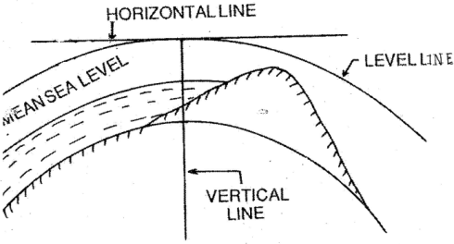

Figure 1.2a
Bench Mark: These are fixed points or marks of known RL determined with reference to the datum line. These are very important marks. They serve as reference points for finding the RL of new points or for conducting leveling operations in projects involving roads, Railways.
Bench mark are of four types.(a)GTS (Great Trigonometric Survey)Bench mark: This Bench mark s are established by Survey of India at large intervals all over the country(Mumbai). The values of Reduced levels, the relevant positions and the number of benchmarks are given in a catalogue published by this department(Ref.Fig:1.2b )
- Permanent Bench marks: These are fixed points or marks established by different Government Departments like PWD, Railway, Irrigation, etc..The R.L’s of these points are determined with reference to the GTS bench mark., and kept on permanent points like the plinth of building, parapet of a bridge or culvert, and so on. Sometimes they are kept on underground pillars as inFig:1.2c
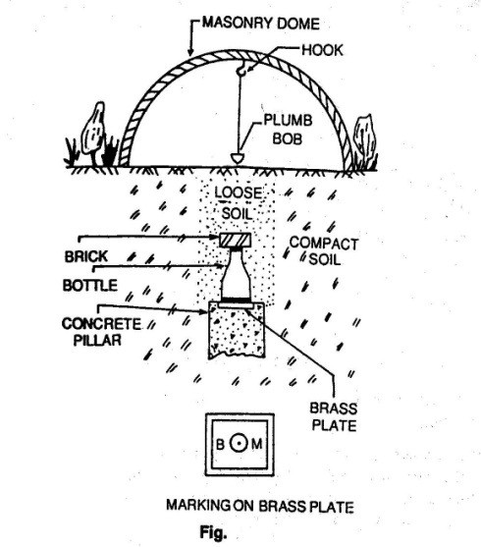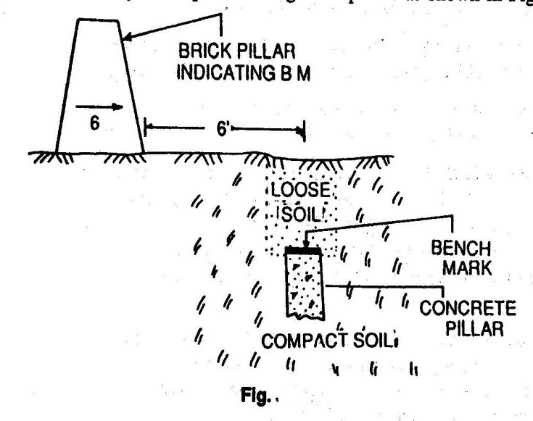

Figure1.2b Figure1.2c

- Arbitrary Bench marks: When the RL’s of some fixed points are assumed, they are termed arbitrary bench-mars. These are adopted in small survey operations, when only undulation of the ground surface is required to bedetermined.
(c)Temporary Bench marks: When the bench marks are established temporarily at the end of a day’s work, they are said to be temporary bench marks. They are generally made on the root of a tree, the parapet of a nearby culvert, a furlong post, or on a similar place.
  - :Description of essential features and use of different types of leveling Instruments:Referring toFig.
1,2,3-Three tripod legs,3a-triangular plate may be fixed on the top of tripod or detachable from the stand,(4),(5),(6) are three foot screws the foot screw(6)is not visible in the picture,(7) is a magnetic compass,(8) is a screw for holding a magnifying lens,(9)eye piece,(10)the object glass of the telescope covered by a detachable sun shade marked(11),(12)a milled headed screw is used for focusing known as focussing screw.(13) is one of the four capstan screws holding the cross hairs in the diaphragm,(14)main spirit level or longitudinal bubble with marked graduations,(15) a cross level which is smaller in size and is not graduated usually,(16)is, the triangular base,called leveling head(trivet),(17)Tribrach
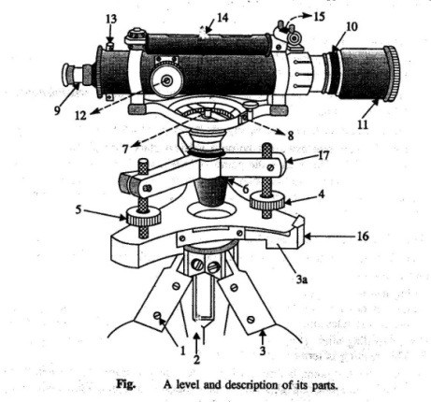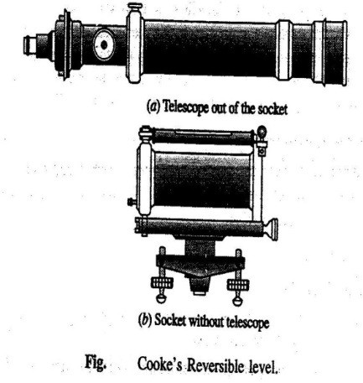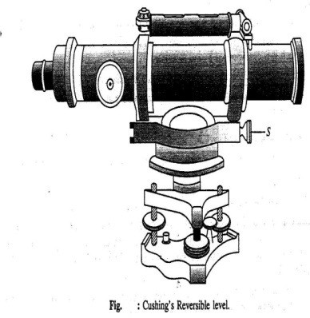

Figure1.3a Fig.1.3b Fig1.3c

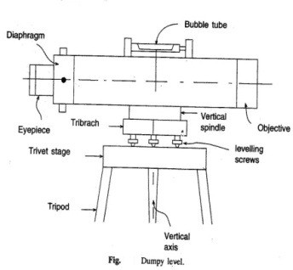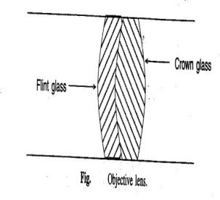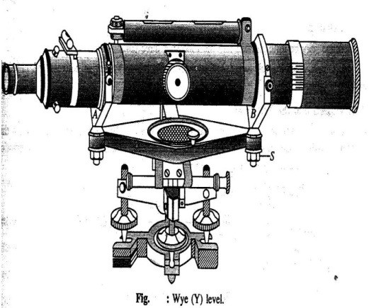

Fig.1.3a Fig.1.3 Fig1.3d

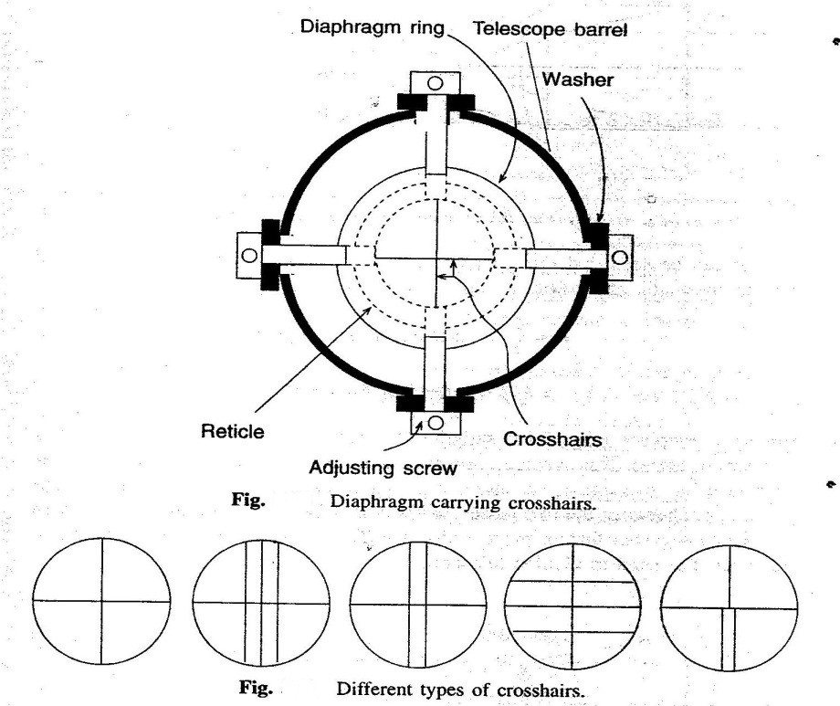

Fig.1.3a

Modifications of dumpy level:Two modified forms of Dumpy level are(1)Cooke’s Reversible level and Cushing’s reversible level.
Cooke’s reversible level:The telescope is placed within a socket as such the telescope can be rotated about its longitudinal axis and (ii) can be taken out to be replaced with its ends interchanged in position,(iii)the axis of the telescope can be tilted a little about its transverse horizontal axis by operating the nut marked “S”.

Cushing’s reversible level:(i) eye piece carrying the diaphragm and object glass are detachable and, thus, can be interchanged,(ii)Object glass and the eye piece can be rotated about the longitudinal axis of the telescope,(iii)The axis of the telescope can be tilted a little about the horizontal transverse axis of the telescope by operating the nut marked “S”.
Wye(Y) level:Here the telescope is placed on Y support,(i)the telescope can be taken out of the socket and can be replaced with its ends reversed,(ii)the telescope can be rotated about its longitudinal axis,(iii)the telescope can be a little about its transverse horizontal axis by operating the nut marked ”S”
Tilting level: The telescope can be tilted about its transverse horizontal axis by operating a screw called tilting screw.The line of collimation, thus can be made horizontal even when the vertical axis of the instrument is not truly vertical.Thus it saves time required for adjustment before taking thereading.

Modern levelling Instruments:

Automatic Levels: The manual adjustment is eliminated in the use of auto level.A compensator mechanism is used in the functioning of this level. Only the telescope is approximately level,the compensator is active and the readings can be taken on the staff at different points.
Electronic digital levels:The level which eliminates the need to read the staff and record readings, modelDL100digital level,Sokkia’s SDL30,TopconDL500series level are available.
  - :Concept of line of collimation:It is an imaginary line passing through the intersection of the cross hairs at the diaphragm and the optical centre of the object glass and its continuation. It is also known as line ofsight.
Axis of the telescope: This is an imaginary line passing through the optical centre of the object glass and the optical centre of the eye piece.
Axis of the bubble tube: It is an imaginary line tangential to the longitudinal curve of the bubble tube at its middlepoint.
  - :Levelling Staff,types features and use: A level staff is a graduated rod of rectangular section. It is usually made of teak wood.It may also be fibre glass or metal.Two types of rodare:-

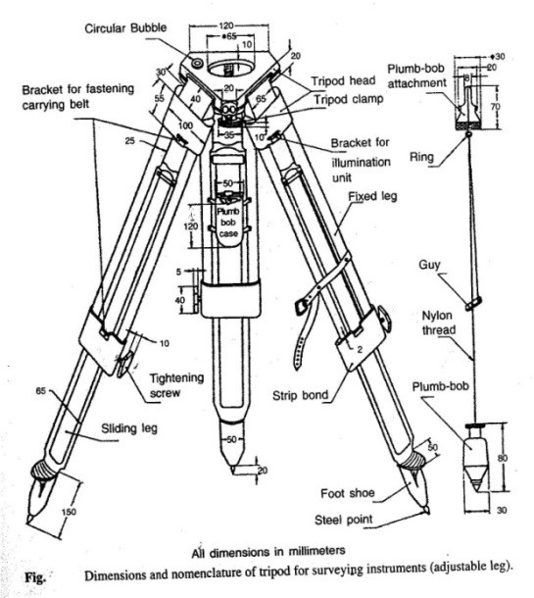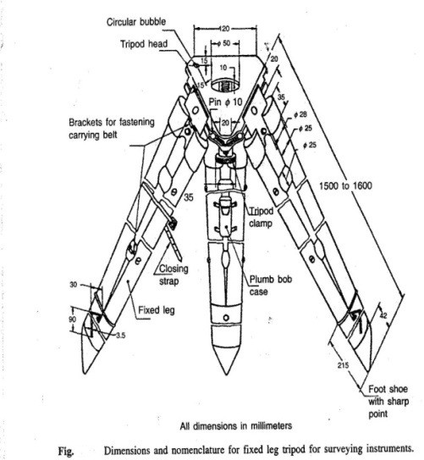

Fig.1.5a

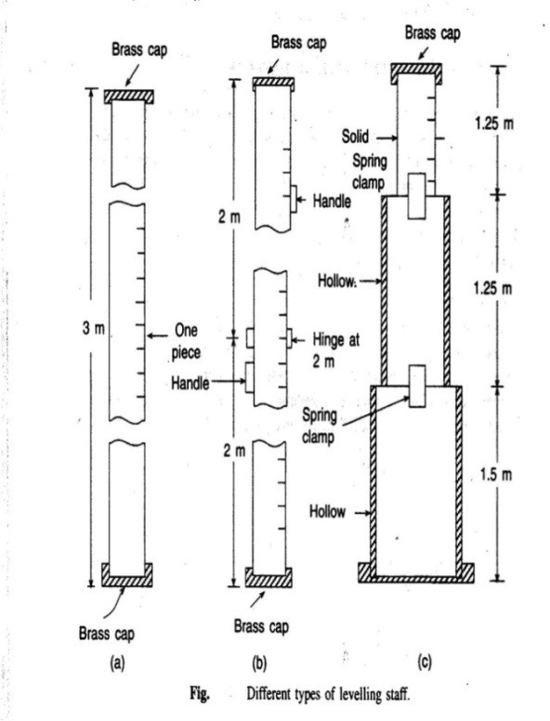
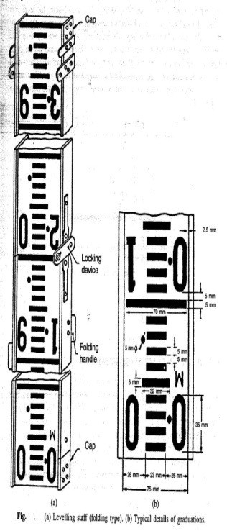
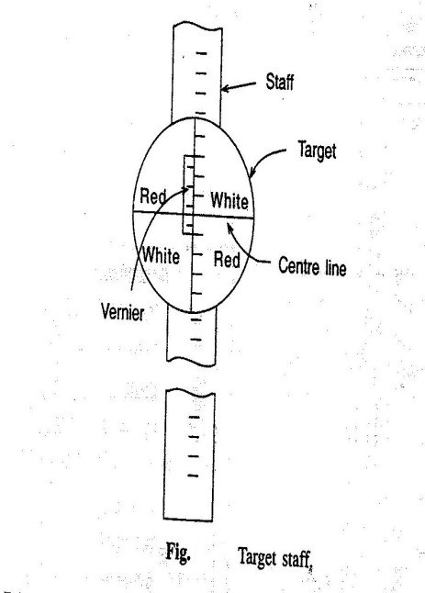
Fig.1.5b

- Self-reading which can be read by the instrument operator with sighting through the telescope and noting the apparent intersection of the cross wires on the rod. This is the most commontype.

- The target rods having a movable target that is set by a rod person at the position indicated by signals from theinstrument-man.
A leveling staff can be of(a)Solid i.e of one piece,(b)Folding when it can be folded to smaller length,(c)Telescopic,when the staff can be shortened by putting one piece inside another.Solid staff being of one piece,gives more accurate reading.Folding staff is light and convenient to handle.As per IS-1779-1961,the width and thickness of the staff are75mm and 18mm respectively. The staff can be folded to2m length.To ensure the verticality the staff has a circular bubble of 25mm sensitivity.each meter is devided into 200sub-divisions,the thickness of the graduations being5mm.In telescopic staff the topmost part is solid and the other two parts are hollow.The two top pieces when pulled up are kept in position by brass flat spring clamps at the back of each piece fixed at its lower end ,While using the telescope staff care should be taken to ensure that the three parts are fully extended.The telescopic staff are is not as accurate as a folding staff because of slippage between the parts.
Target staff has sliding target equipped with vernier. It is used for long distance, when it becomes difficult to take staff readings directly. The target is a small metal piece of circular or oval shape about125mm diameter.It is painted red and white in alternate quadrants .for taking reading the level man directs the staff man to raise or lower the target till it is bisected by the line of sight. The staff holder then clamps the target and take thereading.

:Temporary adjustment of level,taking reading withlevel:

- Setting up:Initially the tripod is set up at a convenient height and the instrument is approximately leveled.Some instruments are provided with a small circular bubble on the tribrach to check the approximatelevelling.At this stage the the leveling screw should be at the middle of itsrun.
- Levelling up:The instrument is then accurately leveled with the help of leveling screws or foot screws.For instruments with three foot screws the following steps are to befollowed.
- Turn the telescope so that the level tube is parallel to the line joining any two leveling screws as shown inFig.
- bring the bubble to the centre of its run by turning the two leveling screws either both inwards or outwards.c)Turn the telescope through 90º,so that the level tube is over the third screw or on the line perpendicular to the line joining screws 1 and 2.Bring the bubble to the centre of its run by the third foot screw only rotating either clockwise oranticlockwise.
- Repeat the process till the bubble is accurately centred in both theseconditions.

- Now turn the telescope through 180º so that it again parallel to leveling screws1 and 2.If the bubble still remains central,the adjustment is all right.If not,the level should be checked for permanentadjustments.

- Focussing:This is done in two steps.First step is focusing the eye piece.This is done by turning the eye piece either in or out until the crosshairs are sharp and distinct.This will vary from person to person as it depends on the vision of the observer.The next step is focusing the objective.This is done by means of the focusing screw where by the image of the staff is brought to the plane of the cross hairs.This is checked by moving the eye up and down when reading the crosshair does not change with the movement of the eye as the image and the cross hair both movetogether.
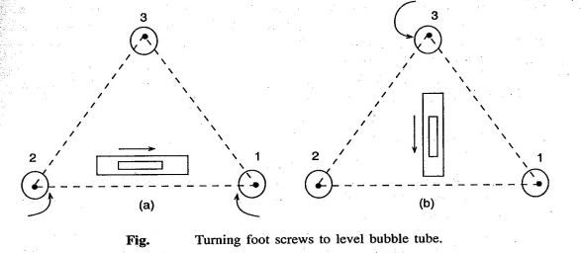
Fig.1.6

:Concept of Bench Mark,BS,IS,FS,CP,HI:

- Station:This is appoint where a leveling staff is held for taking observations with alevel.

- Height of the Instrument(HI):It means elevation of the line of sight or line of collimation with respect to thedatum.
- Back Sight(BS):It is the first reading taken at a station of known elevation after setting up of the instrument.This reading gives the height of Instrument(elevation of line ofcollimation),
elevation of line of collimation=Known elevation+backsight

- Intermediate Sight(IS):These are readings taken between the 1st and last reading before shifting the instrument to a newstation.
- Fore Sight(FS):This is the last reading taken before shifting an instrument to a newstation.

- Turnig Point or Change Point:For leveling over a long distance,the instrument has to be shifted a number of times.Turning point or change point connects one set of instrument readings with the next set of readings with the changed position of the Instrument.A staff is held on the turning point and a foresight is taken before shifting the instrument.From the next position of the instrument another reading is taken at the turning point keeping the staff undisturbed,which is known as backsight.
- Reduced Level(RL):Reduced level of a point is its height relative to the datum. The Level is calculated or reduced with respect todatum.

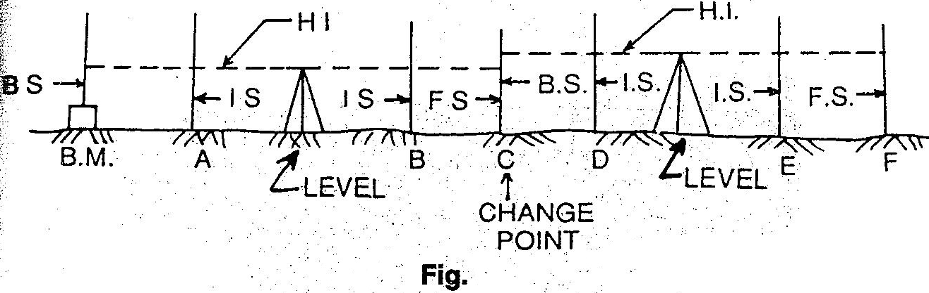

Fig.1.7

:Principles of levelling:

- Direct or simple levelling:In levelling it is desired to find out the difference in level between two points.Then if the elevation of one point is known,the elevation of other point can be easily found out.In fIg.the instrument is placed at C roughly midway between two points A and B.The staff readings are shown in figure.From the figure the R.L of B can be derived as 100.50+1.51- 0.57=101.44mm.From the reading it can also be observed that,if the second reading is smaller than the first reading, it means that the second point is at higher level than that thefirst.
- Trigonometrical levelling: In trigonometrical leveling the difference in elevation is determined indirectly from horizontal distance and the vertical angle.It is used mainly to determine elevations of inaccessible points such as mountain peaks, top of towers etc. as shown infig.
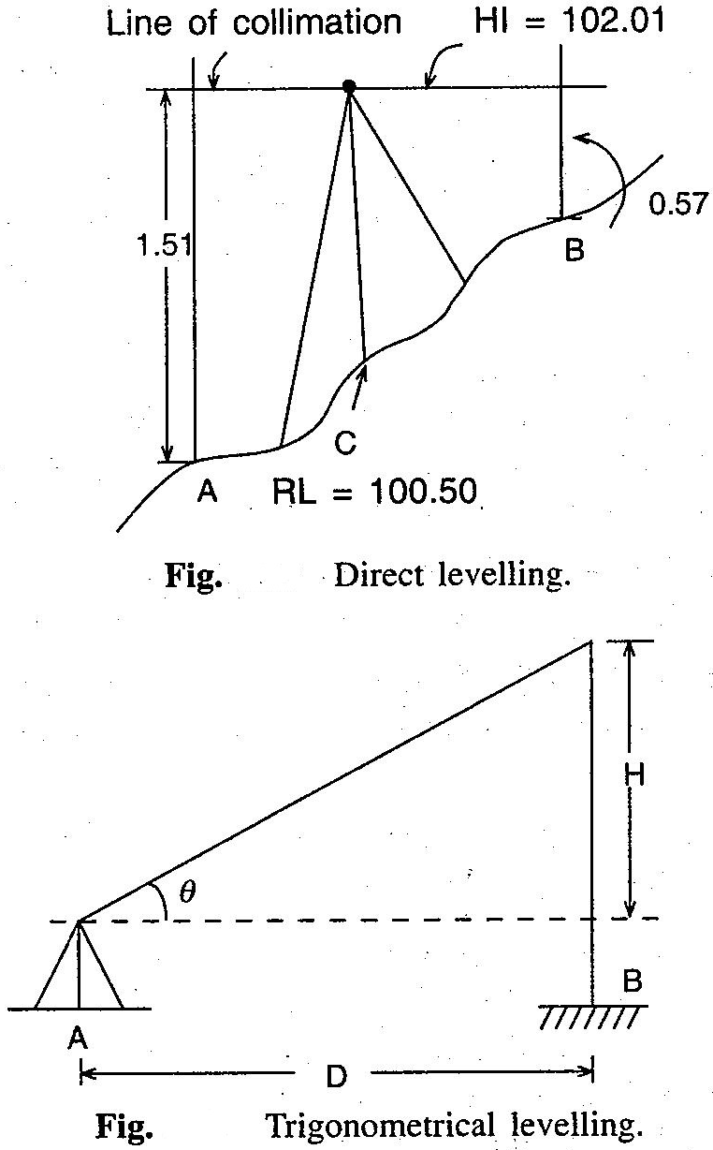
Fig.1.8

- Differential leveling:This type of leveling is adopted when(i)the points are at a great distance apart,(ii)the difference in elevation between the points is large,(iii)there are obstacles between the points.This method is also known as compound levelling.In this method the level is set up at several suitable positons and staff readings are taken at all ofthese.

:Field Data entry:Level book

- Height of collimation or Height of Instrumentmethod:
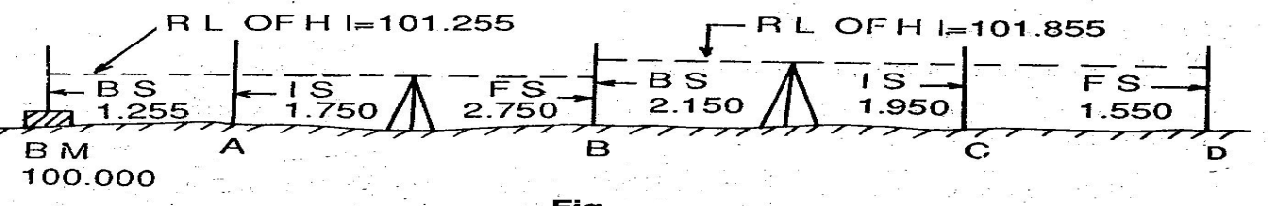
Fig:1.9

The reduced level of the line of collimation is said to be the height of instrument.In this system,the height of the line of collimation is found by adding the backsight reading to RL of the BM on which the BS is taken. Then the RL of the intermediate points and the change point are obtained by subtracting the respective staff readings from the height of Instrument(HI).The level is then shifted for the next set up and again the height of the line of collimation is obtained by adding the backsight reading to the RL of the change point(which is calculated in the first setup).So the ht.of instrument is different in different set ups of the level.Two adjacent places of collimation.Two adjacent planes of collimation are correlated at the change point by an FS reading from one setting and aBS reading from the next setting.The RLs of of unknown points are to be found out by deducting the staff readings from the RL of the height of instrument.Referring toFig.
a)RL of HI in 1st setting=100.00+1.255=101.255,RL of A=101.255-1.750=99.505,RL of B=101.255-2.150=99.105,(b)RLofHIin2ndsetting=99.105+2.750=101.855,RLofC=101.855-
1.950=99.905,RL of D=101.855-1.550=100.305 and so on.,Arithmatic check:Σ BS − ΣFS
=Last RL -1st RL.The difference between the sum of backsights and that of foresights must be equal to the difference between the last RL and the first RL.This check verifies the calculation of the RL of the HI and that of the change point.There is no check on the RLs of the intermediate points.
- The Rise and Fall method:In this method,the difference in level between two consecutive points is determined by comparing each forward staff reading with the staff reading at the immediately preceeding point.If the forward staff reading is smaller than the immediately preceeding staff reading,a rise is said to have occurred. The rise is added to the RL of the preceeding point to get the RL of the forward point.If the forward staff reading is greater than the immediately preceeding staff reading, it means there has been a fall.The fall is subtracted from the RL of the preceeding point to get the RL of the forward point. Refer. toFig.

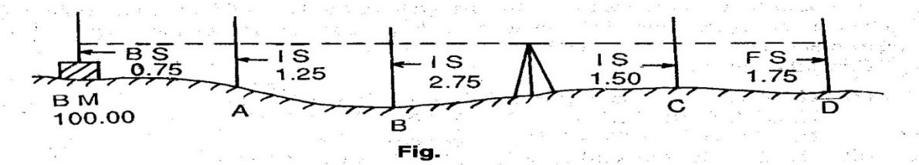

Fig.1.9

Point A(with respect to BM)=0.75-1.25=-0.50(Fall), Point B(with respect to A)=1.25-2.75=- 1.50(Fall),
Point C(with respect to B)=2.75-1.50=+1.25(Rise),Point D(with respect to C)=1.50-1.75=- 0.25(fall)
RL of BM=100.00,RL of A=100.00-0.50=99.50, RL of B=99.50-1.50=98.50, RL of C=98.00+1.25=99.25, RL of D=99.25-0.25=99.00
Arithmetic Check:Σ BS − Σ FS = Σ Rise − Σ Fall = Last RL − 1st RL

In this method,the difference between the sum of BS’s and that ofFS’s,the difference between the sum of rises and that of falls and the difference between the Last RL, and the first RL must be equal.
Note:The arithmetical check is ment only for the accuracy of calculation to be verified.It does not verify the accuracy of field work.There is a complete check on the RLs of the intermediate points in the rise and fallsystem.

Comparison of the two systems:

Sl.No. | Collimation System |  | Rise and fall system
1. | It is rapid as it involves  calculation | few | It is labourious,involving several calculations
2. | There is no check on the RL of  intermediate points |  | There is a check on the RL of intermediate  points
3. | Errors in immediate RLs cannot be  detected |  | Errors in immediate RLs can be detected as all  the points are correlated
4. | There are two checks on  accuracy of RL calculation | the | There are three checks on  calculation | the accuracy of RL
5. | This system is suitable for longitudinal levelling where thereare  a number of intermediate sights. |  | This system is suitable for fly levelling where there are no intermediate sights.

Points to be remembered while entering the level Book:

1.The first reading of any support is entered in the BS column,the last reading in the FS column and the other readings in the IS column.

2.A page always starts with BS and finishes with an FS reading.

- If a page finishes with an IS reading, the reading is entered in the IS and FS columns on that page and brought forward to the next page by entering it in the BS and IScolumns.
- The FS and BS of any change point are entered in the same horizontalline.

- The RL of the line of collimation is entered in the same horizontal line in which the corresponding are entered.
- Bench Mark(BM) and change point(CP) should be clearly described in the remarkcolumn.

Example:The following consecutive readings were taken with a dumpy level along achain line at a common interval of 15m.The first reading was at a chainage of165m,where RL is 98.085.The instrument was shifted after the fourth and ninth readings:3.50,2.245,1.125,0.860,3.125,2.760,1.835,1.470,1.965,1.225,2.390 and3.035
Mark rules on a page of your note book in the form of a level book page and enter on it the above readings and find the RL of all the points by:(1)The line of Collimation method,(2)The Rise and fall method&apply the usual checks.
- The line of Collimationmethod:

Station  point | Chainage | BS | IS | FS | RL of Line of  collimation(HI) | RL | Remarks
1 | 165 | 3.150 | xxxx | xxxx | 101.235 | 98.085
2 | 180 | xxxx | 2.245 | xxxx | xxxx | 98.990
3 | 195 | xxxx | 1.125 | xxxx | xxxx | 100.110
4 | 210 | 3.125 | xxxx | 0.860 | 103.500 | 100.375 | Change  Point
5 | 225 | xxxx | 2.760 | xxxx | xxxx | 100.740
6 | 240 | xxxx | 1.835 | xxxx | xxxx | 101.665
7 | 255 | xxxx | 1.470 | xxxx | xxxx | 102.030
8 | 270 | 1.225 | xxxx | 1.965 | 102.760 | 101.535 | Change  Point
9 | 285 | xxxx | 2.390 | xxxx | xxxx | 100.370
10 | 300 | xxxx | xxxx | 3.035 | xxxx | 99.725
TOTAL= |  | 7.500 | xxxx | 5.860 | xxxx | xxxx
Arithmetic Check: Σ BS −ΣFS =Last RL -1stRL,(7.500-5.860)=+1.640,(99.725-99.085)=
+1.640

2)The Rise and fall method:

Station  point | Chainage | BS | IS | FS | Rise(+) | Fall(-) | RL | Remarks
1 | 165 | 3.150 | xxxx | xxxx | xxxx | xxxx | 98.085
2 | 180 | xxxx | 2.245 | xxxx | 0.905 | xxxx | 98.990

3 | 195 | xxxx | 1.125 | xxxx | 1.120 | xxxx | 100.110
4 | 210 | 3.125 | xxxx | 0.860 | 0.265 | xxxx | 100.375 | ChangePoint
5 | 225 | xxxx | 2.760 | xxxx | 0.365 | xxxx | 100.740
6 | 240 | xxxx | 1.835 | xxxx | 0.925 | xxxx | 101.665
7 | 255 | xxxx | 1.470 | xxxx | 0.365 | xxxx | 102.030
8 | 270 | 1.225 | xxxx | 1.965 | xxxx | 0.495 | 101.535 | ChangePoint
9 | 285 | xxxx | 2.390 | xxxx | xxxx | 1.165 | 100.370
10 | 300 | xxxx | xxxx | 3.035 | xxxx | 0.645 | 99.725
TOTAL= |  | 7.500 | xxxx | 5.860 | 3.945 | 2.305 | xxxx
Σ BS − Σ FS =7.500-5.860=+1.640, Last RL -1st RL=(99.725-98.085=+1.640,
Σ Rise − Σ Fall =3.945-2.305=+1.640

Exercise No.1:The following figures are staff readings taken in order on a particular scheme,the backsights being
underlined.0.813,2.170,2.908,2.630,3.133,3.752,3.277,1.899,2.390,2.810,1.542,1.274,0.643,The
first reading was taken on abench mark39.563.Enter the readings in level book form,check the entries,and find the reduced level of the last point. Comment on your completed reduction.
Exercise No.2:A page of an old level book had been damaged by white ants and the readings marked X are missing.Find the missing readings with the help of available readings and apply arithmetical checks.

Distance in m | BS | IS | FS | RL of Line of collimation(HI) | RL | Remarks
 | X |  |  | X | 209.510 | B.M
0 |  | 1.675 |  |  | X
30 |  | X |  |  | 210.425
60 |  | 3.355 |  |  | 209.080
X | 0.840 |  | X | 209.520 | X | Change Point
120 |  | X |  |  | 208.275
150 |  | X |  |  | 210.635 | Underside of bridge  girder
X | X |  | 2.630 | X | X | X
210 |  | X |  |  | 206.040
240 |  | 1.920 |  |  | 205.895
270 |  |  | X |  | 205.690

:Different types of levelling,uses and methods:

- Differential or Fly Levelling:It is carried out when the difference in elevation between two points that are far apart is to be determined.Here there is no need to determine the RLs of the intermediatepoints.Thismethodisadoptedwhenonewantstoestablishabenchmarknearthe

site of leveling work.Essentially,Backsights and foresights are taken to reach a point B starting from appoint AThis relates the R.L of point B with the known RL of point A.(Ref:Fig.)
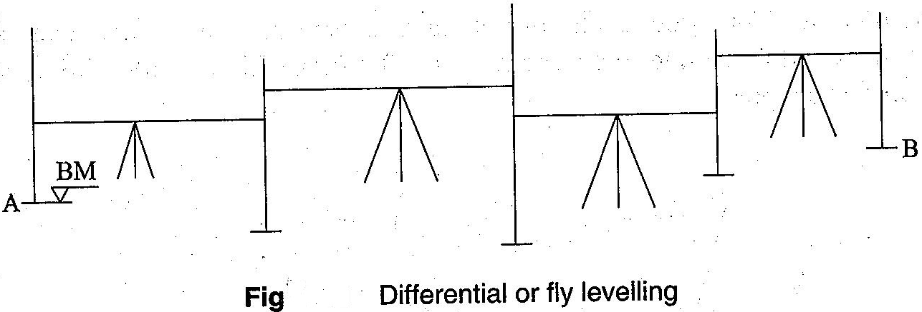

Fig.1.10

Example:

Stationpoint | BS | IS | FS | Rise(+) | Fall(-) | RL | Remarks
BM | 0.955 | xxxx |  | xxxx | xxxx | 250.550 | on BM  No.1
 | 1.250 | xxxx | 2.150 |  | 1.195 | 249.355
 | 0.785 | xxxx | 1.760 |  | 0.510 | 248.845
 | 1.535 | xxxx | 2.055 |  | 1.270 | 247.575 | ChangePoint
 | 1.260 | xxxx | 0.835 | 0.700 | xxxx | 248.275
 | 0.675 | xxxx | 0.955 | 0.305 | xxxx | 248.580
 | 1.275 | xxxx | 1.505 |  | 0.830 | 247.750
 | 1.675 | xxxx | 2.050 | xxxx | 0.775 | 246.975 | ChangePoint
 | 0.450 | xxxx | 2.160 | xxxx | 0.505 | 246.470
A | xxxx | xxxx | 1.005 | xxxx | 0.555 | 245.915 | Starting point of  roadproject
TOTAL= | 9.840 | xxxx | 14.475 | 1.005 | 5.640 | xxxx
Σ BS − Σ FS =9.840-14.475=-4.635, Last RL -1st RL=(245.915-250.550=-4.635,
Σ Rise − Σ Fall = 1.005-5.640=-4.635

- Check Levelling:It is the operation done to check the leveling work done.A simple method is to run run a series of levels as in fly leveling up to the starting point of the survey at the end of the day.This will check the accuracy of the levelingwork.
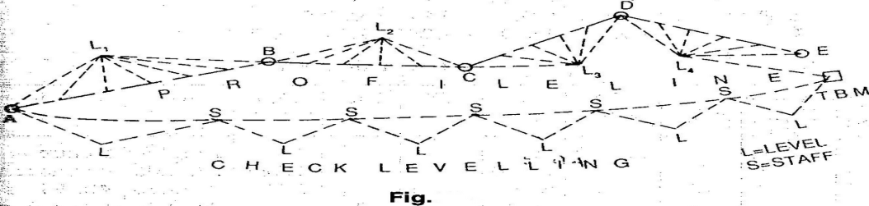
Fig:1.10

- Profile Levelling:Profile leveling or sectioning is leveling done across aline,e.g.,along the centre line of the road,to get a sketch of the profile.Essentially the staff stations have to be ranged to be along aline.Reading are taken on the staff held along this line.When the levels are plotted along the distances in aline,we get aprofile of the ground showing the elevations of the points.(Ref.Fig.)

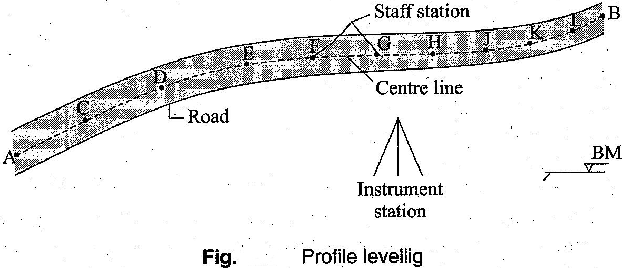

Fig:1.10

- Cross sectioning:It involves taking levels across alinee.g the centre line of a road,or a railway line.Depending upon the width of road,a number of staff stations are fixed across the centre line.This again gives a profile perpendicular to the longitudinal line and is useful in calculating thevolume,etc.
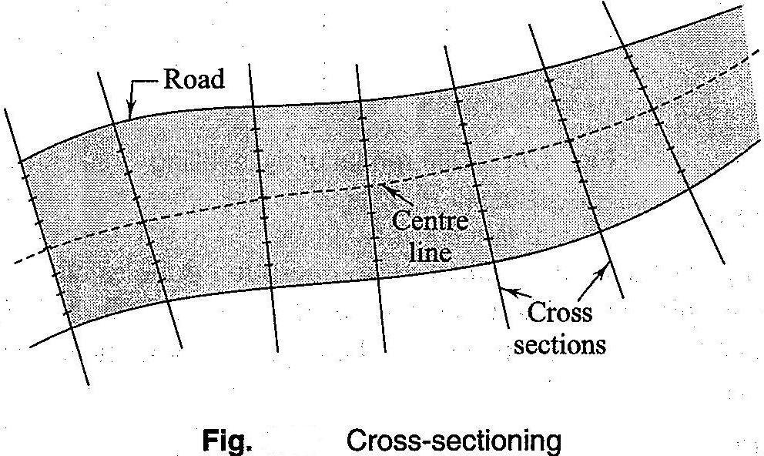

Fig:1.10

- Reciprocal Levelling:Reciprocal levelling is done when the distances are long and it is not possible to balance the lengths of the line of sights. This happens,e.g,in the case of points laying on either side of a river, when it is not possible to maintain the level between the two points.This process eliminates many errors due to maladjustment of the instrument and those due to curvature andrefraction.

:Plotting of profiles:a)Longitudinal sections:

For plotting normally the Horzontal scale of 1:1000 or 1:2000 and vertical scale which is of either1:100 or 1:200 is followed.A horizontal line is drawn as the datum line.the chainages are marked along this line according to the horizontal scale.Then the ordinates(perpendicular lines)are drawn at each of the chainage points.The RL of the datum line is assumed in such a

way that the ground surface can be shown above the datum.Now the vertical distances(RL of GL-RL of datum)are plotted along the ordinates according to the vertical scale.The plotted points are joined to obtain the outline of the ground surface(as shown in fig.).The formation line are drawn in Red ink.
a)Cross sections:The cross sections are drawn/plotted in the same way as of longitudinal sections,but the Horizontal and vertical scales are slightly different(Horiz.1:400,Vert.1:100 are normally followed)

Example of profile levelling:
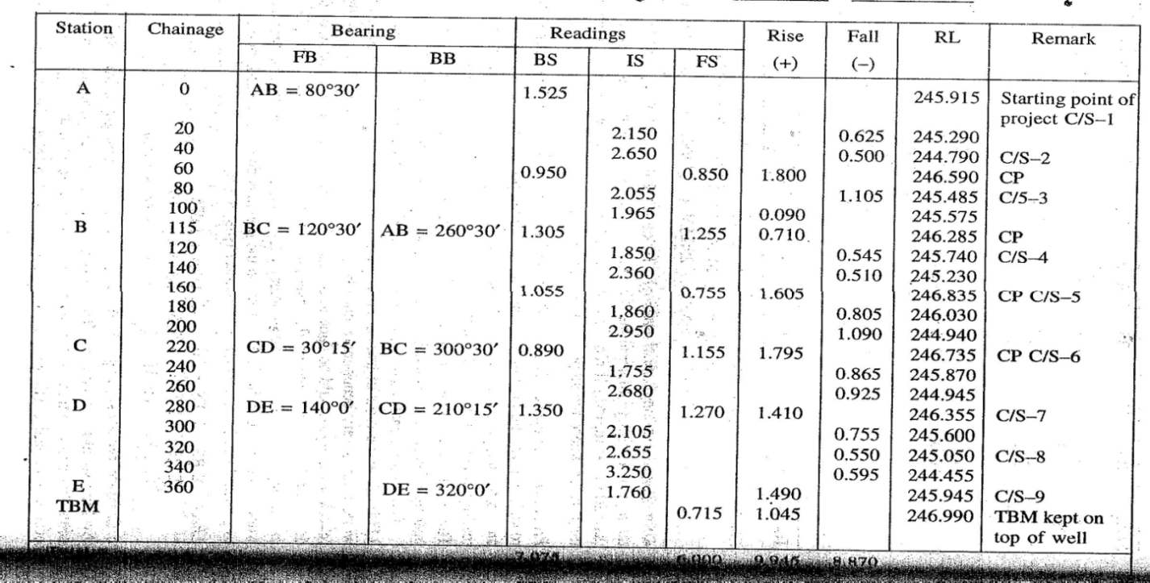

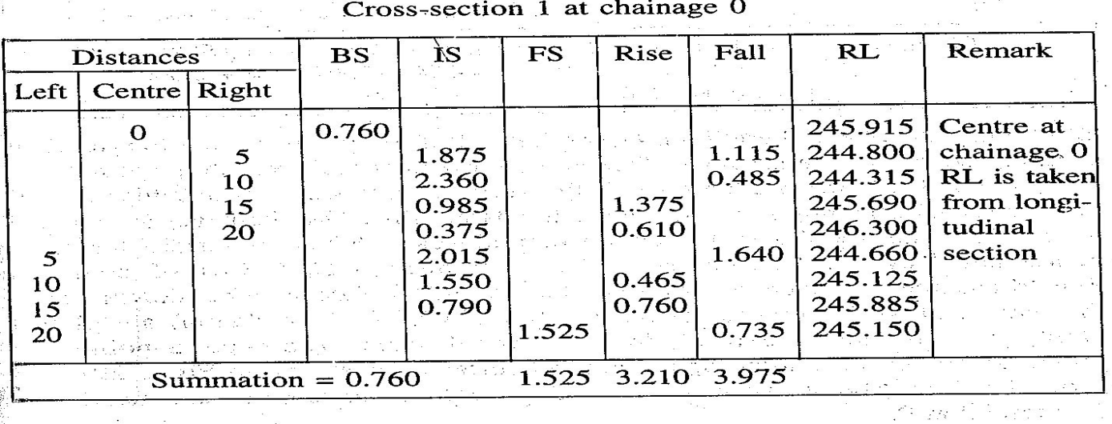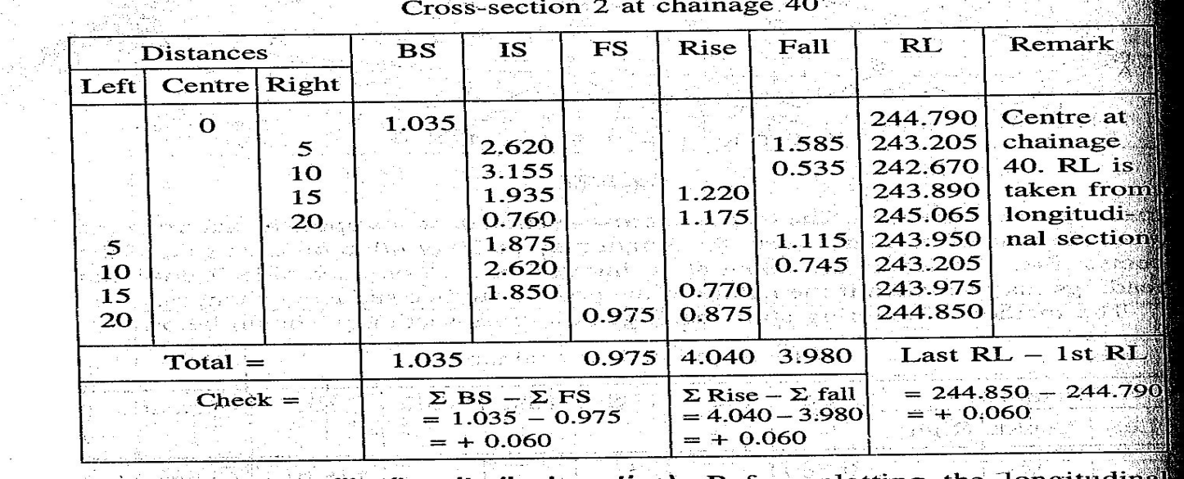
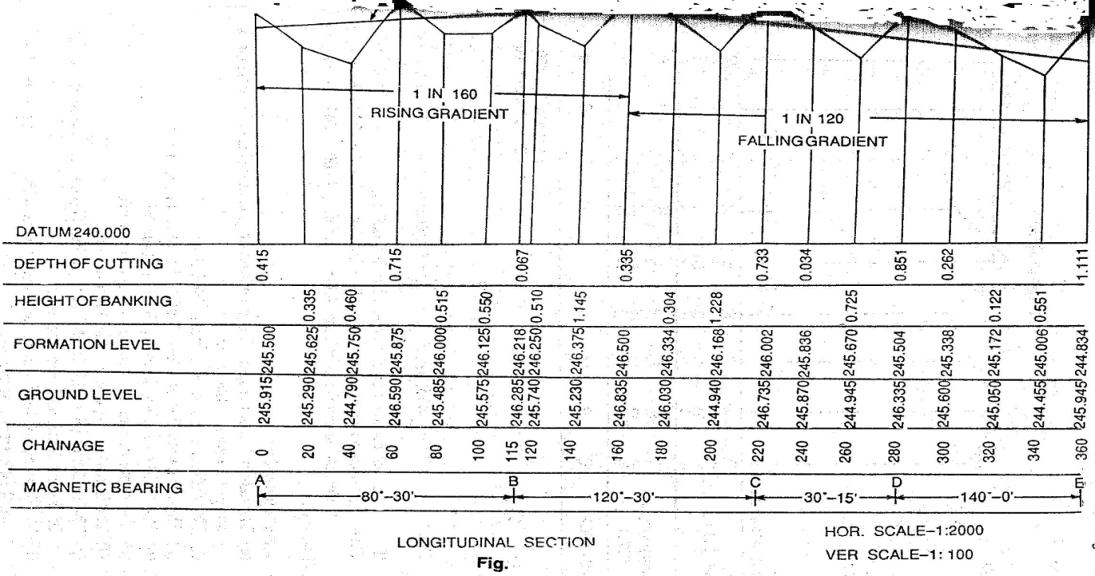

Fig.1.11

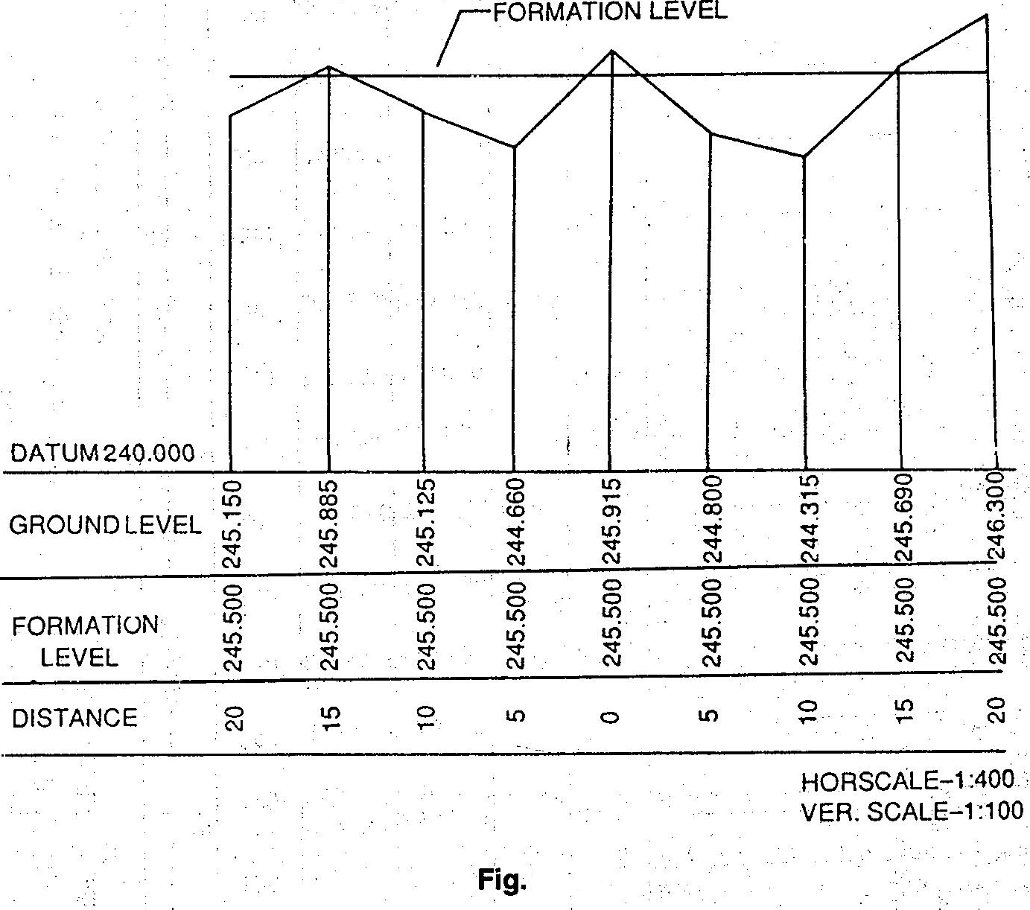

Fig:1.11

Efeects of Curvature andrefraction:

Leveling instruments provide horizontal line of sight and as a result curvature error occurs.In addition due to refraction in earth’s atmosphere the ray gets bent towards the earth introducing refraction errors.Fig. illustrates these errors.Neglecting small instrument HeightSA,OA can be taken as the radius of earth,From Geometry of a circle,AB(2R+AB)=d²,as AB is very small compared to diameter of the earthAB.2R= d²,AB= d²/2R,The dia. Of earth is taken as12734KM,Hence curvature correction:AB=d²/12734Km=0.078d²m,d is expressed in Km.The radius of rayIC isbent due to refraction is taken as seven times the radius of earth.The refraction correction is taken as1/7th of the curvature correction.Refraction correction reduces the curvature

correction and hence combined correction is 6/7th of0.078d²m,i,e0.067d²and d is expressed in Km. The correction is subtractive from staff reading.
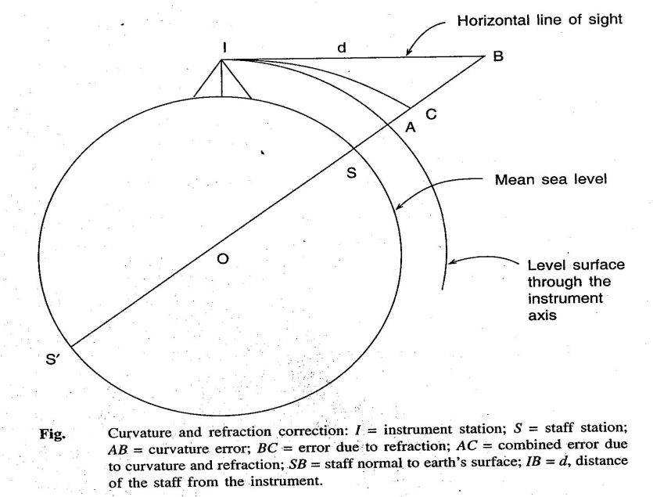
Fig.1.12

Example: Determine the distance for which the combined correction is 5mm.

Correction in m=0.067d^{2,}where d is inKm,d²=0.005/0.067,d=√0. 005 ÷ 0.067)
=0.273Km=273m

Exercise: A sailor standing on the deck of a ship just seesthe top of alight house.The top of the light house is 30m above sea level and the height of sailors eye is 5m above sea level.Find the distance of the sailor from the light house.

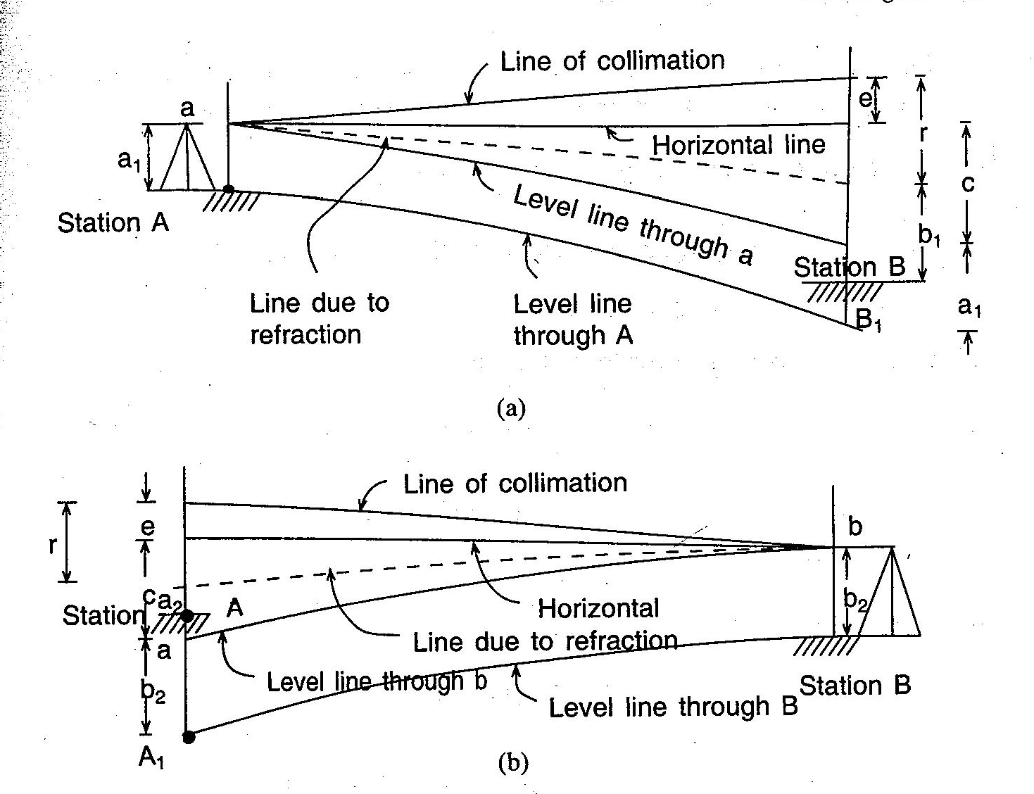

Fig:1.13

Reciprocallevelling:

While crossing a river or ravine it is not possible to put the level midway so that the back sight and foresight are equal. Sight distance ,however, is long and errors due ti (i)collimation,(ii)curvature and refraction are likely to occur. To avoid these errors two observations are made.As shown in fig. instrument is placed near station A and observations are made. On staffs at A and B.Similarly instrument is placed near B and staff readings are taken on B and A.
From 1st set of reading: difference in level=d=BB₁=a₁+c+e-r-b₁=(a₁₋b₁)+(c-r)+e
From 2nd set of reading: Difference in level =d=AA₁=-(b₂+c+e-r-a₂₎=(a₂₋b₂)-(c-r)-e(-sign as difference is measured at A instead of at B),By adding:2d= (a₁-b₁)₊(a₂-b₂),or, d=½[(a₁-b₁)₊(a₂- b₂)],
Subtracting,2 (c-r)+e=[(a₂-b₂)-(a₁-b₁)],or(c-r)+e =½[(a₂-b₂)-(a₁-b₁)],C=curvature error,r=refraction error,e=error due tocollimation.

Example:The results of reciprocal leveling between stationA and B 250m apart on opposite sides of a wide river were asfollows.
Level at A ----------- ht. ofeyepiece(m)1.399 staff reading2.518 onB

Level at B ----------- ht. ofeyepiece(m)1.332 staff reading0.524 onA

Find the true difference of level between the stations.and the error due to imperfect adjustment of the instrument assuming the mean radius ofearth6365Km.
Solution:Since the staff is very close to A and B in 1st and 2nd set up respectively,the height of theeyepieceistakenasthestaffreading.Truedifferenceoflevel=½[(a₁-b₁)+(a₂-b₂)]=
½[(1.399-2.518)+(0.524-1.332)]=-0.964m,Indicating that A is at lower level than B.

Total error=½[(a₂-b₂)-(a₁-b₁)]= ½[(-0.808)-(-1.119)]=+0.156m,Error due to curvature and refraction=L²/2R[1-2m]=0.00422m,Error due to collimation=+0.156-0.004=+0.152 in 250m,Hence error/100m=+0.06m
Precise leveling:Precise levelling aims at establishing the RL of a point with highest precision.The objective of providing such high order of precision in the measurement is to establish network of Bench marks.Precise leveling employs precise level,precise leveling staff and all possible corrections in order to attain accuracy of highest order in the Instrument.
Field Work:1)Back sights and fore sights are taken with instrument equidistant from the staffs for eliminationof collimation errors,error due to curvature and refraction.(2)More than one setting at the same instrument position will help in the reduction of error.(3)Reading in the staff are taken in three levels of stadiahairs.

Difficulties in leveling:

- When the staff is too near the staff:if the staff is held very near the leveling instrument, the graduations of the staff are not visible.In such acse a piece of paper is moved up and down along the staff until the edge of the paper is bisected by the line of collimation.Then the reading is noted from the staff with nacked eye.Sometimes the reading is taken by looking through the objectglass.
- Levelling across a large pond or lake:As the water surface is level,all the points on it will have the same RL.Two pegs A and B are fixed on opposite banks of the lake or Pond.The tops of the pegs are just flush with the water surface.The level is set up at O₁and the RL of A is determined by taking the FS on A.The RL of B is assumed to be equal to that of A. Now the level is shifted and set up at O_{2.}Then by taking the BS on Peg B,leveling is continued(Ref:Fig.)

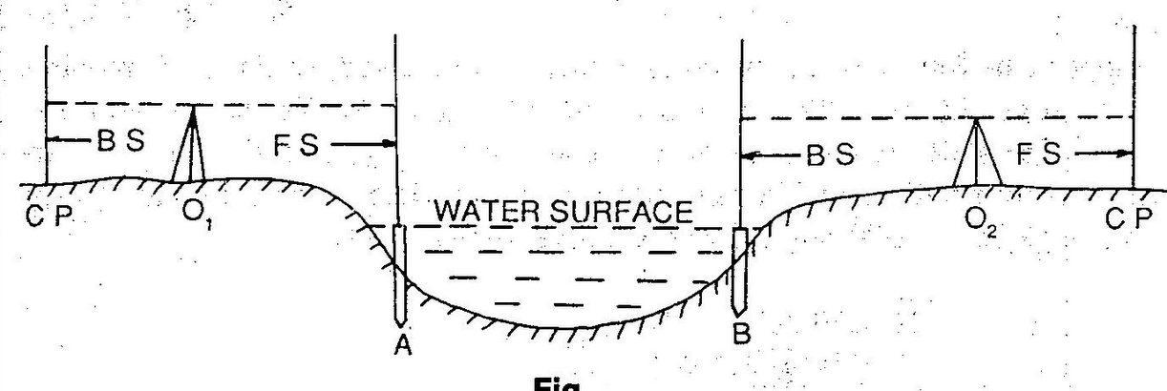

Fig:1.14

- Levelling across a River:In acse of a flowing water the surface cannot be considered to be level.The water levels on opposite edges will be different. In this case the method of Reciprocal leveling isfollowed.
- Levelling across a Solid wall: When leveling is carried across a brick wall, two pegs A and B are driven on either side of the wall just touching it.The level is setup at O₁ and astaff reading is taken on A.Let this reading is Ac.Then the height of the wall is measured by staff.Let the ht.be AE.The HI is found out by taking aBS on any BM or CP,Then RL of A=HI-AC,RL of E=RL of A+AE=RL of F(Same level).The level is shifted to some point O₂.The staff reading Bd is noted and the Ht. measured.Thus RL of B=RL of F-BF,HI at O₂=RL of B+BD,The leveling is then continued by working out the HI of thesetting(Ref.Fig)
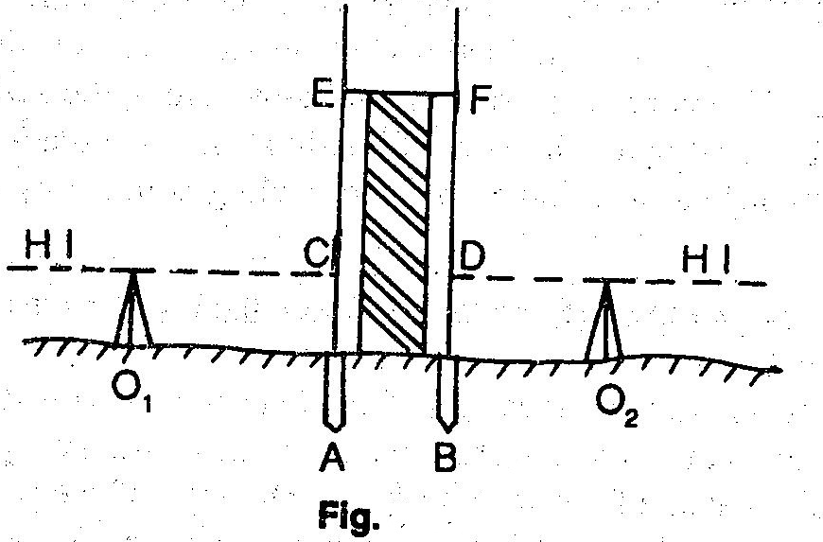
Fig:1.14

- When the BM is above the Line of collimation:This happens when the BM is at bottom of abridge girder or on the bottom surface of aculvert.Suppose theBM exists on the bottom surface of a culvert and that is required to find out the RL of A.The level is Set up at O and the staff is held inverted on the BM.The staff reading is taken and noted with a negative sign.The remark “staff held inverted” is to be entered in the appropriate coloumn.Let the BS and FS readings be- 1.500 and 2.250 respectively. Now. HI=100.000-1.500=98.500,RL ofA=98.500-2.250=95.250.
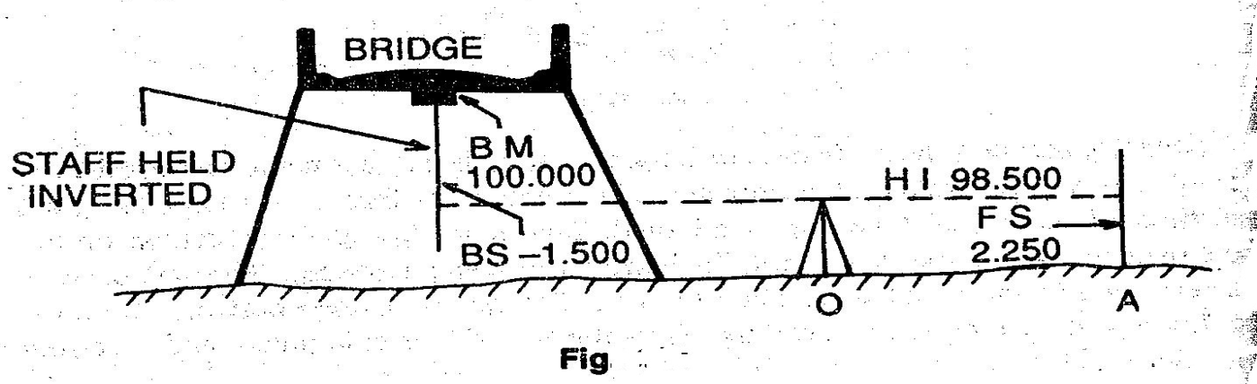
Fig.1.14

- Levelling along a steep slope:While leveling along a steep slope in a hilly area, it is very difficult to have equal BS and FS distances.In such cases the level should be set up along a Zig- zag path so that the BS and FS distances may be kept equal.Let AB be the direction of leveling.I_{1,}I₂….are the positions of the level and S₁,S₂,S₃… are the staff position(Ref.Fig.).levelling is continued in this manner and the RLs of the points arecalculated.
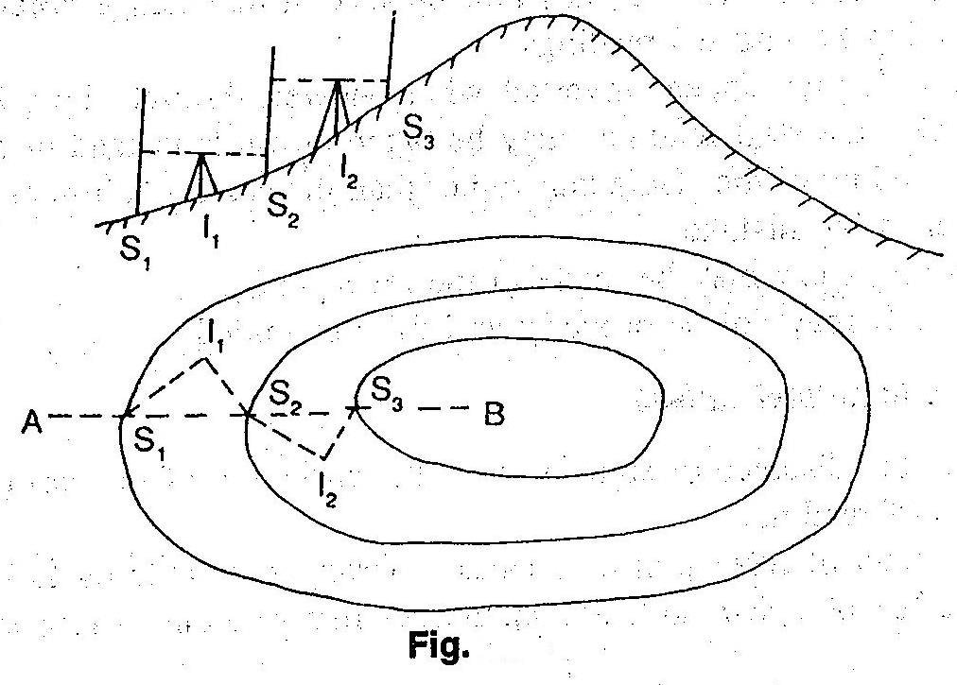
Fig:1.14

- Levelling across arising ground or depression:While levelling across high ground,the level should not be placed on top of this high ground,but on one side so that the line of collimation just passes through the apex. While leveling across a depression, the level should be set up on one side and not at the bottom of thedepression.(Ref:Fig.)
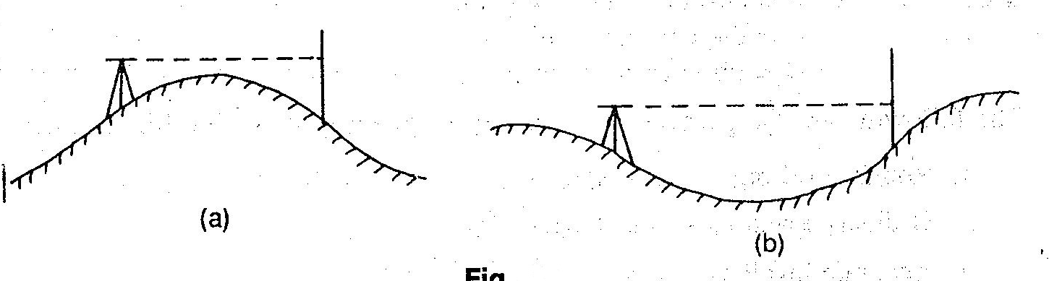
Fig:1.14

Errors in levelling and precautions:

- Instrumental errors:(a) The permanent adjustment of the instrument may not be perfect.That is the line of collimation may not be parallel to the axis of the bubble tube.(b)The internal arrangement of the focusing tube is not perfect.(c)The graduation of the leveling staff may not be perfect.
- Personal errors: (a)The instrument may not be leveled perfectly.(b)The focusing of eye piece and object glass may not be perfect and the parallax may not be eliminated entirely.(c)The position of the staff may be displaced at the change point at the time of taking FS and BS readings.(d)The staff may appear inverted when viewed through the telescope.By mistake,the staff readings may be taken upwards instead of downwards..(e)The reading of the stadia hair rather than the central collimation hair may be taken by mistake.(f)A wrong entry may be made in the level book.(g)The staff may not be properly and fullyextended.
- Errors due to natural Causes:(a)When the distance of sight is too long, the curvature of the earth may effect the staff reading.(b)The effect of refraction may cause a wrong staff reading to be taken.(c)The effect of high winds and a shining Sun may result in a wrong staffreading.
Permissible Errors in Levelling:

The precision of levelling is ascertained according to the error of closure.The permissible limit of closing error depends upon the nature of work for which the leveling is to be made.It is expressed as:E=C√D,Where,E= closing error in meter,C=the constant,D=distance inKm.The
following are the permissible errors for different types of leveling:

1)Rough leveling-E=±0.100√D,(2)Ordinary leveling: -E=±0.025√D,(3)Accurate Levelling: - E=±0.012√D,(4)Precise Levelling: -E=±0.006√D

Sensitiveness of bubble tube, determination of sensitiveness:

The sensitivity of the level tube depends on the Radius of curvature( R) and usually expressed as θ per unit division(d).This angle may vary from 1” to 2” in the case of precise level,up to 10” to 30” on engineer’s level..This can be determined by in the field by observing the staff readings at aknown distance from the level by changing the bubble position by means of a foot screw as shown in Fig.
tan nθ=S/l,Since θ is very small,tan nθ≈nθ, nθ_{rad}=S/l, θ_{rad}=S/nl, θ_{sec}=206265S/nl,Where S= diff. in staff reading a and b, n= no. of divisions the bubble is displaced between readings,l=distance of staff from instrument. If d=length of one division of the bubble tube then, d=Rθ_{rad,}
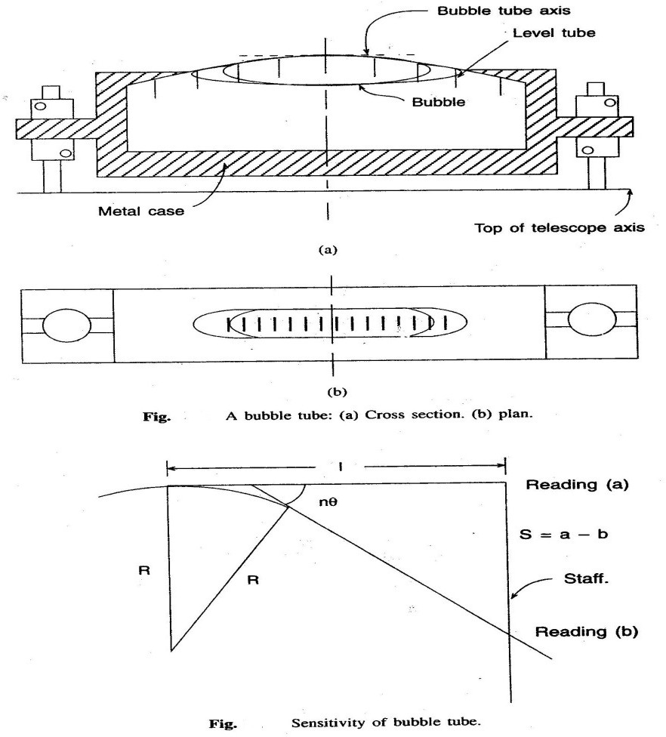
Fig:1.15
or R=d/θ=ndl/S, A tube is said to be more sensitive,if the bubble moves by more divisions for a given change in the angle.The sensitivity of a bubble tube can be increased by:
a)Increasing internal radius of the tube,(b) Increasing diameter of the tube,(c) Increasing the lengthof the bubble,(d)decreasing the roughness of wall,(e)decreasing viscosity of the liquid.The

sensitivity of the bubble tube should tally with the accuracy achievable with other parts of the equipment.If the bubble is graduated from the centre than an accurate reading is possible by taking readings at the objective and eye piece ends (ref Fig.)

Let L=length of bubble=O₁+E₁=O₂+E₂,XX=
(O1+E1) 2
- E₂,YY=
(O2+E2) 2
- O₂,Total

movement=
(O1–E1)
2
(E2–O2)
+
2

Example: A three screw dumpy level, set up with the telescope parallel to two foot screws is sighted on astaff 100m away.The line of sight is depressed by manipulating the foot screws until the bubble on the telescope reads4.1 at the object glass end and 14.4 at the eye piece end, these readings representing divisions from a zero at the centre of the bubble tube.The reading on the staff was0.930m.By similarly elevating the sight the bubble reading were-O12.6,E5.7 and staff reading1.025m

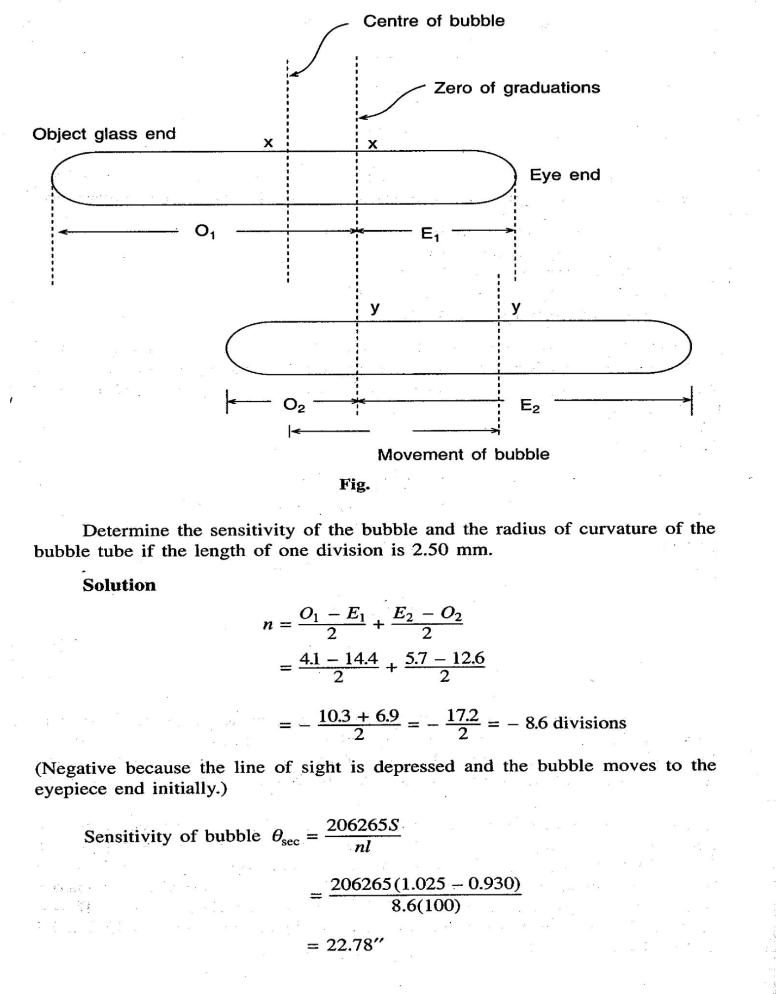

Permanent adjustment of different types oflevels:

The establishment of desired relationship between fundamental lines of a levelling instrument is termed as permanent adjustment.So,permanent adjustment indicates the rectification of instrumental errors.
The fundamental lines are as follows:

1.The line of collimation,(2)The axis of the bubble tube,(3)The vertical axis,(4)The axis of telescope.
The relationships between the lines are as follows:-

- The line of collimation should be parallel to the axis of bubble tube,(2)The line of collimation should coincide with the telescope,(3)The axis of the bubble should be perpendicular to the vertical axis.i.e, the bubble should remain in the central position for all directions of the telescope.
Principle of reversal: If there is any error in a certain part of the instrument, then it will be doubled by reversing,i.e by revolving the telescope through180°. Thus the apparent error becomes twice the actual error on reversal.In a right angled triangle ABC, the angle ACB is not exactly90° but less by 8°.If this triangle is reverses as A₁B₁C,then the angle between the faces BC and B₁C becomes 2 8°.This is the principle of reversal.By this principle,the relationship between the fundamental lines can be determined and hence necessary correction can beapplied.
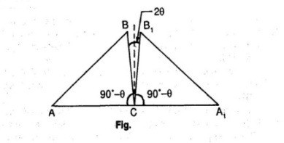
Fig:1.16

Permanent adjustment of dumpy level:(1)To make the axis of the bubble tube perpendicular to the vertical axis.
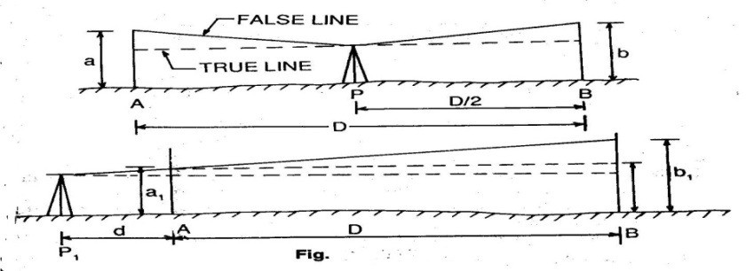
Fig:1.16

- The level is set up on fairly level and firm ground,with its legs well apart.it is firmly fixed to the ground.(b)The telescope is placed parallel to any pair of foot screws and by turning the foot screws either both inward or both outward,the bubble is brought to the centre.(c)The telescope is the turned through 90°,so that it lies over the third foot screw.Then by turning the third foot screw the bubble is brought to the centre,(d)The process is repeated several times until the bubble is in central position in both the directions,(e)Now the telescope is turned through 180° and the position of the bubble is noted.If the bubble still remains in the central position,the desired relationship is perfect.If not,the amount of deviation of the bubble is noted.,(f)suppose the deviation is2n divisions.Now by turning the capstan headed nut(which is at one end of the tube),the bubble is brought half-way back(i.e n division).The remaining half division is adjusted by the foot screw or screw just below the telescope.(g)The procedure of adjustment is continued till the bubble remains central position of thetelescope.
- Two peg method(1)Two pegs A and B are driven at aknown distance apart(Say D)on level and firm ground.The level is set up at P,just mid way between A and B.After bringing the bubble to the centre of its run(usual),the staff readings on A and ?B are taken.the staff readings are be a and b.Now the difference of level between A and B is calculated, this difference is the true difference, as the level is set up just mid-way between BS and FS.Then the rise or fall is determined by comparing the staff readings.(b)The level is shifted and set up at P₁(very near to A),say at a distance d from A.Then after proper leveling(following usual method),staff readings at A and B are taken.Suppose the readings are a₁ and b₁.Then the apparent difference of level is calculated.(c)If the true difference and apparent difference are equal,the line of collimation is in adjustment.If not, the line of collimation is inclined.,(d)In the second set up,let e be the staff reading on B at the same level of the staff reading a₁. Then e=a₁±true difference(use the positive sign in case of a fall and negative sign in case ofRise)
(e)If b₁ is greater than e, the line of collimation is inclined upwards and if b₁ is less than e,it is inclined downwards.Collimation errors=b₁-e(in a distanceD)(f) By applying the principle of

d
similar triangle,Correction to near peg,C₁=
D
(b₁-e),correction to far peg,C₂=
D+ d D
(b₁-e),Correct

staff reading on A= a₁±C_{1,}corrct staff reading on B=b₁±C₂ (use the positive sign when the line
of collimation is inclined downwards,and the negative sign when it is inclined upwards)(g)Then the cross hair is brought to the calculated correct reading by raising or lowering the diaphragm by means of the diaphragmscrew.
Field procedures:(1)If the correct reading is seen below the collimation hair on looking through the telescope, the cross hair is to be lowered. This is done by loosening the upper screw and tightening the lower screw of the diaphragm.(2)If the correct reading is seen above the collimation hair, on looking through the telescope,the cross hair should be raised. This is done by loosening the lower screw and tightening the upper screw of the diaphragm.

Setting grades and stakes:
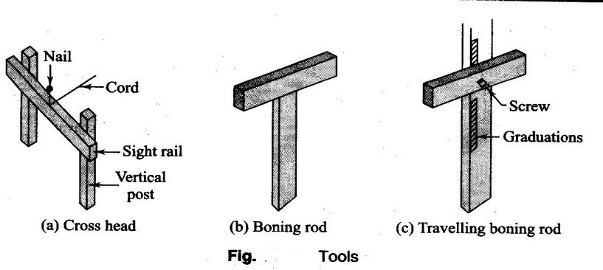
Fig:1.17

Setting out of sewer Lines:Underground pipelines and sewer pipes have to be laid to a particular gradient designed for the ease of flow of water or sewage. The inside bottom of the sewer pipe is known as invert.Some special tools are required to set the line gradient.
Cross head:It consists of two posts and ahorizontal bar.The posts are of suitable heavy cross section and the horizontal member,known as the sight rail,has an area of 50mmX150mm.cross heads are kept at the top and bottom of the gradient.The top of the sight rail is kept at a convenient height,2-5m.
Boning rod:It resembles a cross.A vertical wooden piece measuring100mm long,and is plotted at a convenient height depending upon the setting of the sight rail.The top of the boning rod is a reference for determining the depth of excavation in a section.One boning rod is required for a particular gradient.Different boning rods are required for differentgradients.
Travelling Rod:It is an adjustable boning rod. The horizontal piece can be moved over the vertical piece thus varying the height of the rod.

Setting out:
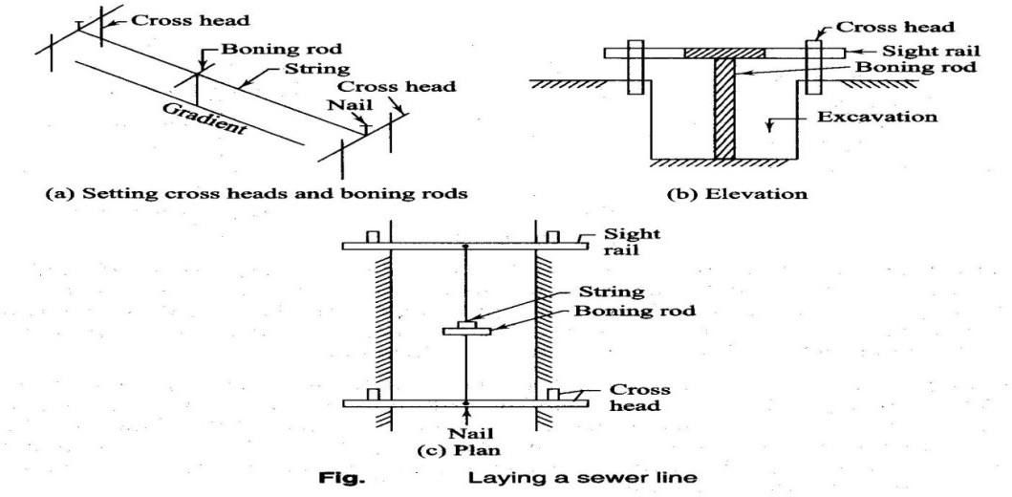
Fig:1.17

To set out the sewer on the gradient, the following procedure is adopted.

- Set the alignment of the line on the surface with reference to the control points brought near the site. Also establish the vertical control points for setting out thegrade.
- Lay a line parallel to the alignment for reference,as the first line will be lost once the excavationstarts.
- Start work from the lower point.Place the sight lails at the bottom and top of the gradient line.Drive nails at the centre of the croo piece of the cross heads.Stretch a string between the nails to act as a reference for verticaldistances.
- Drive the cross heads in such a way that the top of the sight rail is 2-5m above the invert of the sewer.This may be done with a level and take the readings.The boning rod is used of same length as the setting of the sight rail in the gradientsection.
- The string stretched between the nails on the sight rails should have the same gradient as that of the sewerline.
- Check the proper depth of the excavation at any intermediate point using the boningrod.

CHAPTER-2

CONTOURING:

2.1Definations of related terms,concepts of contours,characteristics of contours:

1)Contour line:The line of intersection of a level surface with the ground surface is known as the contour line or simply the contour.It can also be defined as a line passing through points of equal reducedlevels.
1)Contour line:The line of intersection of a level surface with the ground surface is known as the contour line or simply the contour.It can also be defined as a line passing through points of equal reducedlevels.
Forexample,acontourof100inindicatesthatallthepointsonthislinehaveanRLof100m. Similarly, in a contour of 99min, all the points have an RL of 99 in,and so on (Fig.).A map showing only the contour linesofan a r e a is called a contourmap.

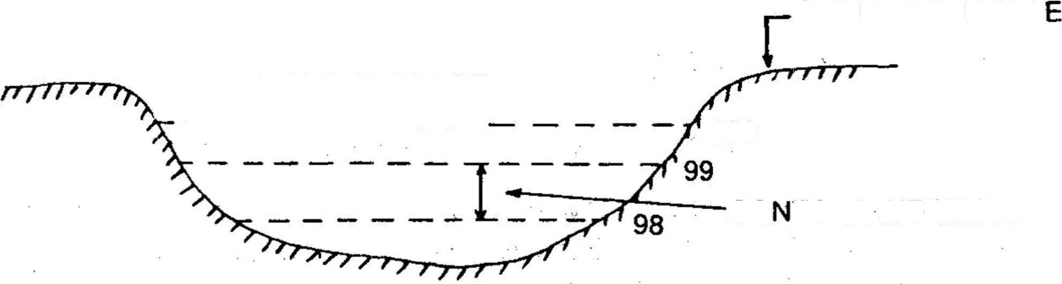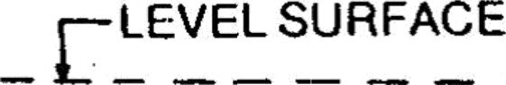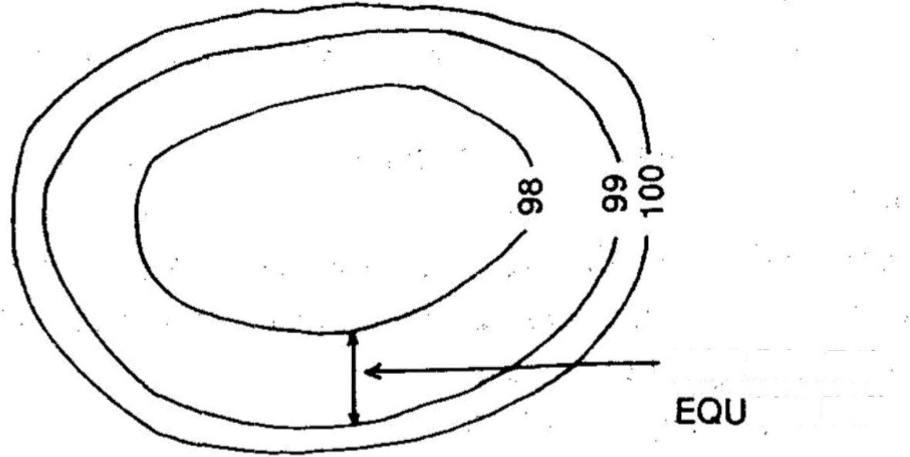Fig.2.1
GROUND SURFAC
100
CO TOUR INTERVAL
HORIZONTAL
IVA LENT

- ContourInterval:Theverticaldistancebetweenanytwoconsecutivecontoursisknown as a contour interval. Suppose a map includes contour lines of 100 in, 98 in, 96 in, and soon.Thecontourintervalhereis2m.Thisintervaldependsupon:(i)thenatureofthe ground (i.e. whether flat or steep), (ii) the scale of the map, and (iii) the purpose of the survey.

Contour intervals for flat country are generally small, e.g. 0.25 in, 0.50 in,
0.75 in, etc. The contour interval for a steep slope in a hilly area is generally greater, e.g. 5 m, 10 m, 15 m,etc.
Again for a small-scale map, the interval may be of 1 in, 2 in, 3 in, etc. and for L a r g e s c a l e mapit may be of 0.25m,0.50m0.75metc.It should be remembered that the contourintervalforaparticularmap isconstant.Thehorizontaldistancebetween anytwoconsecutivecontoursisknownashorizontalequivalent.Itisnotconstant.Itvariesaccording tothesteepnessoftheground.Forsteepslopes,thecontourlinesrunclosertogether,andforflatter slopes they are widelyspread.

2.1:Methods of contouring, plotting contour maps OBJECT0FPREPARING CONTOUR MAP:
Thegeneral mapofacountry includes thelocationsofroads,railwaysriversVillages,towns,and soon.Butthenatureofthegroundsurfacecannotberealised,fromsuchamap.However, forall engineering projects involving roads. railways, and so on, a knowledge of the nature of t h e ground surface is required for locat- ing suitable alignments and estimating the volume of earth work. Therefore, the contour map is essential for all engineering project. This is why contour maps areprepared.
USES OF CONTOUR MAP:

The following are the specific uses of the contour map:
Thenatureofthegroundsurfaceofacountrycanbeunderstoodbystudyingacontourmap.Hence,the possible route of communication between different placescan be demarcated.
Asuitablesiteoraneconomicalalignmentcanbeselectedforanyengineeringproject. Thecapacityofareservoirortheareaofacatchmentcanbeapproximatelycomputed.
Theintervisibilityorotherwiseofdifferentpointscanbeestablished. Asuitablerouteforagivengradientcanbemarkedonthemap.
A section of the ground surface can be drawn in any direction from the contour map. Quantities of earth work can be approximately computed.
CharacteristicsofContours:1.(RefFig.)thecontourlinesareclosernearthetopofahillorhighground and wide apart near the foot. This indicates a very steep slope towards the peak and aflatter slope towards thefoot.

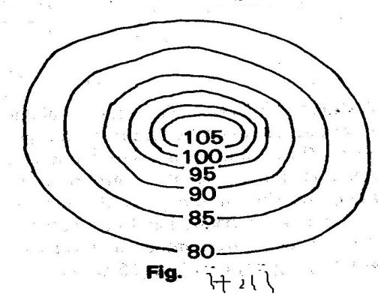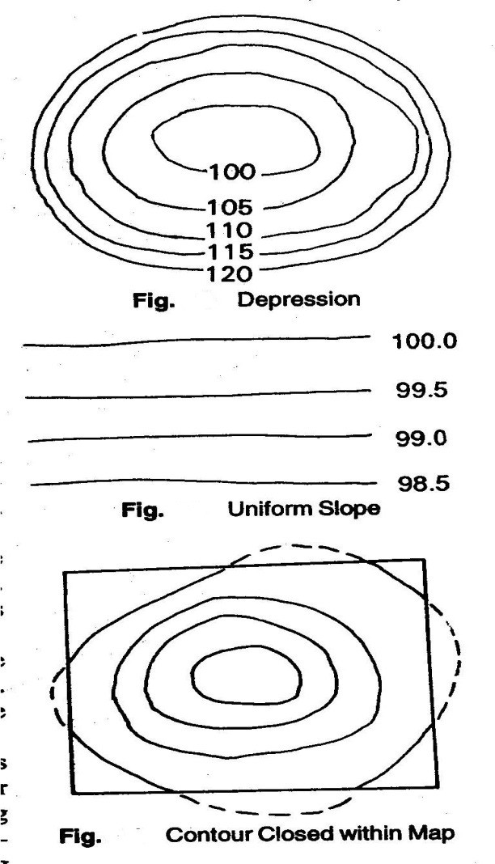

Fig:2.1

2. In Fig. the contour lines are closer near the bank of a pond or depression and wide apart towards thecentre.Thisindicates a steep slope near the bank and a flatter slope at the centre.
3.Uniformlyspaced,contourlinesindicateauniformslope(Fig..‘-).
- Contour lines always form a closed circuit. But theseinesmay be within or outside the limits of the map (Fig.)
- Contour lines cannot cross one another, except in the case of an overhanging cliff. But the over-lapping portion must be shown by a dotted line (Fig.).
- When the higher value are inside theloop,it indicatesaridgeline.Contour lines cross ridge linesat rightangles(Fig. ’).

- Whenthelowervaluesareinsidietheloop,itindicatesavalleyline.Contourlinescrossthevalley line at right angles (Fig.).

- Aseries ofclosed contours always indicates a depression or summit. The lower values being insidetheloopindicatesadepre-ssionandthehighervaluesbeingInsidetheloopindicatesasummit. (Fig.).
- Depressions b e t w e e n summit are called saddles (Fig.) 10.Contour lines meeting at a point indicate a verticalcliff.

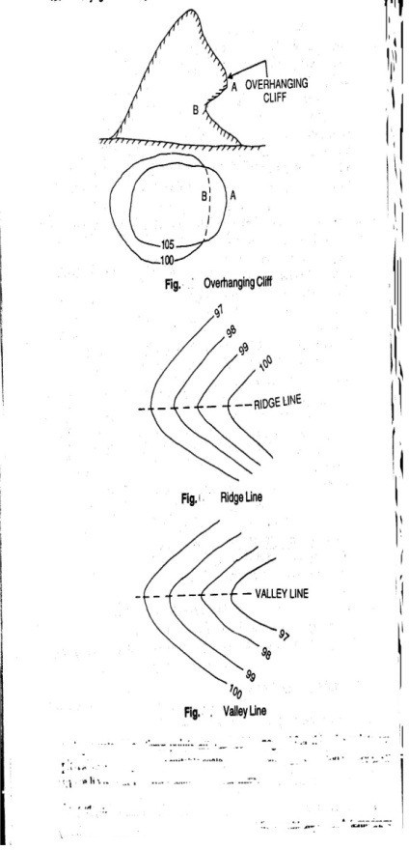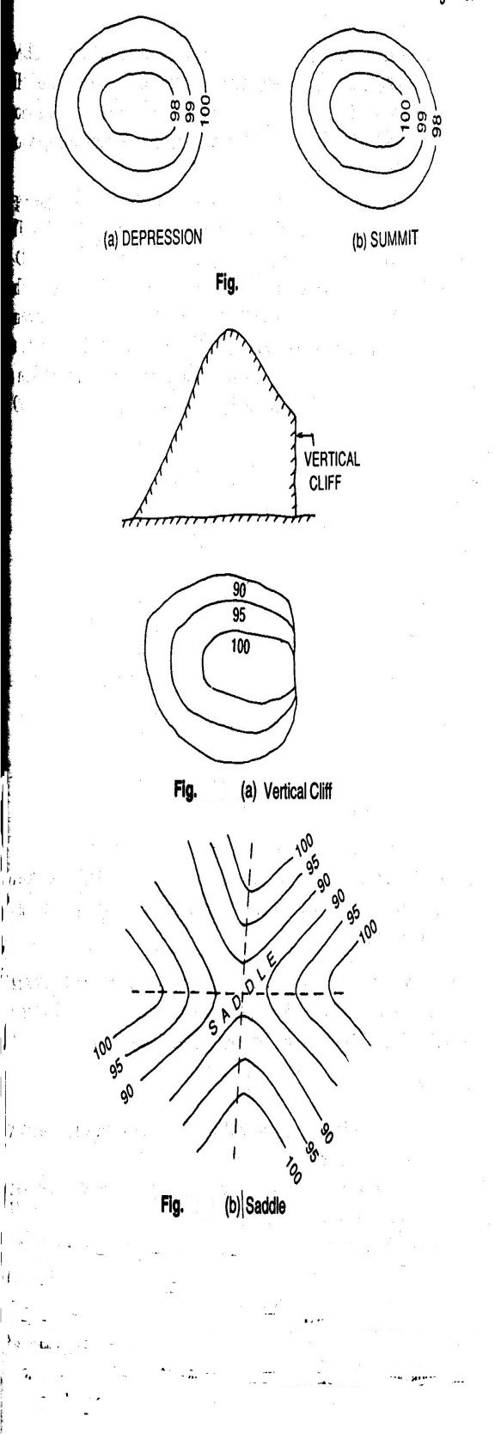

Fig:2.1

METHODS OFCONTOURING
There are two methods of contouring----direct and indirect.

A)Direct Method:
There may be two cases, as outlined below.
Case-I:Whentheareaisoblongandcannotbecontrolledfromasinglestation:Inthismethod, thevariouspointsonanycontourarelocatedonthegroundbytakinglevels.Thenthesepointsare marked by pegs. After this,the points are plotted on the map to any suitable scale ,by plane table.Thismethodisveryslow.Andtedious.Butitgivesaccuratecontourlines.
Procedure:1)Supposeacontourmapistobepreparedforanoblongarea.AtemporaryBenchmark issetupnearthesitebytakingflylevelreadingsfromapermanentbenchmark.(2)Thelevelis then set up at a suitable position L from where maximum area can be covered.(3)ThePlane tableissetupatasuitablestationPfromwheretheaboveareacanbeplotted.(4)Abacksight reading is taken on the TBM. Suppose the RL of the TBM is249.500 m and that the BS readingis2.250m.thentheRLofHI251.750m.Ifscontourof250.000isrequired,thestaff readingshouldbe1.750m.Ifacontourof249.000misrequired,thestaffreadingshouldbe 2.750 m, and so on.(5)The staff man holds the staff at different points of the area by movingUp and down, or left and right, until the staff reading is exactly 1.750. Then,the points are marked by pegs. Suppose, these points are A, B, C,D,….


- AsuitablepointpisselectedonthesheettorepresentthestationP.Withthealidadetouchingp, rays are drawn to A, B, C and D. Tue distancesPA, PB, PC and PD are measured and plotted to a suitable scale. In This manner, the points a, b, c and d of the contour line of RL 250.000m are obtained. These points are joined to obtain the contour of 250.000m
- Similarly,thepointsoftheothercontoursarefixated.(8)Whenrequired,thelevellinginstrument andtheplanetableareshiftedandsetupinanewpositioninordertocontinuetheoperationalongthe oblongarea.

‘

Case-II:Whentheareaissmallandcanbecontrolledfromasinglestation:Inthiscase,themethod ofradiallinesisadoptedtoobtaincontourmap.Thisisalsoveryslowandtedious,butgivesthe actual contourlines.

Direct Method:
1)TheplanetableissetupatasuitablestationPfromwherethewholeareacanbecommanded. 2)A point p is suitably selected on the sheet to represent the station P. Radial lines are then drawnin
different directions.

3) A temporary bench-mark is established near the site. The level is set upat a suitable position L and a BS reading is taken on the TBM. Let the HI in this setting be 153.250 m. So, to Find the contour of RL, 152.000 in a staff reading of 1.250 in is required at a particular point, so that the RL of contour of that point comes to 152.000 m.

RL = HI — Staff reading
= 153.250 — 1.250 = 152.000 in

4.The staff man holds the staff along the rays drawn from the plane table station in such a way that the staff reading on that point is exactly 1.25In this manner, points A, B, C, D and E are located on the ground, where the staff readings are exactly 1.250.(5)The distances PA, PB, PC, PD and PE are measured and plotted to anysuitablescale. Thus the points a, b, c, d and e are obtained which are joined in order to obtain a contour of 152.000.(6)The other contours may be located in similar fashion (Fig.).

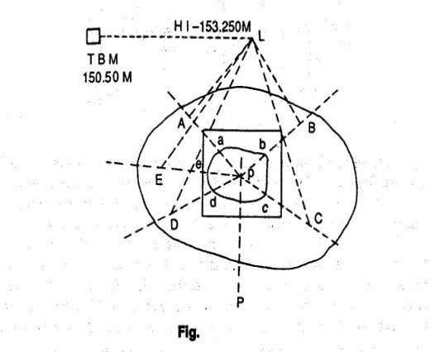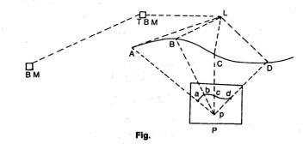

Fig:2.2

Indirect Method: In this method, the RLs of different points (spot levels) are taken at regular intervals along a series of lines set up on the ground. The positions of these points are plotted on a sheet to any suitable scale. The spot levels are noted at the respective points. Then the points of contour lines are found out by interpolation, after which theyarejoinedtogettherequiredcontourlines.Althoughveryquick,thismethodgivesonly theapproximatepositionsofthecontourlines.Thismethodcanbeadoptedintwoways,(i) cross-sections, and (ii)squares.

- Using Cross-sections: In this method, a base line, centre line or profile line is considered. Cross-sections are taken perpendicular to this line at regular intervals (say 50 m,100m etc.). After this, points are marked along the cross-sections at-regular intervals(say,5m,10m,etc).Atemporarybench-markissetupnearthesite.Staffreadings are taken along the base line and the cross-sections. The readings are entered in the levelbook;thebaselineandthecross-sectionsshouldalso bementioned.TheRLofeachof the points calculated. Then the base fine and cross-sections are plotted to a suitable scale. Subsequently the RLs of the respective points are noted on the map, after which the required contour line is drawn by interpolation . This method is suitable for routesurvey,whenthecrosssectionsaretakentransversetothelongitudinalsection.

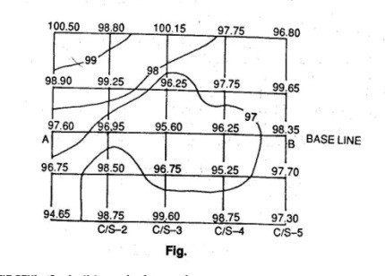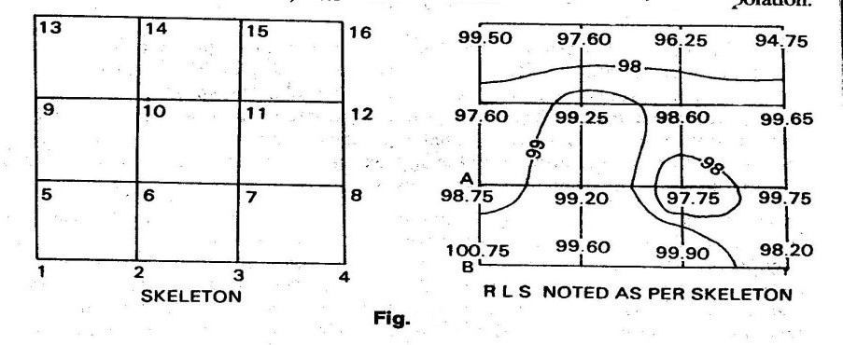
Fig:2.2

- UsingSquares:Inthismethod,theareaisdividedintoanumberofsquares.Thesizeof thesesquaresdependsuponthenatureandextentoftheground.Generallytheyhaveasides varying from5 to 20m.The corners of the squares are numbered serially, as 1,2,3,…..A temporarybenchmarkissetupnearthesite,andthelevelissetupatasuitableposition.The staffreadingsonthecornersofthesquaresaretakenandnotedinthelevelbookmaintaining thesequenceoftheserialnumbersofthecorners.TheRLsofallthecornersarecalculated. Theskeletonsofthesquaresareplottedtoasuitablescale.TherespectiveRLsonthecorners, afterwhichthecontourlinesaredrawnbyinterpolation.

Interpretetion of contour maps,toposheets:

Method of Interpolation of Contours: The process of locating the contours proportionately between the plotted points is termed interpolation. This can be done by:
- ArithmeticalCalculation:LetAandBbetwocornersofthesquares.TheRLofAis98.75m,and that of B 100.75m.The horizontal distance between A and B is 10m,Horizontal distance between A and B=10m,Vertical distance between A and B=100.75-98.75=2m,Let a contour of 99.00m be required.Then,differenceoflevelbetweenAand99.00mcontour=99.00-98.75=0.25m,∴Distance
10

of99.00mcontourlinefromA=
2
x0.25=1.25m. This calculated distance is plotted to the same scale

inwhichtheskeletonwasplotted,toobtainapointofRLof99.00m,Similarlytheotherpointis located.
- Bygraphicalmethod:Onasheetoftracingpaper,alineABisdrawnanddividedintoequalparts. AB is bisected at C, and a perpendicular is drawn at this point. A point O is selected on this perpendicular.ThenradiallinesaredrawnfromOtothedivisionsonAB.Theselinesserveasguide

lines.Theboundarylineandeveryfifthlineismarkedwithathickorredline.Supposewehaveto interpolatea2mcontourintervalbetweentwopointsaandbofRLs92.5and100.75m.Letusconsider thelowestradiallineOBtorepresentanRLof90.00.Soeveryfifthline(whichisboldredorred)will represent 95.100,105,etc.The tracing paper is moved over the plan until a lies at 92.5 and b at 100.25.LineabshouldbeparalleltoAB.Nowthepoints94,96,98,100arepickedthroughtoobtainthe positions of the requiredcontour.
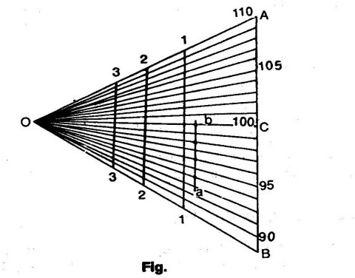

Fig:2.3

  - Use of contour maps on civil engineering projects-drawing cross-sections from contour maps, locating:
Since a contour map is a three dimensional representation of the earth’s surface. it furnishes a lot of information. Some of the uses that a contour map can be put to are as follows.
Determination of intervisibility:Let it be required to ascertain the intervisibility of two stations A and B having elevations 62m and 90m,respectively,as shown in the contour map(Ref:fig.).Join A and B is 28m(90-62=28).The line of sight will have an inclination of 28m in the distance ab. draw projections to mark points of elevation of90,85,…,62 on the line ab. Compare these points with the corresponding points in which the contours cut the line ab.At the point e,the ground has an elevation of 75 and 70m),whereas line of sight will have an elevation less than 75m(between 75 and 70m).It can be seen that there will be obstruction in the range CD.Similarly,checks can be made for the other points.

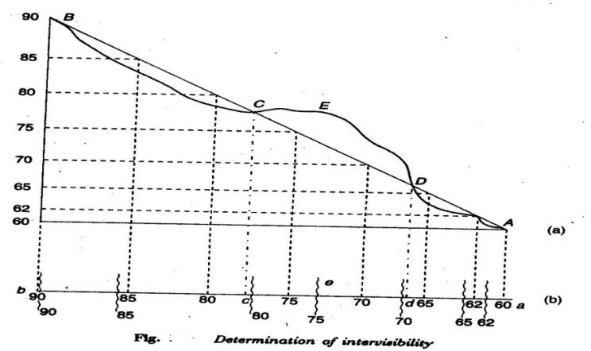

Fig:2.4

Drainage area:The extent of drainage area may be estimated on a contour map by locating the ridge line around the watershed.The ridge line should be located in such apposition that the ground slopes are down on either side of it.The area is found out by Planimetric measurements.
Capacity of reservoirs:Reservoirs are made for water supply and for power or irrigation projects.A contour map is very useful to study the possible location of a dam and the volume of water to be confined.All the contours are closed lines within the reservoir area.
Site of structures:The most economical and suitable site for structures such as buildings,bridges,dams etc. can be found from large –scale contour maps.
Earthquake estimates:On the contour line of the original surface,the contours of the desired altered surface are drawn.By joining the intersections of the original contours and new ones of equal value,the line in which the new surface cuts the original is obtained.Exacavation is required within this line,whereas the surrounding parts will be in the embankment.The volume of cut or a fill is found by multiplying the average by the contourinterval.
Route Location:By inspecting a contour map the most sitable site for a road,railway,canal etc. can be selected.By following the contour lines,steep gradients,cutting and filling,etc.may be avoided.

CHAPTER-3

INTRODUCTION
An instrument used for measuring horizontal and vertical angles accurately, is known as a theodolite. Theodolite is also use for prolongation or survey line, finding difference in elevation and setting out engineering work requiring higher precision I.e. ranging the highway and railway curves ,aligning tunnels,etc.

PARTS OF A TRANSIT THEODOLITE: -

A transit theodolite consists of the following essential parts:

    - Leveling head: - It consists of two parts i.e. upper tribarch and lowertribarch.
      - The upper tribarch: - It has three arms. Each arm carries a leveling screw.levellingr screw are provided for supporting leveling the instrument. The boss of the upper tribarch is pierced with a female axis in which lower male vertical axisoperates.
      - The lower tribarch: - it has a circular hole through which a plumb bob may be suspended for centering the instrument quickly andaccurately.
The three distinct functions of a leveling head are:

- To support the main part of theinstrument.
- To attach the theodolite to thetripod.
- To provide a means for leveling thetheodolite.

    - Lower plates (or scale plate). The lower plate which is attached to the outer spindle carries a horizontal graduated circle at its beveled edge. It is thefore some time known as the scale plate. It is divided into 360°. Each degree is further divided into ten minutes or twenty minutes arc intervals .Scale plate can be clamped at any position by clamping screw and a corresponding slow motion can be made with a tangential screw or slow motion screw. When the lower clamp is tightened, the lower plate is fixed to the upper tribarch of the leveling head .The size of the theodolite is determined by the size of the diameter of the lowerplate.
    - Upper plate (or vernier plate): - The upper plate or vernier plate is attached to the inner spindle axis. Two verniers are screwed to the upper plate diametrically opposite. This plate is so constructed that it overlaps and protests the lower plate containing the horizontal circle completely except at the parts exposed just below the verniers. The verniers are fitted with magnifiers. The upper plate supports the Ys or As which provide the bearings to the pivots of the telescope. It carries an upper clamp screw and a corresponding tangent screw for accurately fixing to the lower plate on clamping the upper clamp and unclamping the lower clamp, the instrument may be rotate on this outer spindle without any relative motion between two plates. On the other hand if the lower clamp screw is tightened and upper clamp screwisunclamped,theinstrumentmayberotateabouttheinnerspindlewitharelative

motion between the vernier and the graduated scale of the lower plate. This property is utilized for measuring the angle between two settings of the instrument. It may be ensured that the clamping screws are properly tightened before using the tangent screws for a finer setting.
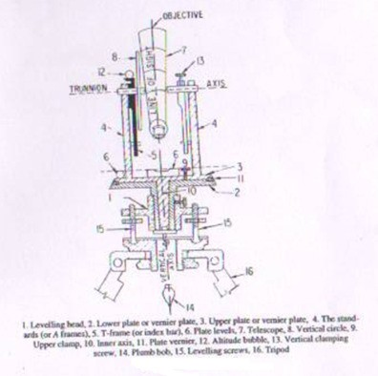
Fig.3.1 Shows parts of transittheodolite

    - The standards (or A frame): - Two standards resembling the English letter A are firmly attached to the upper p[late. The tops of these standards form the bearing of the pivots of the telescope. The standards are made sufficiently high to allow the rotation of the telescope on its horizontal axis in vertical plane. The T-frame and the arm of vertical circle clamp are also attached to thestandards.
    - T-frame or index bar:- It is T-shaped and is centered on the horizontal axis of the telescope in the frame of the vertical circle. The two verniers C and D are provided on it at the ends of the horizontal arms, called the index arm. A vertical leg known as clipping arm is provided with a fork and two clipping screw at its lower extremity. The index and clipping arms together are known as T-frame. At the top of this frame, if attached a bubble tube which is called the altitude bubbletube.
    - Plate levels: - The upper plate carries two plate levels placed at right angles to each other. One of the plate bubbles is kept parallel to the trunnion axis. The plate levels can be centered with the help of the foot screws. In some theodolites only one plate level isprovided.
    - Telescope: - The telescopes may be classifiedas
      - The external focusingtelescope

      - The internal focusingtelescope.

DEFINATIONS AND OTHER TECHNOICAL TERMS

Following terms are used while making observations with a theodolite.

- Vertical axis:- The axis about which the theodolite, may be rotated in a horizontal plane, is called vertical axis. Both upper and lower plates may be rotated about verticalaxis.
- Horizontal axis:- The axis about which the telescope along with the vertical circle of a theodolite, may be rotated in vertical plane, is called horizontal axis. It is also sometimes called trunnion axis or traverseaxis.
- Line of collimation: - The line which passes through the intersection of the cross hair of the eye piece and optical center of the objective and its continuation is called line of collimation. The angle between the line of collimation and the line perpendicular to the horizontal axis is called error ofcollimation.
The line passing through the eye piece and any point on the objective is called line of sight.
- Axis of telescope: - The axis about which the telescope may be rotated is called axis of telescope.
- Axis of the level tube: - The straight line which the tangential to longitudinal curve of the level tube at its center is called the axis of the level tube. When the bubble 0f the level tube is central, the axis of the level tube becomeshorizontal.

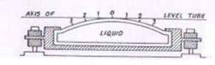

Fig.3.2 Cross section of level tube
- Centering: - The process of setting up a theodolite exactly over the ground station mark, is known as centering. It is achieved when the vertical axis of the theodolite is made to pass through the ground stationmark.
- Transiting: - The process of turning the telescope in vertical plane through 180˚ about its horizontal axis is known as transiting. The process is also sometimes known as reversing orplunging.
- Swing: - A continuous motion of the telescope about the vertical axis in horizontal plane is called swing. The swing may be in either direction i.e. left or right. When the telescope is rotate in the clockwise right direction, it is known as right swing. If it is rotated in the anticlockwise left direction it is known as leftswing.

- Face left observations: - When the vertical circle is on the left. of the telescope at the time of observations, the observations of the angles are known as face leftobservations.
- Face right observations: - When the vertical circle is on the right of the telescope at the time of observations, the observations of the angles are known as face rightobservations.
- Changing face:- It is the operation of changing the face of the telescope from left tom right andvice-versa.
- Telescope normal: - Telescope is said to be normal when its vertical circle is to its left and the bubble of the telescope isup.
- Telescope inverted: - A telescope is said to be inverted or reversed when its vertical circle is to its right and the bubble of the telescope isdown.

FUNDAMENTAL LINES OF A TRANSIT THEODOLITE

The fundamental lines of a transit theodolite are:

- The verticalaxis
- The axis of platebubble
- The line of collimation which is also sometimes called line ofsight.
- The horizontal axis, transverse axis or trunnionaxis.
- The bubble line of telescope bubble or altitudebubble.

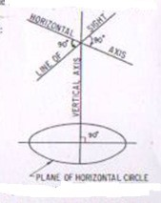
Fig.3.3 Fundamental lines of transit theodolite

ADJUSTMENTS OF THEODOLITE

The adjustments of theodolites are of two kinds.

- Temporaryadjustment
- Permanentadjustment

Temporary adjustments: The adjustments which are required to be made at every instrument station before making observations are known as temporary adjustments.
The temporary adjustments of a theodolite include the following:

- Setting up the theodolite over thestation.
- Leveling of thetheodolite
- Elimination of theparallax.
  - Setting up: - The operation of setting up a theodolite includes the centering of the theodolite over the ground mark and also approximate leveling with the help of tripod legs.
  - Centering: - The operation with which vertical axis of the theodolite represented by a plumb line, is made to pass through the ground station mark is calledcentering.

The operation of centering is carried out in followingsteps:
    - Suspend the plumb bob with a string attached to the hook fitted to the bottom of the instrument to define the verticalaxis.
    - Place the theodolite over the station mark by spreading the legs well apart so that telescope is at a convenientheight.
    - The centering may be done by moving the legs radially and circumferentially till the plumb bob hangs within 1cm horizontally of the stationmark.
    - By unclamping the center shifting arrangement, the finer centering may now be made.

Approximate leveling with the help of the tripod:
It is very necessary to ensure that the level of the tripod head is approximately level before centering is done. In case there is a considerable dislevelment, the centering will be disturbed when leveling is done. The approximate levelling may be done either with reference to a small circular bubble provided on the tribarch or by eye judgment.

Levelling of a theodolite: The operation of the making the vertical axis of a theodolite truly vertical is known as leveling of the theodolite.
After having leveled approximately and centered accurately, accurate leveling is done with the help of plate levels. Two methods of leveling are adopted to the theodolites, depending upon the number of leveling screws.
Levelling with three screw head: - The following steps are involved

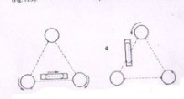

Fig.3.4 Leveling of a theodolite with a three screwhead

- Turn the horizontal plate until the longitudinal axis of the plate level is approximately parallel to line joining any two leveling screws [fig(a)].
- Bring the bubble to the center of its run by turning both foot screws simultaneously in opposite directions either inwards or outwards. The movement of the left thumb indicates the direction of movement of thebubble.
- Turn the instrument through 180˚ inazimuth.
- Note the position of the bubble. If it occupies a different position, move it by means of the same foot screws to the approximate mean of the twopositions.
- Turn the theodolite through 90˚ in a azimuth so that the plate level becomes perpendicular to the previous position [fig.(b)].
- With the help of the third foot screw move the bubble to the approximate mean position alreadyindicated.
- Repeat the process until the bubble retains the same position for every setting of the instrument inazimuth.
The mean position of the bubble is called the zero of the level tube. If the theodolite is provided with two plate levels placed perpendicular to each other, the instrument is not required to be turned through 90˚.in this case, the longer plate level is kept parallel to any two foot screws and the bubble is brought to central position by turning both the foot screws simultaneously. Now with the help of the third foot screw, bring the bubble of second plate level central. Repeat the process till both the plate bubbles occupy the central position of their run for all the positions of the instrument.
ELEMATION OF PARALLAX: - An apparent change in the position of the object caused by change in position of the surveyor’s eye is known as parallax.
In a telescope parallax is caused when the image formed by the objective is not situated in the plane of the cross hairs. Unless parallax is removed accurate bisections and sighting of objects become difficult.

Elimination of parallax may be done by focusing the eye piece for distinct vision of cross hairs and focusing the objective to bring the image of the object in the plane of the cross-hairs as discussed below.
Focusing the eye piece: To focus the eye-piece for distinct vision of cross hairs, either holds a white paper in front of the objective or sight the telescope towards the sky. Move the eye piece in or out till the cross hairs are seen sharp and distinct.
Focusing the objective: After cross hairs have been properly focused, direct the telescope on a well defined distant object and intersect it with vertical wire. Focus the objective till a sharp image is seen. Removal of the parallax may be checked by moving the eye slowly to one side. If the object still appears intersected, there is no parallax.
If, on moving the eye laterally, the image of the object appears to move in the same direction as the eye, the observer’s eye and the image of the object are on the opposite sides of the vertical wire. The image of the object and the eye are brought nearer to eliminate the parallax. This parallax is called farparallax.
If, on the other hand, the image appears to move in reverse direction to the movement of the eye, the observer’s eye and the image of the object are on the same side of the vertical wire and the parallax is then called near parallax. It may be removed by increasing the distance between the image and the eye.

MISCELLANEOUS USES OF THEODOLITE:

Theodolites are commonly used for the following operations.

- Measurements of horizontalangles.
- Measurements of verticalangles.
- Measurements of magnetic bearing oflines.
- Measurements of directangles.
- Measurements of deflectionangels.
- Prolongation of straightlines.
- Running a straight line between twopoints.
- Laying off an angle by repetitionmethod.

Measurement of horizontalangles
    - To measure the angle by method of repetition:-

Let ABC be the required angle between sides BA and BC to be measured by repetitio0n method as shown in Fig 3.5. When the measure of an angle is small, slight error in its sine value introduce a considerable error in the computed sides as the sine value of the angle changes rapidly. Therefore, for accurate and precise work, the method of repetition is generally used. In this method, The value of the angle is added several times mechanically and the accurate value of the angular measure is determined by dividing the accumulated reading by the number of repetition.
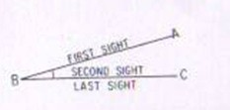
Fig. 3.5 Method of repetition
    - To measure the angle by reiteration method: When several angles having a common vertex, are to be measured the reiteration method is generally adopted. In this method angles are measured successively starting from a reference station and finally closing on the same station. The operation of making last observation on the starting station is known as closing horizon. Making observations on the starting station twice provides a check on the sum of all angles around a station. The sum should invariably be equal to 360˚, provided the instrument is not disturbed during observations. As the angles are measured by sighting the stations in turn, this method is sometimes known as direction method of observation of the horizontalangles.
  - Measurement of vertical angles: A vertical angle may be defined as the angle subtended by the inclined line of sight and the horizontal line of sight at the station in vertical plane. If the point sighted is above the horizontal axis of the theodolite, the vertical angle is known as angle of elevation and if it is below, it is known as angle of depression.
Procedure: To measure a vertical angle subtended by the station B at the instrument station A, The following steps are involved:

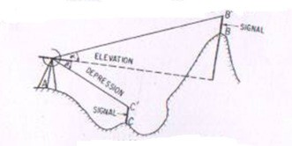

Fig. 3.6. Measurement of vertical angle.
- Set up the theodolite over the ground station mark A. Level it accurately by using the altitudebubble.
- Set the zero of the vertical vernier exactly in coincidence with zero of the vertical scale using vertical clamp and vertical tangent screw. Check up whether the bubble of the altitude level is central of its run. If not, bring it to the centre of its run by means of the clip screw. In this position, the line of collimation of the telescope is horizontal and the verniers read tozero.
- Loosen the vertical circle clamp and move the telescope in vertical plane until the station B is brought in field of view. Use vertical circle tangent screw for accuratebisection.
- Read both the verniers of the vertical circle. The mean of two vernier readings gives the value of the verticalangle.
- Change the face of the instrument and make the observations exactly in similar way as on the faceleft.
- The average of two values of the vertical angle is the required value of the verticalangle.
  - Measurement of magnetic bearing of a line: To measure the magnetic bearing of a line AB, the theodolite should be provided with either a circular or a trough compass. The following steps areinvolved:
- Centre and level the instrument accurately on stationA.
- Set the vernier to readzero.
- Loosen the lower plate and also release the magneticneedle.
- Swing the telescope about its vertical axis until the magnetic needle points S- N graduations of the compass boxscale.
- Clamp the lower plate. Using the lower tangent screw bring the needle exactly against the zero graduation is exact coincidence with the north end of the needle.
- In this position, the line of collimation of the telescope lies in the magnetic meridian at the place while verniers still reads to zero. The setting of the instrument is now said to be oriented on the magneticmeridian.

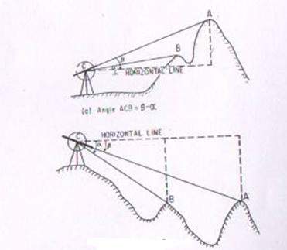
(b) Angle ACB = α-β
Fig. 3.7 Measurement of vertical angle
- Loosen the upper plate, swing the instrument and bisect B accurately, using the upper tangentscrew.
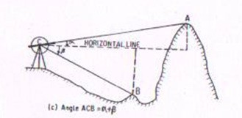
Fig. 3.7 Measurement of vertical angle
- Read both the vernier. The means of the two readings is the required magnetic bearing of the lineAB.
- Change the face of the instrument and observe the magnetic bearing exactly in a similar way as on the leftface.
- The mean of magnetic bearings observed on both faces is the accurate value of the magnetic bearing of lineAB.

  - Measurement of direct angles: The angle measured clockwise from the preceding line to the following line is called a direct angle. These angles are also sometimes known as azimuths from the back line, or angles to the right and may vary from 0˚ to 360˚.

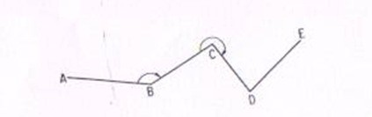

Fig. 3.8 Measurement of direct angles

  - Measurement of deflection angles: The angle which any survey line makes with the prolongation of the preceding line is called deflection angle. Its value may vary from 0˚ to 180˚ and is designated as right deflection angle if it is measured in clockwise direction and as left deflection angle if it is measured in an anticlockwise direction. In fig. the deflection angles α and δ at stations B and E respectively are left deflection angles whereas angles β and γ at stations C and D are right deflectionangles.
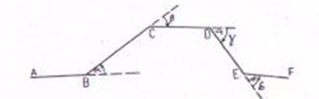

Fig. 3.9 Measurement of deflection angles

  - Prolongation of a straight line: Prolongation of any straight line AB to a point F may be done by any one of the followingmethods:

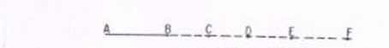
First method: -

Fig. 3.10 Prolongation of a line

The following steps are involved:
- Set up the theodolite at A, center and level itaccurately.

- Bisect an arrow centered over the mark atB.
- Establish a point C in the line of sight at a convenientdistance.
- Shift the instrument toB.
- Centered t5he theodolite over B, level it and sight C. Establish another point D.
- Proceed in a similar manner until the desire point F isestablished.

Second method:-
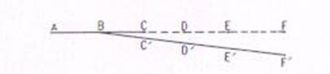
Fig. 3.11 Prolongation of a line The following steps are involved:
  - Set up the theodolite at B and centered itcarefully.
  - Bisect A accurately and clamp both theplates.
  - Plunge the telescope and establish a point C in the line ofsight.
  - Shift the instrument to C and center itcarefully.
  - Bisect B and clamp both theplates.
  - Plunge the telescope and establish the point D in the line ofsight.
  - Continue the process till the last point F is established. NOTE:-
The following points may be noted.

    - If the instrument is in perfect adjustment, the points B, C, D, E and F will lie in a straightline.
    - If the line of collimation is not perpendicular to the horizontal axis, the established point C’, D’, E’ and F’ would lie on acurve.

Third method: -
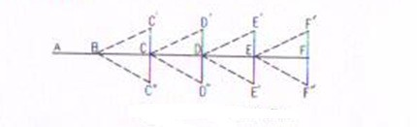
Fig. 3.12 Prolongation of a line Following steps are involved
- Set up the theodolite at B and center itcarefully.
- Bisect A on face left and clamp both theplates.
- Plunge the telescope and establish a pointC’.
- Change the face and bisect Aagain.
- Plunge the telescope and establish a point C’ at the same distance as C’ fromB.
- If the instrument is in adjustment, the point C’ and C’’ will coinside.
- If not establish a point C midway between C’ andC”.
- Shift the instrument to C and repeat the process to establish a pointD.
- Repeat the process until the required point F is established. NOTE: - The following points may benoted.
  - This method of prolongation of a line requires two sightings and as such it is known as double sightingmethod.
  - This method is used only when greater precession is required with a poorly adjustedinstrument.
SOURCES OF ERROR IN THEODOLITE WORK: The sources of error in theodolite work may be broadly divided into three categories, i.e.
- Instrumenterror.
- Personalerror
- Naturalerrors

Instrumental errors: - The theodolites are very delicate and sophisticated surveying instrument. In spite of best efforts during manufacturing perfect adjustment of fundamental axes of the theodolite, is not possible. The unadjusted errors of the instrument are called residual errors. We shall now discuss how best to avoid the effect of these residual error while making field observations.Instrumental errors may also be divided into different types as discussed below:

  - Error due to imperfect adjustment of plate level: - If the plate bubbles are not adjusted properly, the vertical axis of the instrument does not remain vertical evenif plate bubbles remain at the center of their run. Non verticality of the vertical axis introduced error in the measurements of both the horizontal and vertical angles. Due to non verticality of vertical axis the horizontal plate gets inclined and it does not remaining in horizontal plane. The error is especially important while measuring the horizontal angles between stations at considerable differentelevations.
Elimination of the error: - this error can be eliminated only by leve3lling the instrument carefully, with the help of the altitude or telescope bubble, before starting the observations.

Error due to line of collimation not being perpendicular to the trunnionaxis:
- If the line of collimation of the telescope is not truly perpendicular to the trunnion axis, it generates a cone when it is rotated about the horizontal axis. The trace of the intersection of the conical surface with the vertical plane containing the station sighted the hyperbolic. This imperfect adjustment introduces errors in horizontal angels measured between stations at different elevations.

Personal errors:
Personal errors are due to mainly following causes.
- inaccurate centring over astation
- slip of instrument when not put firmly on thetripod
- faulty manipulation of instrument controls like clamping the instrument and operating wrong tangentscrew
- inaccurate leveling, inaccurate bisection oftarget
- non-verticality of rangingrod
- displacement of target stations,parallax
- errors in sighting, reading and recording

Natural errors
Errors due to natural causes include the followings.
- settlement of tripod due to softsoil
- wind causing vibrations andturning
- high temperature causing faults in reading due to refraction, differential expansion of differentparts
- direct sunlight on the instrument making sighting and readingdifficult.

CHAPTER-4

TRAVERSE COMPUTATIONS
After the field work is over, the positions of different points are plotted on a map with reference to lines XX1and YY1 as shown in fig. which are perpendicular and parallel to the meridian and are called “axes of coordinates”. The point of intersection of these lines, O, is called the “origin”. This origin may either be any traverse station or entirely outside the survey area. The distances of various points from YY1 and XX1 are called the x-coordinates” and “y-coordinates” respectively. The coordinates of various traverse stations can be used for calculations of the area of the closed traverse and also for checking the fieldmeasurements
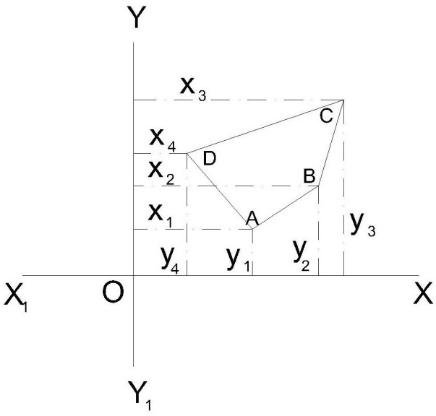

Traverse computation
If the length and bearing of a line are known, the projection of such a traverse line may be obtained on the line parallel to the meridian YY1, and on the line perpendicular to the meridian XX1.

Latitude:

Theprojectionofthelineparalleltothe meridian (N-S line) is called the “latitude” of theline.

Departure:
The projection of the line perpendicular to meridian (N-S line) is called the
“departure” of the line.
The latitude when measured upward or northward along the meridian, is positive and termed as “northing” and when it is measured downward or southward along the meridian it is negative and is called “southing”.
The departure when measured eastward or towards right, is positive and is known as “easting” and when it is measured westward or to the left, it is negative and is known as “westing”.

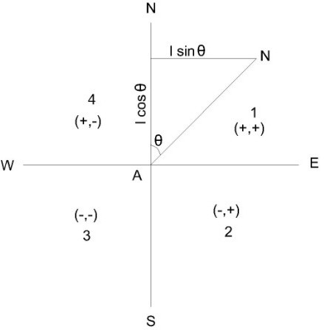
Traverse computation
if the length of line AB is known and its reduced bearing from meridian (i,e,θ) is known, the latitude and the departure may be determined.
Latitude of a line = Length of line x The cosine of reduced bearing of line
= Length x cos θ
Departure of a line = Length of line x The sine of reduced bearing of line
= Length x sinθ
The letter N or S of the reduced bearing will give the sign of the latitude as +ve or –ve respectively and the letter E or W will give the sign of the departure as +ve or – ve, respectively. If the bearings of various traverse lines have been measured as whole circle bearings, the same should be expressed in the form of reduced bearings and consequently can be utilized in determining the latitudes and the departures.
The following table in such a case, may be used.
Sign of

Whole circle bearing  (WOB) | Quadrant | Latitude Departure
0° to 90° | (1) or NE | + +
90° to 180° | (2) or SE | - +
180° to 270° | (3) or SW | - -
270° to 360° | (4) | + -

Consecutive and independent coordinates
The latitude and departure of any point with reference to the preceding point are known as “consecutive coordinates”. And the coordinates of any point with reference to a common origin are called the “independent coordinates” of the point. The independent coordinates are also known as “total latitude” and “total departure” of thepoints.
The independent coordinates of any point may be determined by adding (algebraically) the latitudes and departures of the lines between that point and the origin. Thus,
x-coordinate (or total = x-coordinate of the first point of the departure) of any point
traverse+ Algebraic sum of the departures of the lines between the first point and that point

y-coordinate (ortotal = y-coordinate of the first point of the latitude) of anypoint
traverse + Algebraic sum of latitudes of the lines between the first point and that point
The above rule follows that
x-or y-coordinateoflast = x. or y-coordinate of the first point point ofthetraverse + Algebraic sum of all departuresor
Latitudes
Note
The theodolite traverse should always be plotted with the help of rectangular coordinates.

Adjustment of closing errors in a closed traverse:
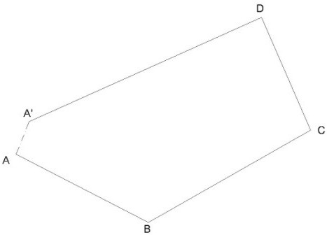
If the survey work is correct, in a closed traverse, the algebraic sum of latitudes (I e, ΣL) should be equal to zero and also the algebraic sum of latitudes (I e, ΣD) should be equal to zero. It follows that the sum of northings should be equal to sum of southings and the sum of eastings should be equal to sum ofwestings.
closing errors in a closed traverse
There are always errors in a theodolite traverse mainly due to two sources, viz :
- the angles between the sides,and
- the lengths of thesides.
Out these, the first is usually less important than the second. The traverse is plotted according to the field measurements, the same will not close on paper and the end point of the traverse will not coincide exactly with the starting point. The distance by which the last point of the traverse falls short to coincide with the starting point is called the “error of closure” or “closing error”. As per the Fig shows plotting of traverse ABCD. The traverse is not closing at A but instead it ends at some other point A1 and thus AA1 is the closing error. The components of this error A1A2 and AA2 as in Fig parallel and perpendicular to the meridian may be obtainedbyfindingthealgebraicsumofthelatitudesΣL,andthealgebraicsumofdepartures
ΣD.
ΔAA1A2 is right-angle at A2 .
Linear error of closure AA1 =√
Where Φ is the reducedbearing.
The signs of ΣL and ΣD will determine the position of closing in a particular quadrant.

The closing error is usually expressed as a fraction having the numerator as unity and is called the relative error of closure.

Note
The errors in lengths of sides are more likely to occur along the longest sides of the
traverse.

Angular error
If the angles of a traverse do not add up correctly, ie, a difference exists between the sum of the measured angles and the theoretical sum of (2n±4) right angles, where n is the number of sides of closed traverse ; necessary correction to the angles nearest the short sides (since these are the angles most likely to be slightly more in error) is to be applied. If the angular error is small, the same may be arbitrarily distributed to two or three angles. If the survey work is carried out with ordinary precision, the correction applied to any angle is not less than the least count of thevernier.

Adjustment of error inbearings
The closing error in bearing may be obtained by comparing the two bearings of the last line as observed at the first and the last stations of the traverse or if the traverse ends on a line of known bearing, the closing error can be obtained by finding the difference between its observed bearing and known bearing. This error ….. then, should be distributed among the sides of the traverse. If n is the number of sides, the corrections to the bearings of the sides will be as given below :
Correction to thefirstbearing = Correction to thesecond bearing = Correction to thethirdbearing = Correction to thelastbearing =

BALANCING THE TRAVERSE
When the closing error in latitude and in departure is determined, the latitudes, and departures should be adjusted such that the algebraic sum of the latitudes should be adjusted such that the algebraic sum of the latitudes and departures should each be equal to zero. This operation of applying correction to the latitudes and the departuresis called the “balancing of the traverse”. If one or more sides of a traverse have not been measured with equal care due to some typical field conditions, the whole or the largest part of the error may be adjusted to the same side or sides. But, if all the sides have been measured with equal precision and care, the following rules may be applied to determine the corrections foe balancing thetraverse.
  - Bowditch’srule
The Bowditch’s Rule or the “compass rule” is generally used to balance the traverse when the angular as well as linear measurements are taken with equal precision. By this rule, the total error in latitude and in departure is distributed in proportion to the length of thesides.

Correction to the latitude or to the departure of any line
=Total error in latitude or departure X Length of the line
Perimeter of the traverse
The traverse can also be adjusted as it is explained in “compass traverse adjustment”.
  - Transitrule
The transit rule may be applied to balance the traverse when the angular measurements are taken with greater care and precision than the linear measurements as in the case of a theodolite and stadia traverse. According to thisrule,
Correction to latitude of any line
= Total error in latitude XLatitude of that line
Arithmetical sum of all the latitudes
Similarly,
Correction to departure of any line
= Total error in departure X Departure of that line Arithmetical sum of all the departure
  - Thirdrule
According to the third rule, Correction to northing of any side
= Total error in latitude X Northing of that side Sum of all northings
Correction to southing of any line
= Total error in latitude X southing of that side
Sum of all southings
Similarly,
Correction to easting of any side
= Total error in departure X Easting of that side Sum of alleasting
Correction to westing of anyside
= Total error in departure X Westing of that side
Sum of all wrstings
When the traverse is thus balanced, the lengths and bearings of lines arechanged. Note
In case the traverse adjustments are made by the Bowditch’s Rule, angles are changed more and the lengths are charged less than when the adjustment is made by the transit rule.

Gales Traverse Table:
The following steps may observed.
    - Find out the sum of the observed included angles which should be equal to (2n± 4) right angles according as the interior or exterior angles are measured. If they arenot

equal, apply the necessary corrections to the angles so that the sum of the corrected angles is exactly equal to (2n ± 4) right angles.
    - From the observed bearing of the first line AB and the corrected included angles, calculate the WCB of all the other lines BC, CD, etc. As a check, find out the bearing of the first line which should be equal to its observedbearing.
    - Calculate the reduced bearings of lines from the whole circle bearing and find out the respectivequadrants.
    - Compute the latitudes and departures of lines, I e, the consecutive coordinates (coordinates with respect to preceding point, e g, in a closed traverse ABCD, the coordinates of A, with respect to D and coordinates of B with respect to station A, and so on) from their observed lengths and corrected reduced bearings. For example in the above traverse, to compute the coordinates of A, the length and reduced bearing of line DA should be taken, and similarly for point B, the length and reduced bearing of line AB should beconsidered.
    - Find out the algebraic sum of latitudes (ΣL) and that of departures (ΣD). Apply necessary corrections to the latitudes and departures so that their sum is equal to zero for closedtraverse.
    - From the corrected consecutive coordinates, obtain the independent coordinates of the lines such that they are all positive and the whole traverse lies in the first quadrant (NE).

Example
The following corrected latitudes and departures correspond to the sides of a traverse ABCDE. Compute the independent coordinates.
Latitude Departure

Lines | Northing | Southing | Easting | Westing
AB |  | 325.16 | 620.24
BC | 449.35 |  | 946.24
CD | 980.25 |  |  | 742.60
DE |  | 536.89 |  | 797.80
EA |  | 567.55 |  | 26.08
The independent coordinates of an origin or the starting point A of the survey should be so chosen that the coordinates of all otherStation points are positive, i.e. all the points of the traverse lie in the firstquadrant.
Also the chosen independent coordinates should be in multiples of 100 and 1000. Here, the coordinates of point A may be chosen as (400,0). Applying the rule, North coordinate ofpointA =400.00
Deduct southing ofpointB = 325.16 North coordinate ofpointB =78.84
Add northing ofpointC =449.35

North coordinate of point C | = 524.19
Add northing of point D | = 980.25
North coordinate of point D | = 1504.44
Deduct southing of point E | =536.89
North coordinate of point E | = 967.55
Deduct southing of point A | = 567.55
North coordinate of point A | = 400.00 (same as assumed)
East coordinate of point A | = 0.00
Add easting of point B | = 620.24
East coordinate of point B | = 620.24
Add easting point C | = 946.24
East coordinate of point C | = 1 566.48
Deduct westing of point D | = 742.60
East coordinate of point D | = 823.88
Deduct westing of point E | = 797.80
East coordinate of point E | = 26.08
Deduct westing of point A | = 26.08
East coordinate of pointA | = 0.00 (same as assuned)

Area of closed traverses:

The following methods are generally used for calculating the area of closed traverses : a)Area from coordinates (y and x).
- Area from latitudes and doublemeridian.

- Area from departures and totallatitudes.

Area of closed traverses from coordinates:

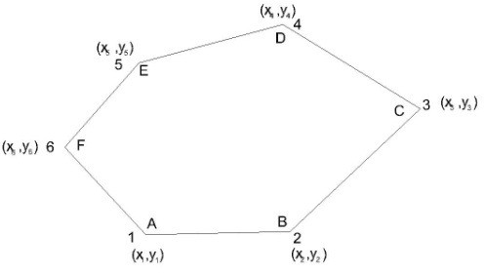

If the coordinates (x₁, y₁), (x₂, y₂), etc. of various points in a closed traverse are known, the area can be easilycalculated.
In Fig ABCDEF is a closed traverse of six sides and the coordinates are also indicated for each station.
To find the area, multiply (ordinate/abscissa) by the difference of (abscissae/ordinates) of the points before and after the point considered, e g, when point A is considered, the ordinate of point A is multiplied by the difference of abscissae of points B and F, i e, y₁, (x₂–x₆).
Always the preceding abscissae/ordinates are subtracted from the following abscissae/ordinates. Find the sum of all such products which is equal to twice the area of the traverse.
Half of this sum gives the required area of the traverse. Thus, the area of closed traverse is given below:
Area = ½[y₁(x₂, x₆) +y₂(x₃, x₁)+ y₃(x₄– x₂) + y₄(x₅, x₃) + y₅(x₆, x₄) + y₆(x₁, x₅)] Area = ½[y₁(x₂ – x₆) + y₂(x₃– x₁) + y₃(x₄ – x₂) + … +y_{n}(x_{n+1} –x_{n-1})]
Wherex_{1,}x_{2,}x_{3,}etc.aretheabscissaeandy_{1,}y_{2,}y₃etc.aretheordinates. The abscissae or x-coordinates are along X-axis or east-westline.
The ordinates or y-coordinates are along Y-axis or north-south line.

Area of closed traverse from latitudes and double meridian distances(DMD):
The meridian distance (MD) of a line or “longitude” is the perpendicular distance of the middle point of the line from the reference meridian.
The double meridian distance (DMD) or the double longitude of a line is equal to the sum of the meridian distance of the two ends of the lines. The MD of various lines can be calculated by the following principles:

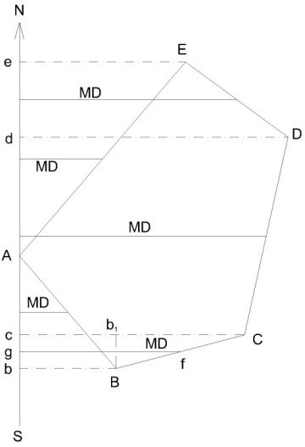
- The DMD of first line is equal to the departure of thatline.

- The DMD of each succeeding line is equal to DMD of the preceding line plus the departure of the lineitself.
- The DMD of the last line is numerically equal to the departure of the last line but with oppositesign.
Rule
To find out the area of the closed traverse by latitudes and DMD, multiply each DMD by the latitude of that line.
Find the algebraic sum of all these products which gives twice the area of the traverse. Half of this sum is equal to the required area of traverse.
The figure clearly shows the meridian distance from the reference meridian.
For example, the meridian distance of line BC will be f g and the DMD of line BC is (Cc
+Bb).(Cc + Bb) = Cb₁+ b₁c+ Bb
= Cb₁+ Bb + Bb = (Bb + Bb + b₁C)
DMD of line BC=DMD of line AB + Departure of line AB + Departure of line BC It proves the given principal.

Area of closed traversed from departures and total latitudes:
To find out the area of closed traverse by this principal proceed as follows:
  - Find out the total latitude of each statin of thetraverse.
  - Find the algebraic sum of departures of the two lines meeting at thatstation.
  - Multiply the total latitude of that station by the corresponding algebraic sum of the departures.
  - Find the algebraic sum of these products which is equal to twice the area of thetraverse. Example
The latitudes and departures of the survey lines of a traverse ABCD are given as follows: Line Latitude Departure
 | N | S | E | W
AB | 204.6 |  | 113.9
BC |  | 234.9 | 205.8
CD |  | 150.7 | 86.0
DA | 181.0 | 233.7

Calculate its area if the sides are measured in meters.

Area of traverse ABCD by coordinates (independent):
The independent coordinates can be calculated as already explained. Here, the independent coordinates of A can be assumed as (200,0) so that all the coordinates are positive and the traverse may lie in first quadrant only. The coordinates can be tabulated as given below.
Independent coordinates

Line | Latitude | Departure | Station | North, | East,
AB | + 204.6 | + 113.9 | A | Y  200.0 | x  0.0
BC | - 234.9 | + 205.8 | B | 404.6 | 113.9
CD | - 150.7 | - 86.0 | C | 169.7 | 319.7
DA | + 181.0 | - 233.7 | D | 19.0 | 233.7
 |  | Cheek : | A | 200.0 | 0.0
Now, the area of the traverse
=½[y₁(x₂– x₄) +y₂(x₃ – x₁) +y₃(x₄ – x₂) +y₄(x₁ – x₃)]
½[200(113.9 – 233.7) + 404.6(319.7 – 0.0)
+ 169.7(233.7 – 113.9) + 19(0.0 – 319.7)]
=½[200X – 119.8 + 404.6 X 319.7 + 169.7 X 119.8 + 19 X –319.7]
=½[– 23 960.0 + 129 350.62 + 20 330.06 –6 074.30]
=½[149 680.68 – 30 034.30] = ½[119 646.38]= 59 823.19
∴ Area of the traverse ABCD = 59 823.19 m²

Area of traverse ABCD by latitudes and double meridiandistance:
In this method, first of all the DMD of each line should be calculated. DMD of line AB = Departure of line AB = 113.9
MD of line BC = DMD of line AB + Departure of line B + Departure of BC
= 113.9 113.9 + 205.8 = 433.6
DMD of line CD = DMD of line BC + Departure of line BC + Departure of line Cd
= 433.6 + 205.8 – 86.0 =639.4 – 86.0 = 553.4
DMD of line DA = DMD of line CD + Departure of line CD + Departure of line DA
= 553.4 – 86.0 – 233.7 = 553.4 –319.7
= 233.7

Check
The DMD of last line DA should be numerically equal to its departure but should be of opposite sign.
Hence, the above calculations are correct. Now, the results may be tabulated as follows:
Twice the area(Column 2 X Column 4)
Line | Latitude | Departure
 |  |  |  |  | + |  | –
1 | 2 | 3 | 4 | 5 |  | 6
AB | + 204.6 | + 113.9 | 113.9 | 23 303.94
BC | – 234.9 | + 205.8 | 433.6 |  |  | 101 852.64
CD | – 150.7 | – 86.0 | 553.4 |  |  | 83 379.38
DA | + 181.0 | – 233.7 | 233.7 | 42 299.70
Total |  |  |  | 65 603.64 | 185 250.02
Algebraic sum |  |  |  | 119 646.38
∴ Area of traverse ABCD = ½ X Algebraic sum
= ½ X119 646.38 = 59 823.19m²
Note
The negative sign of the has no significance.

Area of traverse ABCD from departures and totallatitudes:
Here, station A can be assumed as the reference station and the total latitudes of other stations B, C and D are calculated.
Total latitude of station A = ΣL=00 Total latitude of station B = ΣL = +204.6
Total latitude of station C = ΣL= 204.6 – 234.9 = –30.3
Total latitude of station D = ΣL= 204.6 – 234.9 – 105.7 = – 181.0 Check.
Total latitude of station A = ΣL= 204.6 – 234.9 – 105.7 + 181.0 = 0.0 The results may be tabulated as under:

Twice the area Line Latitude Departure Total latitude Algebraic sum of adjoiningdeparture
1 | 2 | 3 | 4 | 5 | 6 | 7 | 8
AB |  | +204.6 | + 113.9 | B |  | +204.6 | +319.7 | 65 410.62
BC |  | – 234.9 | + 205.8 | C |  | – 30.3 | + 119.8 |  | 3 629.94
CD |  | – 150.7 | – 86.0 | D |  | – 181.0 | –319.7 | 57 865.70
DA |  | + 181.0 | – 233.7 | A |  | 0.0 | –119.8 |  | 0.0

Total 123 276.32 3629.94
Algebraic sum119 646.38

∴ Area of the traverse = ½ X Algebraic sum
=½ X 119 646 38
= 59 823.19 m²
Types of problems in traversing
While solving the problems, the following trigonometrically relationship should be remember and employed according to need.
The trigonometrically relationship of the course of a line together with its latitude and departure are employed are follows:
  - Latitude = Length X cosine of reduced bearing
  - Departure = Length X sine of reducedbearing
  - Tangent of reducebearing= Departure
Latitude
  - Length = √ (Latitude)²+(Departure)²
Length = Latitude X secant of reduced bearing Length = Departure X cosecant of reduced bearing The various types of problems may be as follows :
    - To find out the length and bearing of a line joining two-points whose independent coordinates are given :
In such a case proceed as given below:
- Find the difference between the north coordinates;

- Find the difference between the east coordinates;
- Then, if θbe the reduced bearing of the line joining the twopoints,

Tan θ= Departure of the line Latitude of the line
= Difference between the east coordinates Difference between the north coordinates

Omitted or missing measurements:

If the length and bearing of each side of the closed traverse are known, the traverse may be said to be completely surveyed. The bearing of all the sides may either be observed in the field or these may be computed from the observed bearing of any one line and the deflection angles or included angles of the traverse. It is always advisable to find out the length and bearings of the sides of a closed traverse by field measurements. But it is not always possible and due to certain obstacles direct measurements cannot be taken sometimes. For example such a difficulty may be experienced in direct observation of length and bearing of a line joining two points which are not inter visible owing to an intervening obstruction like a building. Similar difficulty may also be experienced if omissions occur in the field notes. To overcome these difficulties, the method of latitudes and departures may be readily employed to determine the omitted measurements provided the omitted measurements are not more than two in number. If the omitted measurements are more than two in number, the problem becomes indeterminate.
The sides of which the length or bearing or both are omitted, are called “affected sides”. The solution of problems of missing measurements is based on the principle that in a closed traverse the algebraic sum of the latitudes (ΣL)and that of departures (ΣD)should each be equal to zero.
Mainly there are two types of problems, viz :
- In which only one side is affected, e g:
  - The bearing of one side may be missing;
  - The length of one side may be missing ;and
  - The length and bearing of one side may bemissing.
- In which two sides are affected, e g:
  - The length of one side and bearing of another side may bemissing;
  - The bearings of two sides may be missing ;and
  - The lengths of two sides may bemissing.
To solve all such problems, the trigonometrical relationships, which are already given, should be used.
The following procedure may be adopted for these cases:
Case 1

In this case, the bearing, or length, or bearing and length of one side is missing. Let in Fig the length or the bearings or both the length and bearing of line ED be missing. Then, to determine the missing parts, adopt the followingprocedure.
Calculate the latitudes and departures of the other known sides EA, AB, BC and CD taking into account the correct signs. Find out the sum of latitudes (ΣL)and that of departures (ΣD). Then from the condition of closed traverse, the latitude and departure of the affected side will be –ΣL, and – ΣD respectively. Calculate the bearing of the affected side from the relationship, tangent of RB =ΣDeparture,
–ΣLatitude and the length of the affected side from the relationships, Length = √ (Σ Latitude)²+ (ΣDeparture)², or Length = Latitude X secant of RB, or Length = Departure X cosecant ofRB.
Case 2
- Length of one side and bearing of another sideomitted
Let in Fig 7.69, the length of line BC and bearing of line CD be omitted. To solve such problems proceed as given below:
- Join B and D to from a closed polygon DEAB, leaving the affected sides. Calculate the length and bearing of closing line BD as in case1.
- Compute the angle (α) between the closing line BD and line BC from their calculated and known bearingsrespectively.
- Now, in Δ BCD, the lengths of sides BD and CD are known and angle α is known. Angle ϒ and length of side BC may be calculated by applying the sine rule.
When ϒ is calculated from the above relationships, angle β may also be calculated,
β = 180⁰– (α+ϒ)
- From the known bearing of side BC and the calculated value of angle ϒ, calculate the required bearing of line CD. Check the result by calculating the bearingoflineCDfromthecalculatedvaluesofbearingoflineDBandangle
β.
- Bearing of two sidesmissing
Refer Fig 7.69 and let BC and CD be the sides whose bearings are not known. Proceed as given below:
- Now since the lengths of all the sides in Δ BCD are known the area of triangle BCDmay be calculated easily by the well-knownformula:
Area, Δ = √ s(s – a)(s – b) (s – c)
Where s is half the perimeter of the triangle and a, b, c are the lengths of the sides of the triangle.
- Since the bearings of sides BC and CD are not known, angles α, β and ϒ cannot be calculated with the help of bearings. First of all, the angles should be found out and then the bearings can be easily calculated. Determine the angles by equating the calculated area to half the products of any two sides and the sine of the angle between them, e g, to find out angle α, the relationship Δ = ½ BD X BC X sin α may be used and soon.
- Next, find out the bearings of sides BC and CD from the known bearing of closing line BD and the calculated angles αandβ.

- Lengths of two sidesmissing
Refer Fig and let sides BC and CD be affected, I e, let their lengths be not known.
  - Ignoring the affected sides, close the polygon and calculate the length and bearing of closing lineBD.
  - Here,sincethebearingsofallthesidesinΔBCDareknown,anglesα,β
and ϒ can be calculated easily. After calculations apply the check :
α+β + ϒ = 180⁰
  - Next, compute the lengths of sides BC and CD by applying the sine rule: BC = BD X sinβ
Sin ϒ
CD = BD X sin α
Sin ϒ
Notes
(1) In case, the two sides of a traverse are affected and are not adjacent as shown in Fig (sides 1 and 4), the following procedure should be adopted.
Shift the known sides 5 and 6 parallel to themselves and in the direction parallel to one of the unknown sides and close the polygon by dotted closing line as shown in the figure. The affected side 4 will be thus shifted towards side 1 and will be adjacent to each other. The length and bearing of a line does not change when it is moved parallel toitself.

CHAPTER- 5

General

Tachometry is the branch of angular surveying in which the horizontal and vertical distances of points are obtained by optical means as opposed to the ordinary slower process of measurements by tape or chain. The method is very rapid and convenient. Although the accuracy of Tachometry in general compares un-favourably with that of chaining, it is best adapted in obstacles such as steep and broken ground, deep ravines, stretches of water or swamp and so on, which make chaining difficult orimpossible.
The primary object of tachometry is the preparation of contoured maps or plans requiring both horizontal as well as vertical control. Also, on surveys of higher accuracy, it provides a check on distances measured with the tape.

Tacheometer:

- A tacheometer is nothing more than a theodolite fitted with stadiahair.
- The stadia hairs are kept in the same vertical plane as the horizontal and vertical cross hair.
- For short distance up to 100 m, ordinary leveling stadia mayused.
- According to measurement process system, it is classified under twocategories

i.e. 1. Stadia hairsystem

2. Tangentialsystem

- The stadia hair system again divided into twocategories
i.e. 1. Fixed hair method
2. Movable hair method

Fixed hair method:

In this method, the distance between the upper hair and lower hair, i.e. stadia interval i, on the diaphragm of the lens system is fixed. The staff intercept s, therefore, changes according to the distance D and vertical angle θ.

Movable hair method:

In this method, the stadia interval ‘i’ can be changed. The stadia hairs can be moved verticallyup and down by using micrometer screws. The staff intercept s, in this case, is kept fixed. Two vanes (targets) are fixed on the staff at a fixed interval of 2 m or 3m.
The fixed hair method is the one which is commonly used and, unless otherwise mentioned, stadia method means fixed hair method. Movable hair method is not in common use due to difficulties in determining the value of i accurately.

Principle of Stadia Method
The stadia method is based on the principle that the ratio of the perpendicular to the base is constant in similar isosceles triangles. In figure (a), let two rays OA and OB be equally inclined to the central ray OC. Let A₂B₂, A₁B₁and AB be the staff intercepts.
Evidently,

0C₂A₂B₂
0C₁
=
A₁B₁
0C
= = constant k = AB
1 þ
cot
2 2

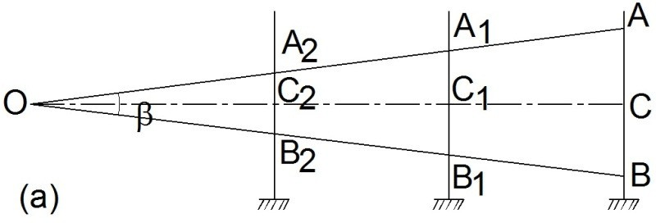

We will derive distance and elevation formulae for fixed hair method assuming line of sight as horizontal and considering an external focusing type telescope. In Figure below, O is the optical centre of the object glass. The three stadia hairs are a, b andc and the corresponding readings on staff are A, B and C. Length of image of AB is ab. The other terms used in this figure are

f = focal length of the object glass,
i = stadia hair interval = ab, s = staff intercept = AB,
c = distance from O to the vertical axis of the instrument,
d = distance from O to the staff,
d′′ = distance from O to the plane of the diaphragm, and
D = horizontal distance from the vertical axis to the staff.

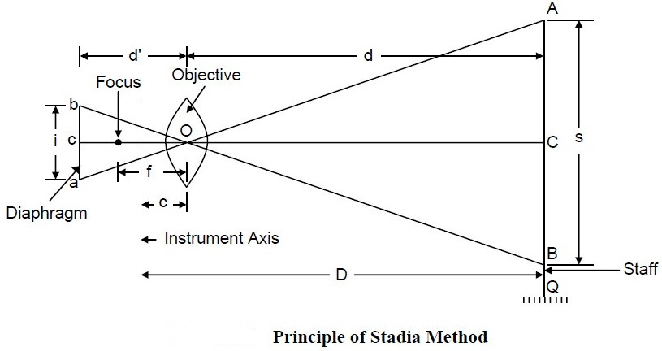

s
From similar ∆ , AOB and aOb, we get
d =c
d′ i
And from lens formula,
1 1 1
ƒ = d′+d
Combining the two equations, we get
ƒs
d= +ƒ i
Adding c to both the sides
ƒs
D= + (ƒ +c)
i
Or D = Ks + C
where the constant K is equal to (f /i). It is called multiplying constant of the tacheometer and is generally kept as 100. The constant C is equal to (f + c). It is called additive constant whose value ranges from 30 cm to 50 cm for external focusing telescopes and 10 cm to 20 cm for internal focusing telescopes. For telescopes fitted with anallactic lens, C equals zero.

Anallactic Lens
The basic formula for determination of horizontal distance in stadia tacheometry is

ƒs
D= + (ƒ +c)
i
Or D = Ks + C
Due to the presence of the additive constant C, D is not directly proportional to s. This is accomplished by the introduction of an additional convex lens in the telescope, called an anallactic lens, placed between the eyepiece and object glass, and at a fixed distance from the latter.

The anallactic lens is provided in external focusing telescope. Its use simplifies the reduction of observations since the additive constant (f + c) is made zero and the multiplying constant k is made 100. However, there is objection to its use also as it increases the absorption of light in the telescope thereby causing reduction in brilliancy of the image. Anallactic lens is not fitted in internal focusing telescopes.

Determination of Tacheometric Constants

The stadia interval factor (K) and the stadia constant (C) are known as tacheometric constants. Before using a tacheometer for surveying work, it is required to determine these constants. These can be computed from field observation by adopting following procedure.

Step 1 : Set up the tacheometer at any station say P on a flat ground.

Step 2 : Select another point say Q about 200 m away. Measure the distance between P and Q accurately with a precise tape. Then, drive pegs at a uniform interval, say 50 m, along PQ. Mark the peg points as 1, 2, 3 and last peg -4 at station Q.

Step 3 : Keep the staff on the peg-1, and obtain the staff intercept say s₁ .

Step 4 : Likewise, obtain the staff intercepts say s₂, when the staff is kept at the peg-2,

Step 5 : Form the simultaneousequations, D₁ = K. s ₁+C (i)
and D ₂ = K. s₂+C (ii)

Solving Equations (i) and (ii), determine the values of K and C say K₁ and C₁ .

Step 6 : Form another set of observations to the pegs 3 & 4, Simultaneous equations can be obtained from the staff intercepts s₃ and s₄ at the peg-3 and point Q respectively. Solving those equations, determine the values of K and C again say K₂ and C₂.

Step 7 : The average of the values obtained in steps (5) and (6), provide the tacheometric constants K and C of the instrument.

Stadia tacheometry

Case 1 When staff held vertical and with line of collimation horizontal

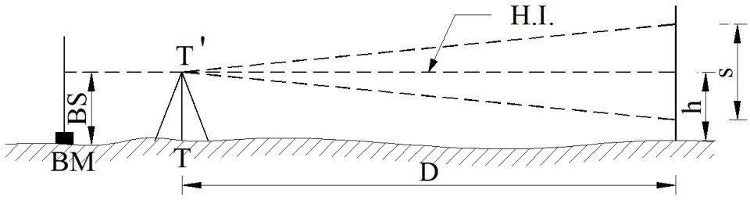

When the line of sight is horizontal , the general tacheometric equation for distance is given by

ƒs
D= + (ƒ +c)
i

The multiplying constant
(ƒ)
i

is 100, and additive constant (ƒ + c) is generally zero.

RL of staff station P = HI – h Where HI = RL of BM + BS h = central hairreading
BS = Back sight

HI = height of instrument

Case 2 When staff held vertical and with line of collimation inclined

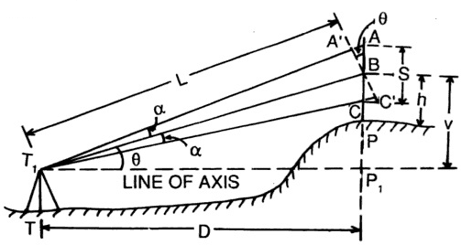
- Considering Angle ofelevation

Let
T = Instrument station T₁= axis of instrument P = staff station
A, B, C = position of staff cut by hairs
S = AC = staff intercept
h = central hair reading
V = vertical distance instrument axis and

central hair
D = horizontal distance between instrument and staff L = inclined distance between instrument axis and B 8 =angle of elevation
α =angle made by outer and inner rays with central ray

A′C′isdrawnperpendiculartothecentralrayT₁B Now , internal distance, L = ƒ (A′C′) + (ƒ +c)
i
Horizontal distance , D = L cos8
=ƒ(A′C′)cos8+(ƒ+c)cos8 (1)
i
Now A′C′ is to be expressed in terms of AC (i. e. S)
In ∆s ABA′and CBC′
< ABA′=<CBC′= 8
< AA′B = 90⁰ +α
<BC′C = 90⁰ −α
The angle α is very small

< AA′B and < BC′C may be taken equal to 90⁰
So A′C′= AC cos8 = S cos8
From equation (1)

D = ƒ (S cos8) cos8 + (ƒ + c) cos8
i

D = ƒ
i
× Scos
²8 +
(ƒ +c)
cos8

Again V = L sin8

ƒ
= { × S cos8 + (ƒ + c)} sin8 i

=ƒ×Scos8sin8+
i
(ƒ +c)
sin 8

V = ƒ × S ×sin 28 + (ƒ + c) sin 8
i 2
Also V = Dtan8

RLoƒstaƒƒstationP=RLoƒaxisoƒinstrunent+V−ℎ

- Considering Angle ofdepression

In this case also the expressions for D and V are same. That is
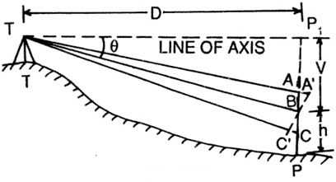

D = ƒ
i
× Scos
²8 +
(ƒ +c)
cos8

V = ƒ × S ×sin 28 + (ƒ + c) sin 8
i 2
RLoƒstaƒƒstationP=RLoƒaxisoƒinstrunent−V−ℎ

Problem

A tacheometer was set up at a station C and the following readings were obtained on a staff vertically held.

Inst.  station | Staff  station | Vertical angle | Hair readings | Remarks
CC | BMD | −5⁰20′  +8⁰12′ | 1.500, 1.800, 2.450  0.750, 1.500, 2.250 | RL of BM =  750.50 m

Calculate the horizontal distance CD and RL of D, when the constants of instrument are 100 and
0.15 .
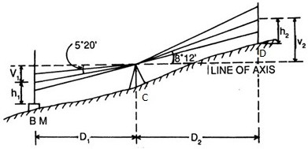

Solution

When the staff is held vertically, the horizontal and vertical distances are given by the relations

D = ƒ × S cos²8 + (ƒ + c) cos8 i

ƒ
V = ×
i
S × sin 28 2

+ (ƒ + c) sin 8

Here ƒ = 100 and (ƒ + c) = 0.15
i

Inthefirstobservation,S₁=2.450−1.150=1.300n8₁=5⁰20′(deeression)
sin10⁰ 40′
0 ′
V₁=100×1.300× 2 +0.15×sin520=12.045n

Inthesecondobservation,S₂=2.250−0.750=1.500n8₂=8⁰12′(elevation)
sin16⁰ 24′

V₂=100×1.500×
+0.15×sin8⁰12′=21.197n
2

D₂=100×1.50×cos²8⁰12′+0.15×cos8⁰12′=147.097n
RLoƒaxisoƒinstrunent=RLoƒBM+ℎ₁+V₁

=750.500+1.800+12.045=764.345n

RLoƒD=RLoƒaxisoƒinstrunent+V₂−ℎ₂

=764.345+21197−1.500=784.042n

So, the distance CD = 147.097 m and RL of D = 784.042 m

CHAPTER-6

Introduction:

Curves are required to be introduced where it is necessary to change the direction of motion from one straight section of a highway or a railway to another. These are provided due to the nature of terrain or other avoidable reasons to enable smooth passage of vehicles.

CLASSIFICATION OF CURVES

For survey purposes, curves are classified as horizontal or vertical, depending on whether they are introduced in the horizontal or verticalplane.
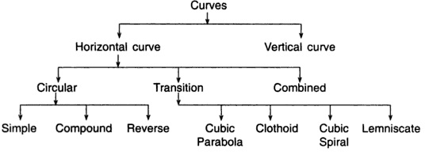

Horizontal Curves
Horizontal curves can be circular or non-circular (transitional) curves. Different types of horizontal curve are shown in figure below.

Simple Circular Curve
When a curve consists of a single arc with a constant radius connecting the two straights or tangents, it is said to be a circular curve.

Compound Curve
When a curve consists of two or more arcs with different radii, it is called a compound curve. Such a curve lies on the same side of a common tangent and the centres of the different arcs lie on the same side of their respective tangents.

Reverse Curve
A reverse curve consists of two arc bending in opposite directions. Their centres lie on opposite sides of the curve. Their radii may be either equal or different, and they have one common tangent.

Transition Curve
A curve of variable radius is known as a transition curve. It is also called a easement curve. Such a curve is provided between a straight and a circular curve, or between branches of a compound or reverse curve to avoid an abrupt change in direction when the alignment

changes. In railways, such curve is used on both sides of a circular curve to minimize superelevation.

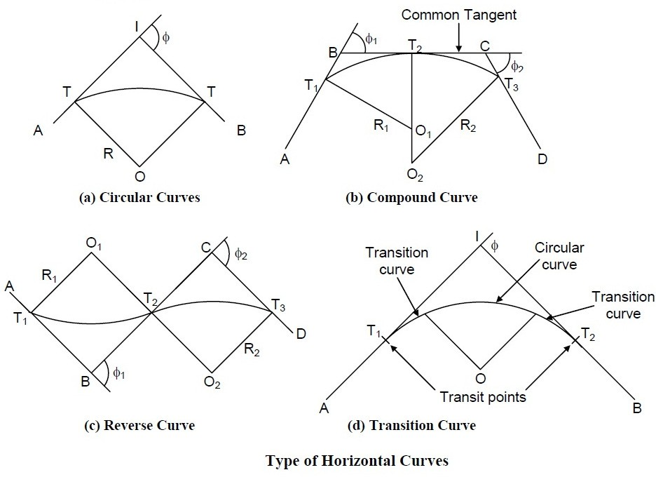

SIMPLE CIRCULAR CURVE

Figure shows a simple circular curve with two straight lines AI and IB intersect at the point I. ThecurveT1CT2ofradiusRisinsertedtomakeasmoothchangeofdirectionfromAItoIB.A
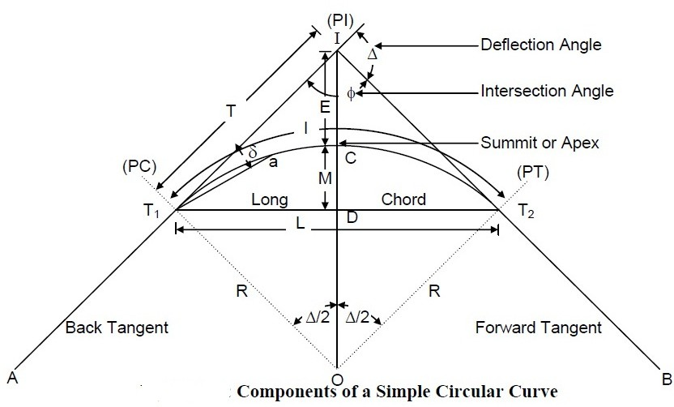
simple circular curve hasvarious
components
whose
definitions are givenbelow.

Definition of Various Components Back Tangent
The tangent (AT1) previous to the curve is called the back tangent or first tangent.

Forward Tangent
The tangent (T2 B) following the curve is called the forward tangent or second tangent.

Point of Intersection
If the two tangents AT1 and BT2 are produced, they will meet in a point I called the point of intersection (PI) or vertex.

Point of Curve (PC)
It is the beginning of the curve (T1) where the alignment changes from a tangent to a curve.

Point of Tangency (PT)
It is the end of the curve (T2) where the alignment changes from a curve to tangent.

Intersection Angle
The angle between the tangent AT1 and BT2 is called the intersection angle ($).

Deflection Angle
The angle ∆ through which the forward tangent deflects is called the deflection angle of the curve. It may be either to the left or the right.

Deflection Angle to any Point
The deflection angle δ to any point a on the curve is the angle at PC between the back tangent and the chord T1 a from PC to point on the curve.

Tangent Distance (T)
It is the distance between PC to PI (also the distance from PI to PT).

External Distance (E)
It is distance from the mid-point of the curve to PI. It is also known as the apex distance.

Length of the Curve (l)
L is the total length of the curve from PC to PT.

Long Chord (L)
It is the chord joining PC to PT.

Mid Ordinate (M)
It is the ordinate from the mid-point of the long chord to the mid-point of the curve. It is also called the versine of the curve.

Normal Chord (C)
A chord between two successive regular stations on a curve is called a normal chord.

Sub-Chord (c)

Sub-chord is any chord shorter than the normal chord. These generally occur at the beginning or at the end of the curve.

Right-hand Curve
If the curve deflects to the right of the direction of the progress of survey, it is called the right-hand curve.

Left-hand Curve
If the curve deflects to the left of the direction of the progress of survey, it is called the left- hand curve.

Elements of Simple Circular Curve Length of the Curve (l)
Length l = T1 CT2 = R ∆, where ∆ is in radians
= (π R) ∆/180o, where ∆ is in degrees.

Tangent Length (T)
Tangent length, T = T1I = IT2
= OT1 tan ∆/2 = R tan∆/2

Length of the Long Chord(L)
L = T1T2 = 2 OT1 sin ∆/2
= 2 R sin ∆/2

Apex Distance or External Distance (E)
E = CI = IO – CO
= R sec ∆/2 – R
= R (sec ∆/2 – l)
= R exsec ∆/2

Mid-ordinate (M)
M = CD = CO – DO
= R – R cos ∆/2
= R (1 – cos ∆/2) = R versin ∆/2

Problem :

o
Two tangents intersect at a chainage of 1250.50 m having deflection angle of 60 . If the radius of
the curve to be laid out is 375 m, calculate the Length of the curve, Tangent distance, Length of the long chord, Apex distance, Mid-ordinate, Degree of curve and Chainage of P.C. and P.T.

Solution :
o
Length of the curve, l = (π R) ∆/180 , where ∆ is in degrees.
o o
= π Χ 375 × 60 /180
= 392.69 m
Tangent Length, T = R tan ∆/2
o
= 375 × tan 60 /2
= 216.50 m
Length of the long chord, L = 2 R sin ∆/2
o
= 2 × 375 × sin 60 /2
= 375.00 m
Apex distance, E = R (sec ∆/2 – 1)
o
= 375 × (sec 60 /2 – 1)
= 58.01 m
Mid-ordinate, M = R (1 – cos ∆/2)
o
= 375 × (1 – cos 60 /2)
= 50.24 m
o

Degree of Arc, D
= 1718.9/R
a
= 1718.9/375
o
= 4 .58

Chainage of PC = Chainage of I – T
= 1250.50 – 216.50
= 1034.00 m
Chainage of PT = Chainage of I + l
= 1250.50 + 392.69
= 1634.19 m

Designation of Curve
The sharpness of the curve is designated either by its radius or by its degree of curvature. The degree of curvature has several slightly different definitions. According to the arc definition generally used in highway practice, the degree of the curve (Dº) is defined as the central angle of
a
the curve that is subtended by an arc AB of 30 m length .
If the degree of curve (Dº) is taken in degrees, for a curve of radius R meter, then
a
o
Dº: 30 = 360 : 2π R
a
or Dº= 10800/2πR
a
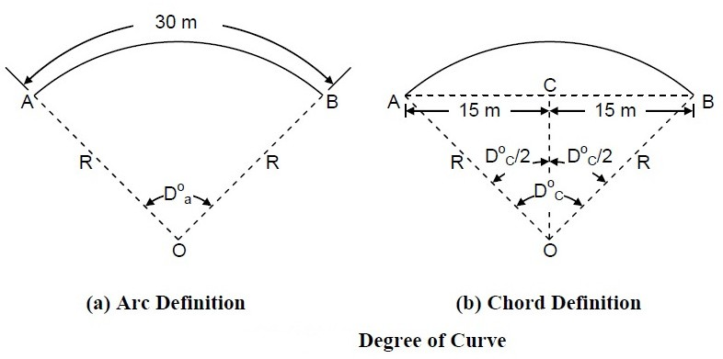
= 1718.9/R (approximate)

According
to thechord
definition
generally used in railway practice, the degree of the curve (Dº) is defined as the central angle of the curve
c
that is subtended by its chord AB of 30 m length.
sin(Dº/2) = AC/AO
c
= 15/R
R = 15/sin (Dº/2)
c
Radius of curvature varies inversely as the degree of curve. A sharp curve has a larger degree of curve whereas a flat curve has a smaller degree of curve.

SETTING OUT SIMPLE CIRCULAR CURVE

A circular curve can be set out in the field by linear method and angular method. These are described below.
- Linear method is also called chain and tape method. In this method, only tape and chains are used and no angular measurement is carriedout.
- In angular method or Instrumental method, a theodolite, tacheometer or a total station instrument is used for angularmeasurement.

Linear Method
Listed below are some of the linear methods of setting out simple circular curve followed by their description :
- Offsets from the longchord
- Successive bisection ofchord
- Offsets from thetangents
- Offsets from the chordsproduced

Offsets from the Long Chord
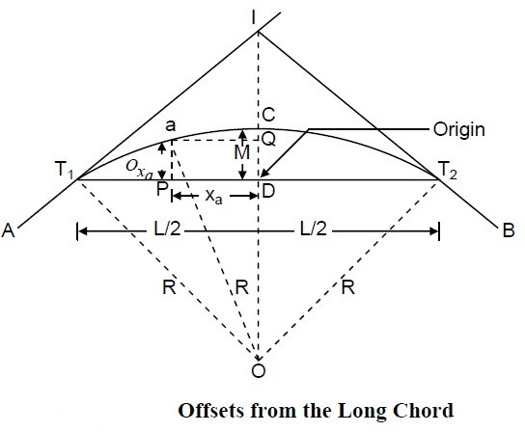
The method is suitable for setting out circular curves of small radius, such as those at road intersections in a city or in boundary walls. In Figure below, the offset 0_{sa}to the point a on the curve is the perpendicular distance of point a from the long chord T T , at a distance x_{a}from Dalong
1 2
the long chord. Considering the origin at D,0_{sa}is the y-coordinate of point a.

From ∆ 0T₁D,

(D0)²= (T₁0)²− (T₁D)²
Or (0C − DC)²= (T₁0)²−(T₁D)²

Or (R −M)²
= R²
L 2
− ( )
2

Or M = R−
JR2
L 2
− ( )
2

Draw a line Qa parallel to DT₁ cutting DC at Q

Fron∆0aQ

0Q = ƒ(0a)²− (Qa)²= ƒR² − x_{a}²
0Q = 0D + DQ = 0D +0_{s}a

0Q=0D+0_{s}a=ƒR²−x_{a}²

0_{s} = ƒR² − x_{a}² − 0D
a
a

0_{s} = ƒR² − x_{a}² − (R − M)

L 2
0_{s}=ƒR²−x_{a}²−JR²−()

a 2
Ingeneral0_{s}=√R²−x²−JR²

L 2
− ( )
2

The long chord is divided into equal parts of suitable length. The offset0_{s}acorresponding to the distances x_{a}from D are calculated for different points on the long chord. These offsets are measured perpendicular to the long chord with the help of an optical square and points are located. Joining these points will produce the desired curve. The points on the right side of CD are set out by symmetry.

Successive Bisection of Chords

The method being approximate is suitable for small curves. It involves the location of points on the curve by bisecting the chords and erecting perpendiculars at the midpoint of the chords.
In Figure ,T T is the long chord and D is its midpoint. C is the point of intersection of the
1 2
perpendicular line at D, with the curve. Dc is the mid-ordinate, which is equal to

∆ L
M=R(1−C0S())=R−JR²−()
2
2 2

At D, a perpendicular offset equal to M is erected and the position C is located. Now consider the chords T C and T C, locate their midpoints d and d respectively. Erect two perpendiculars at d
1 2 1 2 1
andd andmeasuretheoffsetsequaltodc anddc,respectively.Theoffsetsdc anddc are
2 1 1 2 2 1 1 22
computed from the following formula :

∆ d₁c₁ = d₂c₂ = R (1 − C0S (2))
Now, by the successive bisection of these chords, more points can be located in a similar manner.

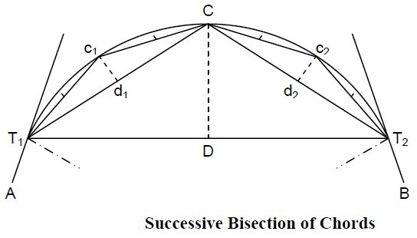

After locating T and T , the midpoint D of TT is obtained, by measuring T T .The
1 2 1 2 12
perpendicularoffsetDCissetoutatDwithanopticalsquareandpointCislocated.Measure
T C, and T C, and locate their midpoints d and d . The perpendicular offsets d c and d c are set
1 2 1 2 1 1 22
out at d and d , and the pointsc and c are established on the curve. The process is continued till
1 2 1 2
sufficient numbers of points on the curve are fixed.

Offsets from the Tangents

This method is used when the deflection angle and the radius of curvature both are comparatively small. In this method, the curve is set out by measuring offsets from the tangent. The offsets from the tangent can be either perpendicular or radial to thetangent.

Perpendicular Offsets Method
Let the point a be on the curve and the perpendicular offset from the tangent T1 to it at P be 0_{s}a . Let the distance of P from T1 be x_{a}. Draw a line Qa perpendicular to T1O, intersecting OT1 at Q.
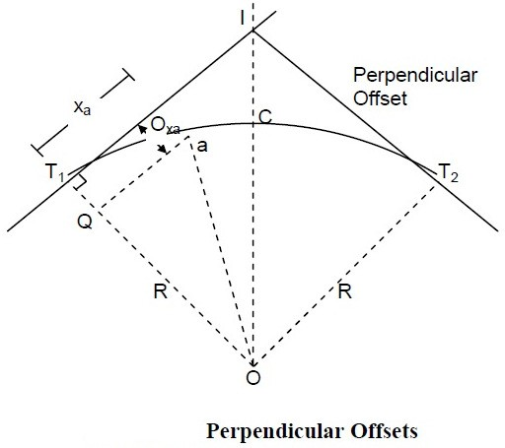
From O QaO
a
a

0Q = ƒ(0a)²− (Qa)²

R − 0_{s} = ƒR² − x_{a}²

R − 0_{s}= R − ƒR²− x_{a}²

In general 0_{s} = R − √R² − x²

Before setting out a curve, a table of offsets for different values of x (e.g., 10 m, 20 m, 30 m, etc.) is made. Then from T the distances x₁, x₂, x₃etc., are measured along the tangent andthe
1
corresponding offsets are measured on the perpendiculars to the tangent with the help of an optical square.
Since the offsets of points equidistant from T and T , are equal, the same table is used for offsets
1 2
from both the tangents.

Radial Offsets Method
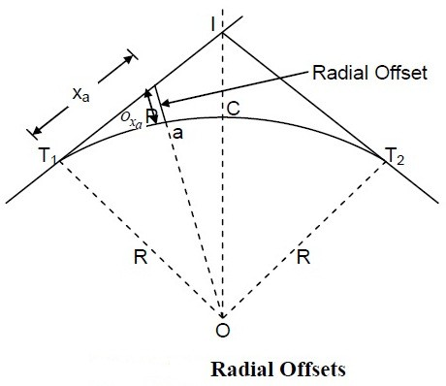
Let the radial offset to the point a on the curve be 0_{s}afrom the point P at a distance of x_{a}from
T .
1

From ∆ OPT
1

0P = ƒ(0T₁)²+ (T₁P)²

R + 0_{s}= ƒR²+ x_{a}²0_{s}= ƒR²+ x_{a}²− R
In general 0_{s} = √R² + x² − R
a
a

Offsets from the Chord Produced

The method has the advantage that not all the land between the tangents points T1 and T2 need be accessible. However to have reasonable accuracy the length of the chord chosen should not exceed R/20. The method has a drawback that error in locating is carried forward to other points. This method is based on the premise that for small chords, the chord length is small and approximately equal to the arc length.
For setting out the curve, it is divided into a number of chords normally 20 to 30 m in length. For the continuous chainage required along the curve, the two sub-chords are taken, one at the beginning and the other at the end of the curve. The first sub-chord length is such that a full number of chainage is obtained on the curve near T1 and the second sub-chord length near T2.

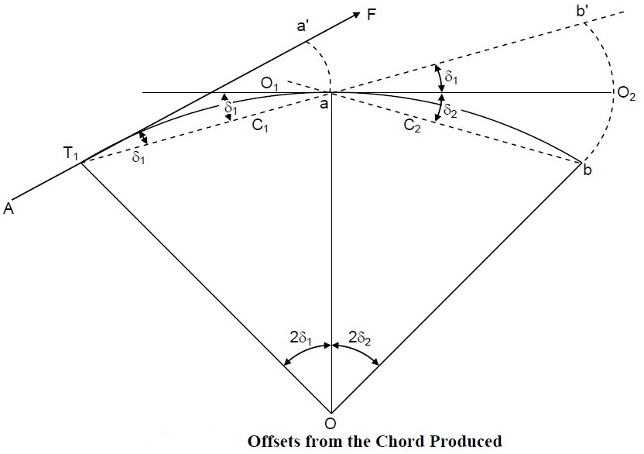
From the property of a circle, if the angle < FT₁a = ð₁
The angle at the centre< T₁0a = 2ð₁
C₁ = cℎordT₁a ≈ arc T₁a
= 2ð₁R

Or ð₁
=C1
2R

The first offset 0₁ = C₁ð₁

0 = C
C₁ C²
=
1

¹ ¹2R 2R

The first chord C is called the sub-chord. The length of the sub-chord is so adjusted that the chordlengthwhenaddedtothechainageofT makesthechainageofpointaasfullchain.
1
Subsequent chord lengths C₂,C₃,C₄ arefullchains.T₁aisthenproducedtob′suchthata
full chain ab′= C₂, a full chain. The second offset
0₂ = C₂(ð₁ + ð₂)
C₁ C₂
= C₂ (2R + 2R)
= C2 (C + C )

2R 1 2
Similarly 0 = C3(C + C)
3 2R 2 3

The last offset 0 = Cn(C
+ C )

n 2R
n–1 n

where C_{n–1}is a full chain and C_{n}is the last sub-chord which is normally less than one chain length.
`

Angular Method

Following are some of the angular method used to set out a simple circular curve :
- Tape and theodolitemethod
- Two theodolitemethod

- Tachometricmethod
- Total stationMethod

Tape and Theodolite Method
In this method, a tape is used for making linear measurements and a theodolite is used for making angular measurements. The curve can be set out by the following procedures:
Rankine’s Method
The method is known as Rankine’s method of tangential angle or the deflection angle method. The method is accurate and is used in railways and highways.
Let T ab be a part of a circular curve with T , the initial tangent point. Thus, T a is the first sub-
1 1 1
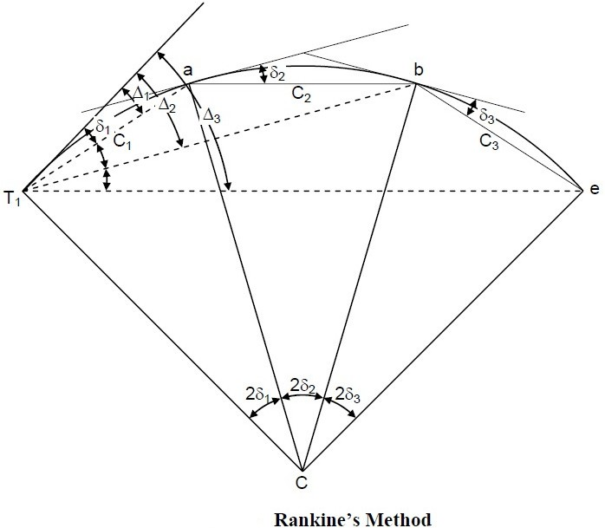
chord which is normally less than one chain length. From the property of a circle
C₁ = 2ð₁R
C₁
ð₁ = 2R radian
C₁ 180⁰
=
2R n

C₁180 × 60
=

ninutes

2R n
C₁

= 1718.87
R
ninutes

Therefore to locate the point a with the help of a theodolite and tape, the instrument isset
at T and the line of sight is put at an angle of δ = ∆ as computed above. Then with the help ofa
1 1 1
tape and ranging rod, the tape is put along the line of sight and distance C is then measured to
1
locate point a along the line of sight.

Similarly,
C₂
ð₂=1718.87Rninutes

Since the theodolite remains at T , b is sighted from T by measuring ð₁ + ð₂ = ∆₂from the
1 1
tangent line. The point b is located with the help of a tape and ranging rod. The tape with the ranging rod is so adjusted that the tape measures ab = C and the ranging rod lies along the line
2
of sight T b
1

Similarly,

∆₃= ð₁ + ð₂ + ð₃ = ∆₂ + ð₃

∆_{n}= ð₁ + ð₂ + ð₃ + … … … + ð_{n} = ∆_{n–1} + ð_{n}
In practice, C is the first sub-chord and C the last sub-chord.
1 n

C₂ = C₃ = ⋯ = C_{n–1}are full chain lengths. As a check the deflection angle ∆_{n}for the last point
T ∆
₂is equal to 2 where ∆ is the angle of intersection.

Field Problems in Setting Out the Circular Curves
The following are some of the field problems in setting out the circular curves.
- Point of curveinaccessible.
- Point of tangencyinaccessible.
- Point of intersectioninaccessible.
- Curve tangential to threelines.
- Both point of commencement and point of intersectioninaccessible

Point of intersection inaccessible
If the point of intersection P.I. is inaccessible then to set out a curve, the following procedure is followed : First locate points P and Q on IT and IT respectively, then measure angles α and β
1 2
with the theodolite and length PQ with a tape .

Then
IP

cinþ
=PQ
cin∆

Or IP=
PQcinþ cin∆

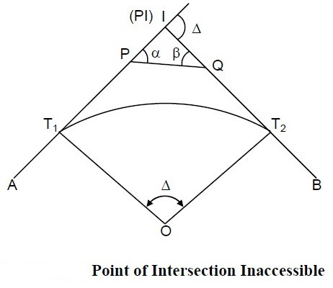
Similarly
9

IQ=
PQsinα sin∆

Calculate PT₁ = IT₁ − IP QT₂ = IT₂ − IQ
Thus, T and T can be located from P and Q respectively and the curve can be plotted from T.
1 2 1

TRANSITION CURVE

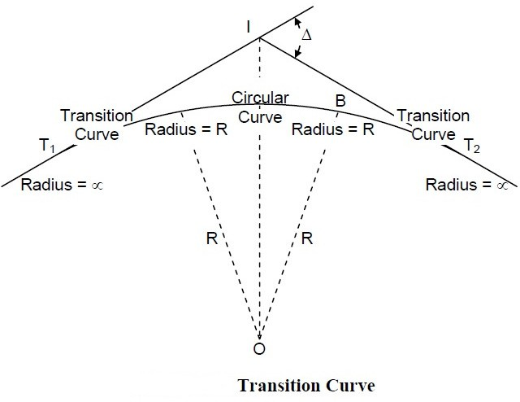
A transition or easement curve is a curve of a varying radius introduced between a straight and a circular curve, or between branches of a compound curve or reverse curve. The introduction of a transition curve between the straight and the circular arc, as indicated in Figure below, permits the gradual elevation of the outer edge or gradual introduction of cant or super-elevation (raising the outer edge over the inner). At the same time, it also permits gradual change of direction from straight to the circular curve and vice-versa.

On a straight track, its two edges are at the same level. On a circular arc the outer edge is elevated depending on the radius of the curve and the speed to the vehicles expected, to avoid over turning of the vehicles due to centrifugal force acting on them while moving on circular path. Also, there is an abrupt change in direction when the alignment changes from straight to circular curve and vice-versa.
In railways, such a curve is provided on bothsidesofacircularcurvetominimise
super-elevation. Excessive super-elevation may cause wear and tear of the rail section and discomfort to passengers.

Advantages of a Transition Curve
The introduction of a transition curve between a straight and a circular curve has the following advantages :
- The chances of overturning of the vehicles and the derailment of trains are reduced considerably.
- It provides comfort to the passengers on vehicles while negotiating acurve.
- The super-elevation is introduced gradually in proportion to the rate of change ofcurvature.
- It permits higher speeds atcurves.

- It reduces the wear on the runninggears

Characteristics of a Transition Curve
- It should be tangential to thestraight.
- It should meet the circular curvetangentially.
- Its curvature should be zero at the origin ontangent.

- Its curvature should be equal to that of the circular curve at the junction with thecircular curve.
- The rate of change of curvature from zero to the radius of the circular curve should be the same as that of increase of cant orsuper-elevation.
- The length of the transition curve should be such that full cant or super-elevation is attained at the junction with the circularcurve.

CHAPTER-7

SETTING OUT WORKS

Using different method of surveying, data are obtained about the ground features that are represented in maps and plans of the ground. Such drawings are prepared of various elements of the project.
Marking the outlines of excavation on the ground for the guidance of the contractor and labour is defined as setting out of works .
  - On completion of the estimates from the approved plan excavation for the foundation is required to be made on theground.
  - In order to minimizes the cost of digging foundation trenches out lines of excavation stakes should accuratelymarked.

( i )Buildings:
To set out the building following materials are required

- A foundation plan is prepared marking the centre lines and excavation width to facilitate setting out onground.
- Depending upon the method used, the instruments areselected.
- For important buildings, a theodolite, tape, a cord to stretch, and marking powder, such as lime
There are two methods of setting out of building

- Circumscribing rectanglemethod
- Centre linemethod

(a ) Circumscribing rectangle method :

The procedure for the circumscribing rectangle method is as follows:

- Established control points A and B near the structure but at sufficiently large distance such that are not disturbed during theexcavation.
- Erect perpendiculars at A and B to get points C and D of sufficient length so that they are away from the excavation limits. This can be done with a tape alone using the 3-4-5 principle, or more accurately using a prismatic compass ortheodolite.
- Check the rectangle set out by measuring the diagonals AC and BD, which should equal to their calculatedlengths.
- Correct any error proceedingfurther.
- The centre lines of the four walls of the building from the rectangle EFGH, Locate the four corners from the respective corners ofABCD.

- Check the lengths of this sides and the diagonals ofEFGH.
- Set temporary stakes at points E, F, G, and H and mark these points with anail.
- Tie cord between the nails and mark the centre line with dry limepowder.
- Mark the inner and outer boundaries of the foundation widths in the sameway.
- Again mark the four corners of these rectangles with temporary stakes. Note that these stakes will go away once the excavationstarts.
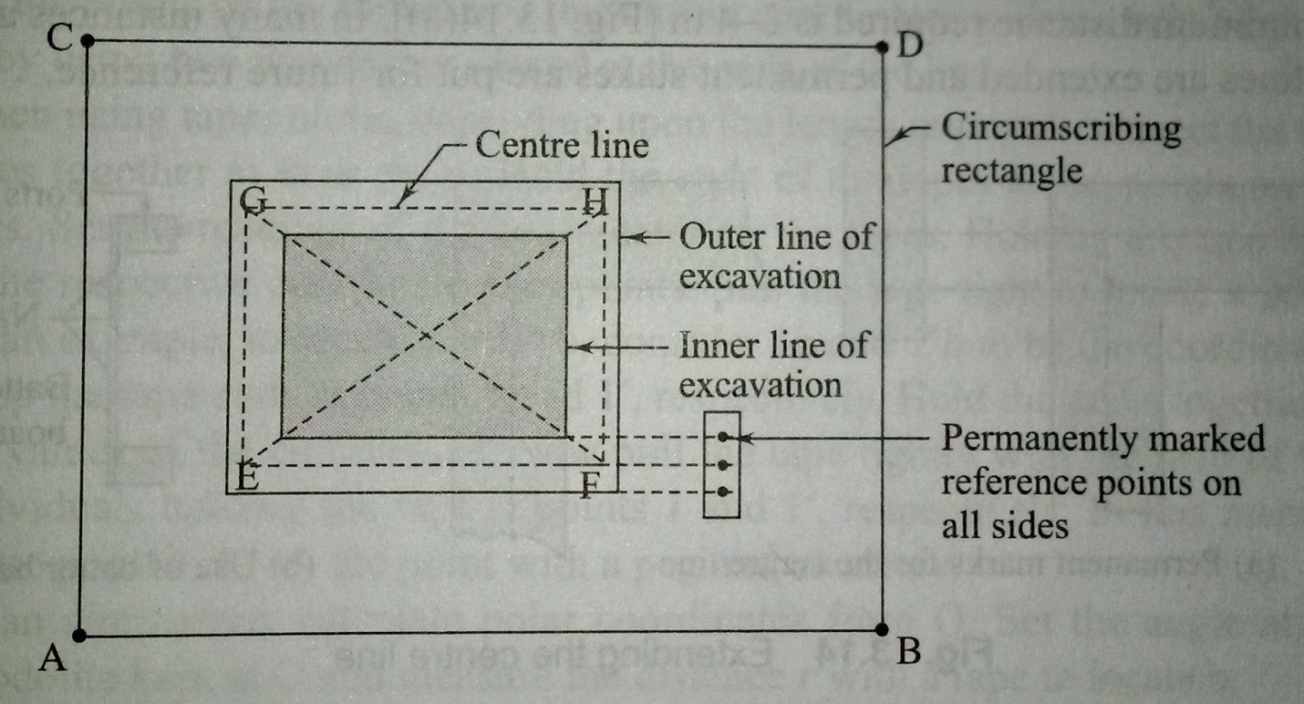
Fig. Circumscribing rectangle method

( b) Centre lines method :

- In the centre lines of the four walls of the building can be used as a referencerectangle.
- The corners of the centre line are accurately set out with respect to the control points near thesite.

- In many instances all the three lines are extended and permanent stakes are put for future reference.
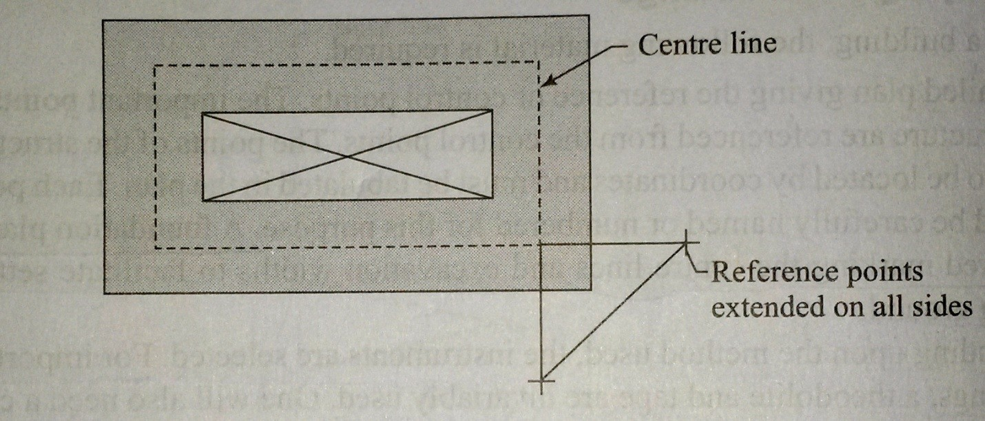
Fig. Centre line method

Setting Out Culverts

For setting out of Culvert foundations, abutments, and wing coordinates of a number of points on the lines are required. For this purpose, the origin is selected at the intersection of the centre lines of a waterway or a road or railway line passing overit.
The following procedure is adopted.

- From the foundation plan of the culvert and the roadways, locate the two centre lines A0A’ and B0B’ where 0 being the origin as shown infig.
- Locate these centre lines, from the control points available, near the sitescoordinates.
- Check and verify that these two lines are at rightangles.
- Drive a peg at 0 and mark itcarefully.
- Set up a theodolite at 0, centre and levelit.
- Set up a number of points along both the lines. Assume that 1, 2, 3, 4, etc. are the points along A0A’ and 1’, 2’, 3’, 4’, etc, are the points alongB0B’.
- Mark the points with pegs and arrows such that a cord tied along the arrows defines the lines and the points marked onthem.

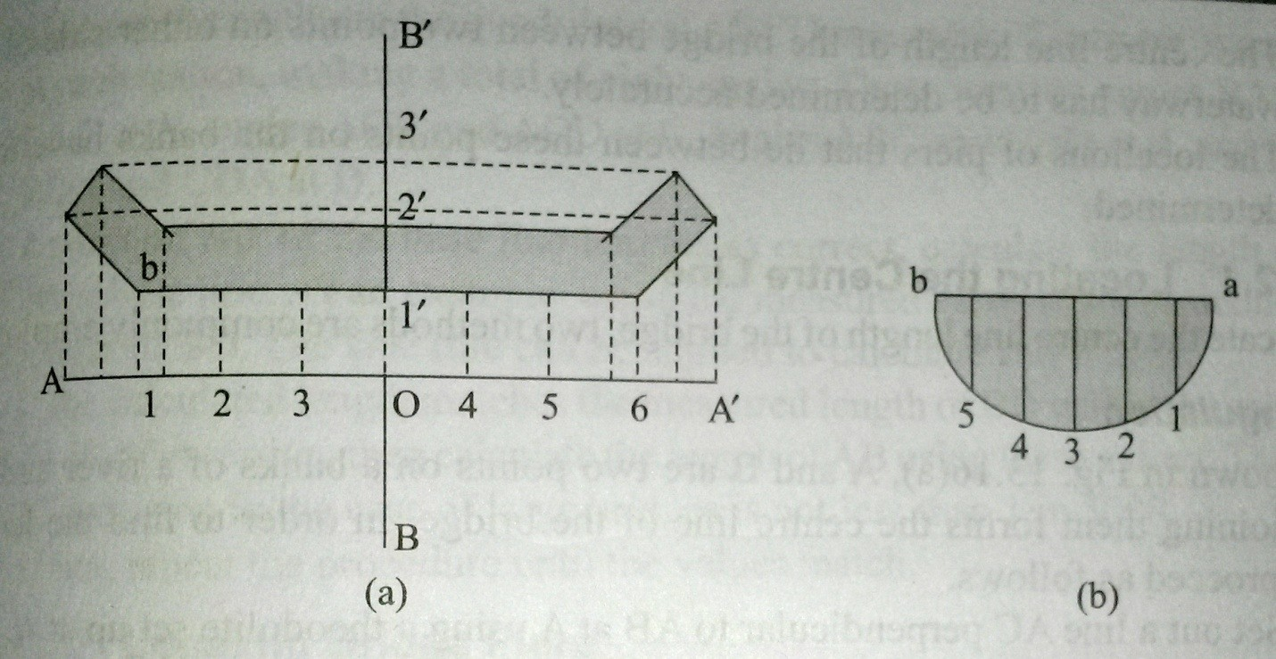

Setting out a culvert

- Set the points on the foundation lines using coordinates with the help of a tape or by using two theodolite placed at the ends of thelines.
- When using tapes alone, depending upon the length required, connect the two tapes together at their rings. Hold the ends of the tapes at the points on the axes. Set the readings of the coordinates on the tapes. Holding the tape ends at the respective coordinate axes points, pull the tight to locate a point. As an example, to locate a point b, consider 1b and 1’b to be the coordinates. Keep the tape ends at points 1 and 1’ respectively, Hold the tapes together at the values of the coordinates. Now pull the tape tightly with help of two individuals holding the tape at points 1 and 1’, respectively. In this manner, locate point b. mark the point with a peg and anarrow.
- As an alternative, calculate polar coordinates from 0. Set the angle at the theodolite kept at 0 and measure the distance ‘r’ with a tape to locateb.
- Once all the points a, b, c, d, etc, are located, tie a string around the pointslocated.
- Make a mark along the string with dry lime powder or make a line bynicking.
- In case any of the walls have a curved outline, locate the end points first. Then locate the curved boundary by using coordinates from the chord of the curve. As shown infig….

CHAPTER -8

COMPUTATION OFVOLUME

Areas of Cross Sections

The common cross section one comes across in practice are shown in figures. The following symbols will be used to indicate the various parameters of the area.
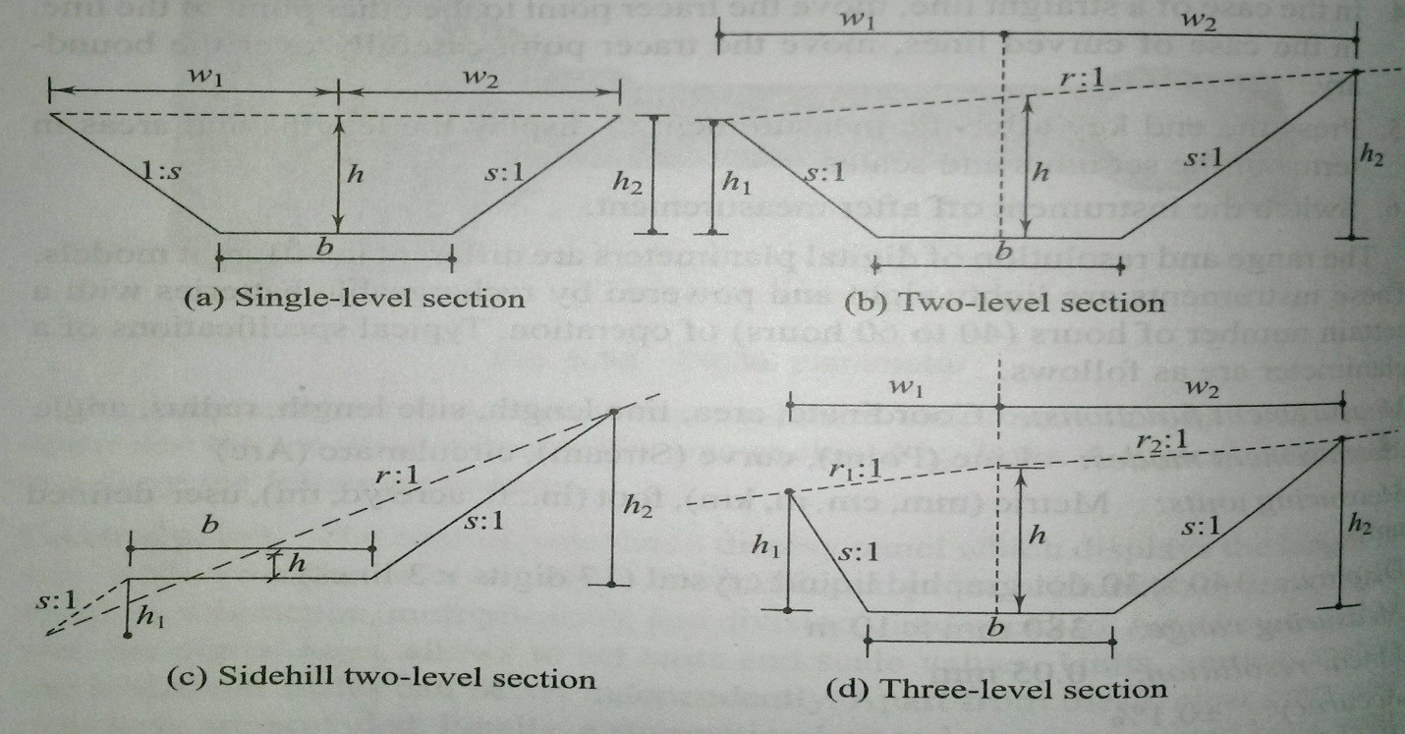
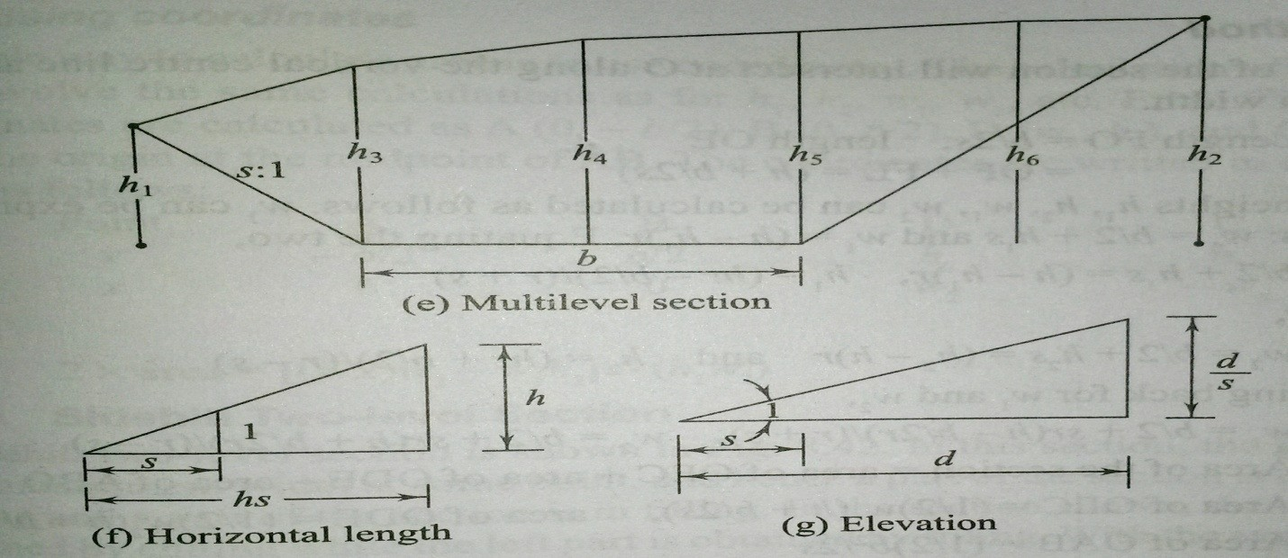

Fig

Formation width (width at formation level): It is the width of the sub-grade (b).

Depth: It is the depth of cutting or filling at the centre line (h).

Cut being denoted by a plus(+) sign and fil by a minus(-) sign.

Half-breadth: This is the horizontal distance from the centre to the intersection of the original ground
with the side slopes (d₁ and d₂).
Side slope: s to 1 is the side slope, s horizontal to vertical [i.e., the ground rises (or falls) by 1 m over a
horizontal length length of s meters].
Transverse slope: n to 1 is the transverse slope of the ground, n horizontal to 1 vertical [ i.e., the ground
rises (or falls) by 1 m over a horizontal length of n metres.
Side heights: h₁ and h₂ are the heights from the formation level to the side slope with the ground.

The following points must be clearly understood in dealing with slopes.

If s:1 is the slope given, then for a given height h, the horizontal distance = hs.
If s:1 is the slope given and the horizontal distance is d, then the vertical distance is given by d/s.

Method of Computation for different types of crosssections:

The area of each of these cross sections can be calculated as follows.

Single – level Section

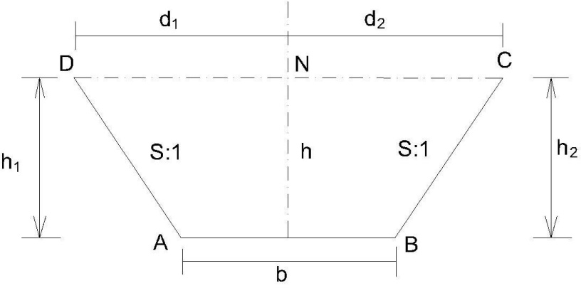

A single – level section may be formed by cutting or filling. In this type cross section the ground is assumed to be level transversely i.e the value of n approach to infinity. In this section, AB is the sub grade of width b, d₁ and d₂ are half-widths – equal in this section, and h₁ and h₂ are end heights – equal to h, the height at midsection. Therefore, d₁=d₂= b/2 + sh, h₁= h₂=h,

Area of the section = (

1
) [2Xhalf breadth + b] X h=
2
b
[ 2(2 + ch)+b ]

2
=bh+sh²

Two-level Section[
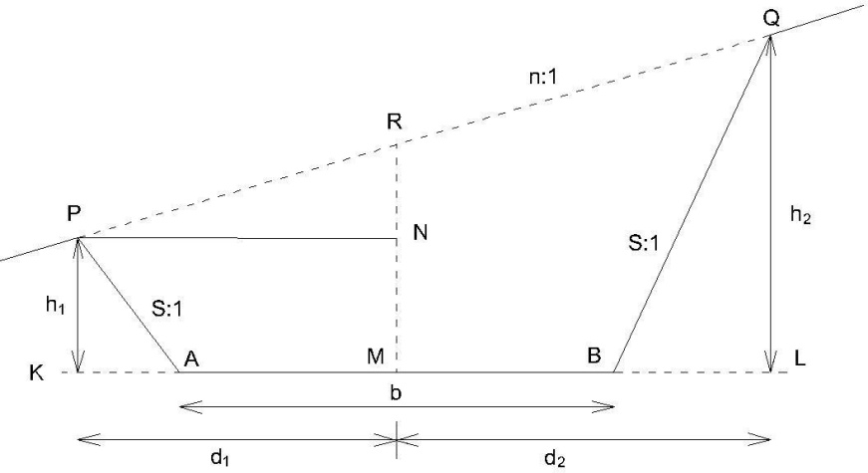

In two level section the top level is not horizontal and the original ground has a slope of n:1. The two end heights, h₁ and h₂, are not equal.

Area of the cross section=
d1d2 b2
–
c 4c
b
Where d₁= ( h +
2c
nc
)( )
n+c

Three Level sections:
b
d₂ = ( h +
2c
nc
)( )
n–c

Assume that transverse slope of the natural ground is not uniform. Let it be n₁ to 1 and n₂ to 1on either side of the central line. ( as shown inFig)

Area of the section =(d₁+d₂) –[ Where D is total top width.
b2 + h ]- b2 =
4c 2 4c

^{D} [ h+ b ] - b2 2 2c 4c

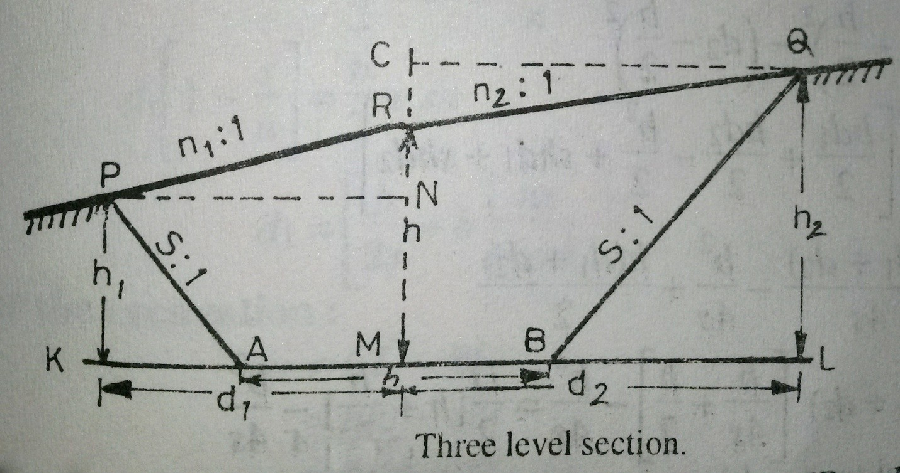

Side hill two levelsection.

In this cases, the ground slopes transversely and the slope of the ground surface cuts the formation level in such a way that one portion of the area is in cutting and the other portion is in embankment i.e. the section consists of two parts one in cutting and the other in filling.
In general two cases may arise.

  - When the centre line of the formation is inexcavation.
  - When the centre line of the formation is inembankment.

(i ) When centre line of the formation is in excavation:
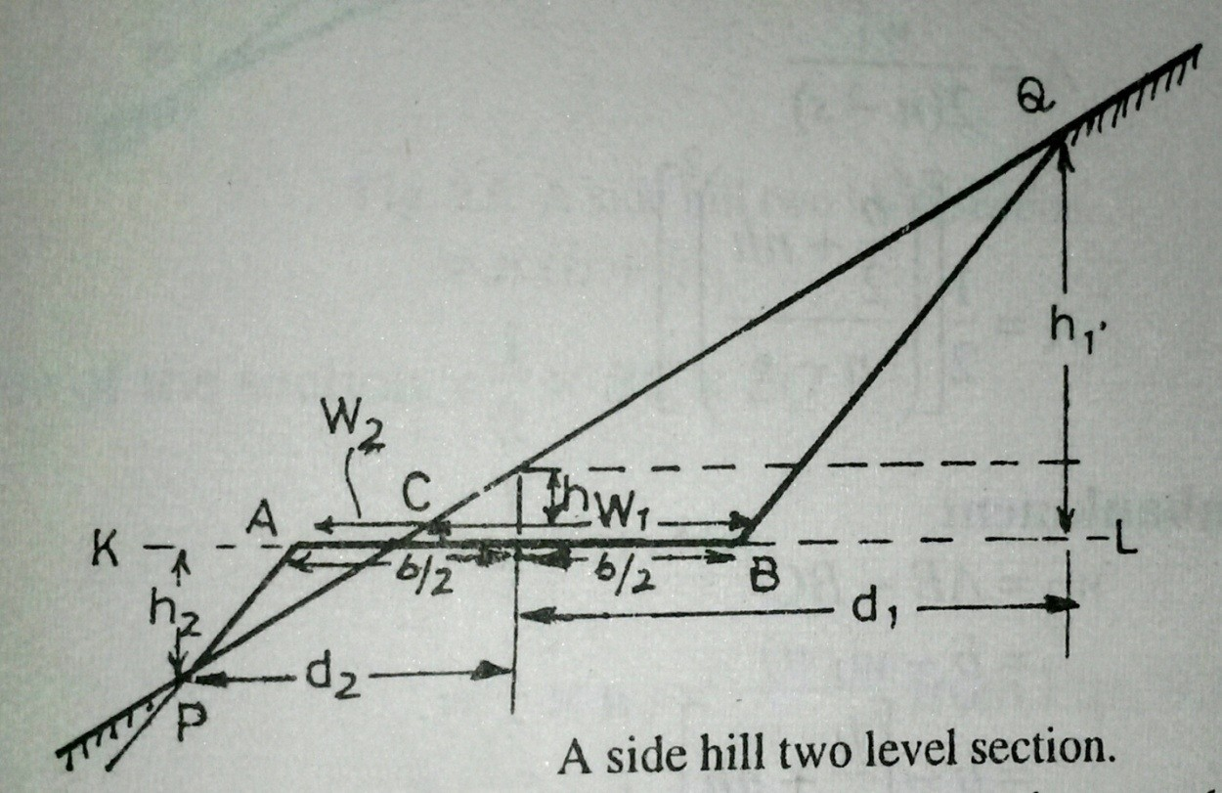
( a ) For the excavation :

w₁= CL – BL= nh₁ – sh₁= h₁ (n-s)

Or h₁₌
w1 n–c

Area in excavation = triangular area BCQ

1
A= x BC x QL=
2

1
X w₁X h₁₌
2
- b+nh
[(² )²]
- n–s

For theembankment
W2=AB-BC = b-w1= b-[b
2
b

b
+ nh] =
2
nc

-nh

And d2 =(
–h )(
2c
)
n–c

Area in embankment = triangular area ACP

=1/2 X w₂X h₂

    - b–nh
₌[(² )²]
    - n–s

( ii )When centre line of the formation is in embankment.

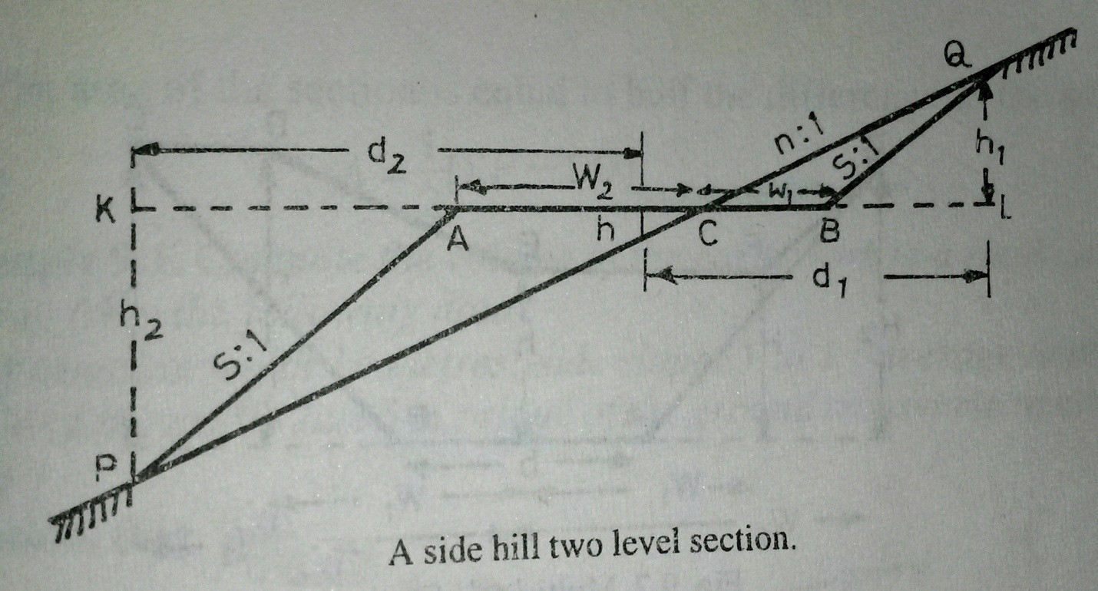
- Forexcavation
w₁ = nh₁ – sh₁= (n-s) h₁ d₁ = nh₁ + nh
= n (h + h₁)
Area of the section =1/2x BC x LQ =1/2 x w₁ x h₁
(w1)2
=
2(n–c)
For embankment
w₂ = b – w₁
b

w₂ =
2
b
d₂ =
2
+nh
+sh₂

Area of the section = ½ x w₂ x h₂

w2
But h₂ =
n–c

(w2)2
A=
2(n–c)

- Multi-Level Section : In this case, spot levels and their distances from the central line, are usually recorded as shown inTable
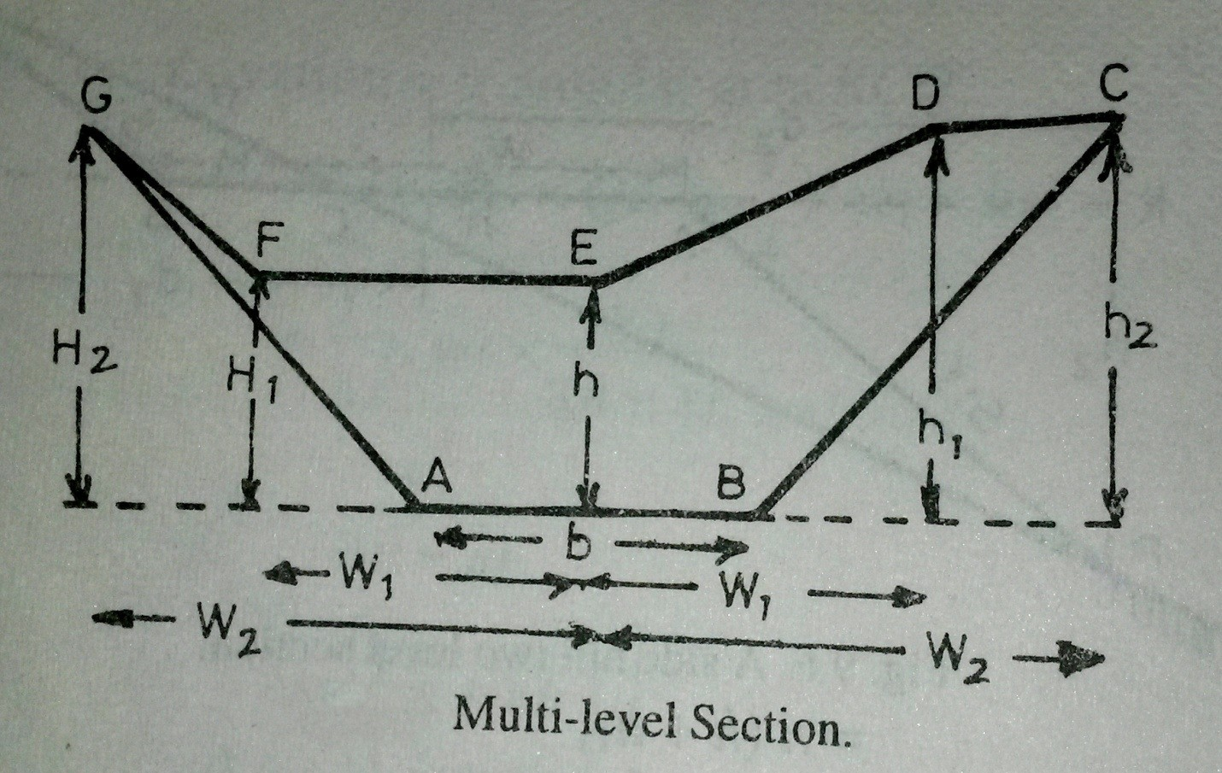
Table

Left |  | Centre | Right
±H2  W2 | ±H1  W1 | ±ℎ  0 | ±ℎ1  W1 | ±ℎ2  W2

In Table numerators of the fractions denote the amount of cutting (+ve) and filling
(- ve) at the various points whereas the denominators denote their horizontal distances from the centre line of the section.
Assuming the formation level AB as x axis and OE, the perpendicular bisector of AB as the Y axis, these notes may be considered as x and y coordinates of each point of the section. The area of the cross-section may then be computed by the method of coordinates. The points A,B.C,D,E,F,G may be written irrespective of their signs in the form of a determinant.

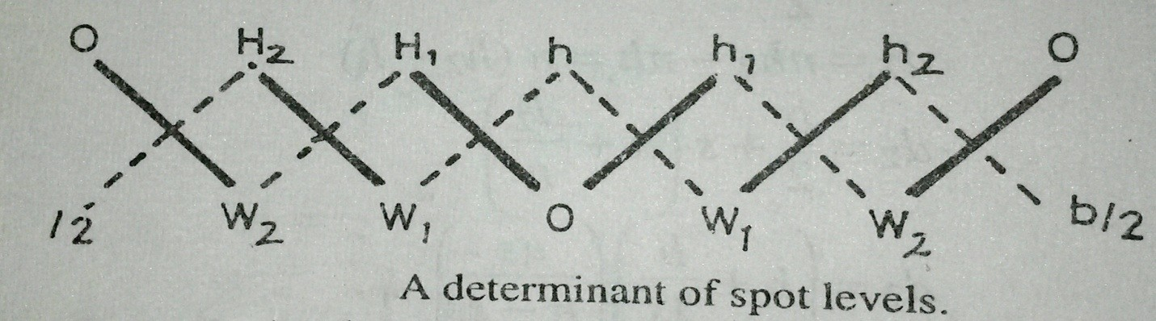

For preparation of the determinant, start from the centre and proceed to the right and to
the left.

For calculation of the area, proceed as under :

- Findthesumoftheproductsoftheco-ordinatesJoinedbyfulllinesanddenotedby∑F
i.e. ∑ F =OH₁+ W₁H₂+W₂O+ Oh₁ +w₁h₂ +w₂O
- Find the sum of the products of the coordinates Joined by dotted lines and denoted by∑D

i.e. ∑ D =hW₁+H₁W₂+H₂
b
2
b
+hw₁+h₁w₂+h₂
2

- The area of the section is equal to half the difference of the sums.i.e.
1

Area =
[ ∑ F -∑ D ]
2

Example 1. Compute the volume of the earth work in a road cutting 50 metres long from the following date :
The formation width 10 metres; side slopes 1 to 1 ; average depth of the cutting along the centre line 5 m ; slope of the ground transverse to cross-section 10 to 1.
Solution. (Fig.9.9)

The cross-sectional area in terms of d₁,d₂ and s is given by

A= Area of the cross section =
d1d2 c
(b)2
–
4c

b
Where d₁= ( h +
2c
nc
)( )
n+c

b
d₂ = ( h +
2c
nc
)( )
n–c

Here h=5m,b=10m,s=1n=10

hence d₁=
100

11
nandd₂=
100n
9

100
A=
11
100
x
9
(10)2
-
4s1
=76.01 sq.m

The required volume in cutting = A x L =76.01 X 50= 3800.05 cubic metres

Calculation ofvolumes:

The volume of the earth work between-cross sections taken along a route, may be calculated by one of the following methods:

    - Prismoidalformula 2. Trapezoidal formula (End areaformula)

Prismoidalformula.
A Prismoid is a solid bounded by planes of which two, . Called end faces, are parallel. The end faces may be both polygons, not necessarily similar or with the same number of sides, one of them may even be a point. The other faces, called the longitudinal faces are planes extending between the endplanes.
Statement of the formula : “The volume of a prismoid is equal to the sum of the areas of end parallel faces plus four times the area of the central section, and multiplied by 1/6the of the perpendicular distance between the endsections.
Let A1, A2, A3,……. An be areas of cross-sections and D is the distance between consecutive sections.

Volume ( V ) =
=
D
[ A₁+ 4A₂+ 2A₃+4A₄ +……+A_{n} ]
3
D
[ A₁+ A_{n} + 2∑ odds + 4∑ evens ]
3

=[area of the first section + area of the last section
+ 2 times area of remaining odd sections
+4 times area of remaining even sections].

It is sometimes known as the Simpson’s rule for volume.

Note : The following points may be noted.
  - In order to apply the prismoidal formula for volumes, number of cross-sections should always beodd.
  - If there is even number of cross-sections, one of them (preferably the last one) may be treated separately and the volume of the remaining length of the route may be computed by the prismoidalformula.
  - The volume of the last section may be calculated by the trapezoidal rule or prismoidalformula.

Trapezoidal formula(End area formula):
While calculating volumes by the end area formula , it is assumed that volume of a prismoid, is equal to the product of the length of the prismoid by the average of the endareas.

i.e. V = L X
Æ1+Æ2 2

where = V= Volume of theprismoid
A₁= Area of one end section A₂ = Area of other end section
L= distance between the sections. For a series of cross sections, the Eqn. may be simplified as
L
V= [ A₁+ 2A₂+ 2A₃+…..2A_{n-1} +A_{n}]
2
Æ1+Æ2

V = L [
2
+ A₂ + A₃ +…..+ A_{n-1} ]

Prismoldal Correction:

The volume obtained by the end area formula is not as accurate as obtained by the prismoidal formula. The accuracy of the result obtained by the end area formula may be increased by applying a correction called, the prismoidal correction. As the volume of any prismoid calculated by the end area formula is somewhat larger than that obtained by the prismoidal formula, hence prismoidal correction is always negative.
Prismoidal Correction (P.C.)
= volume by the end area formula – volume by the prismoidal formula.

L
i.e. P.C. =
2
L
( A₁+ A₂) -
6
(A₁+4Am +A₂ )=
L
( A₁+ A₂-2Am)
3

c(h1+h2)
where A₁ =( b+sh₁)h₁, A₂ ==( b+sh₂)h₂, Am = [b+
2
h1+h2
] ( )
2

substituting the values
P.C.= L s(h1 − h2)²
6

Curvature correction for volumes:

The formulae obtained for the earth work calculation are based on the assumptions that the sections are parallel to each other and normal to the centre line. But, on curves the cross-sections are run in radial lines and consequently the earth solids between them do not have parallel faces. Therefore, the volumes computed by the usual methods, assuming the end faces parallel, require a correction for the curvature of the central line. The calculation of the volumes along the curved line is made by the Pappu’s theorem.

Pappu’s Theorem. It states that the volume swept by a constant area rotating about a fixed axis is equalto the product of that area and the length of the path traced by the centroid of the area.”
Let e₁ = distance of centroid of area A1 from the centre line. e₂ = distance of centroid of area A2 from the centreline.
= mean distance of the areas A1 and A2 from the centre line. L= distance between two curved centre lines.
R= radius of the curved central line Applying Pappu’s theorem of volume,

The Curvature correction = (
d2–d1 2
b
) ( h+
2c
L
) (d2+d1)
3R

The correction is positive or negative according to whether greater half breadth is on he convex or concave side of the curves.
The following points may be noted :

- The Equation for the curvature correction is applicable on the station on the curve and for each tangent point with he station, half the station correction is applied.
- The formula for a three level section is equally applicable to a two level section.
- The curvature correction for a level section iszero
- The curvature correction for the cutting in a side hill two level sectionis
Lwh
( d + b- w)
6R

Measurement of Volumes from SpotLevels:

- Whenever earth work is required for large excavations, the site is divided into triangles, squares or rectangles of equal area of convenientsize.
- The depths of cuttings at the corners of these geometrical figures are obtained by finding the difference in levels between the original and proposed ground surfaces.
- These differences in level may be regarded as the length of the sides of a number of vertical truncated prisms of which areas of horizontal base areknown.
The volume of each prism may be obtained by the product of the area of the right section multiplied by the average height of the vertical edges.

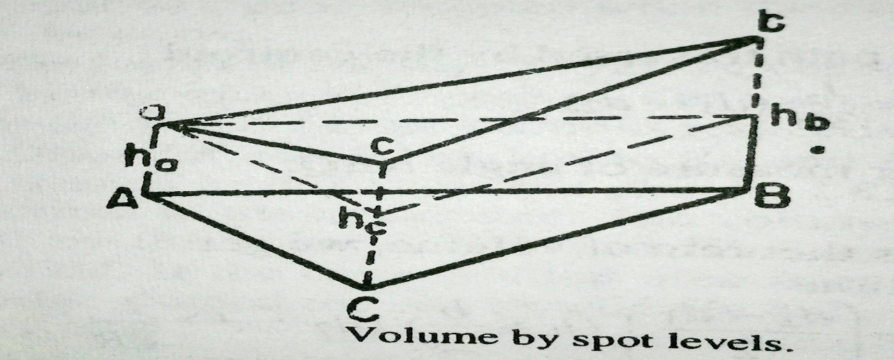

The volume of the truncated triangular prism.

= A (
ha+hb+hc
)
3

and similarly the volume of a truncated rectangularprism

= A (
ha+hb+hc+hd
)
4

Total volume of any excavation which may consist of a number of prisms, having the same cross-section, may be computed as follow.
- Multiply each corner height by the number of times it is used i.e. the number of prisms in which itoccurs.
- Add the products and divide the sum by4.

i.e. H =(
Σ h1+2 Σ h2+3 Σ h3+4 Σ h4
)
4

where Σ ℎ1 = sum of the heights used once.
Σℎ2= sum of he heights used twice.
Σ ℎ3= sum of the heights used thrice.
Σ ℎ4= sum of the heights used four times.
- The total volume V = horizontal area of the cross-section of one prism x H. i,e V= A xH

Calculation of reservoir capacities:

  - The capacity of a reservoir may be easily found out with the help of a contour map.
  - The area enclosed by each contour line is measured by aplanimeter
  - When the finished surface of the ground is horizontal, it becomes parallel to the surface defined by the contourline
  - The area bounded by each contour will be treated as the area of the cross-sections and the vertical contour interval will be taken as the distance between the adjacent cross-sections
  - Calculation of the volume may be done either by the Prismodial formula or by the Trapezoidalformula
  - Cubic contents between successive contours when added together give the required capacity of thereservoir
  - While applying the prismoidal formula, every second contour area is treated as the area ofmid-section,

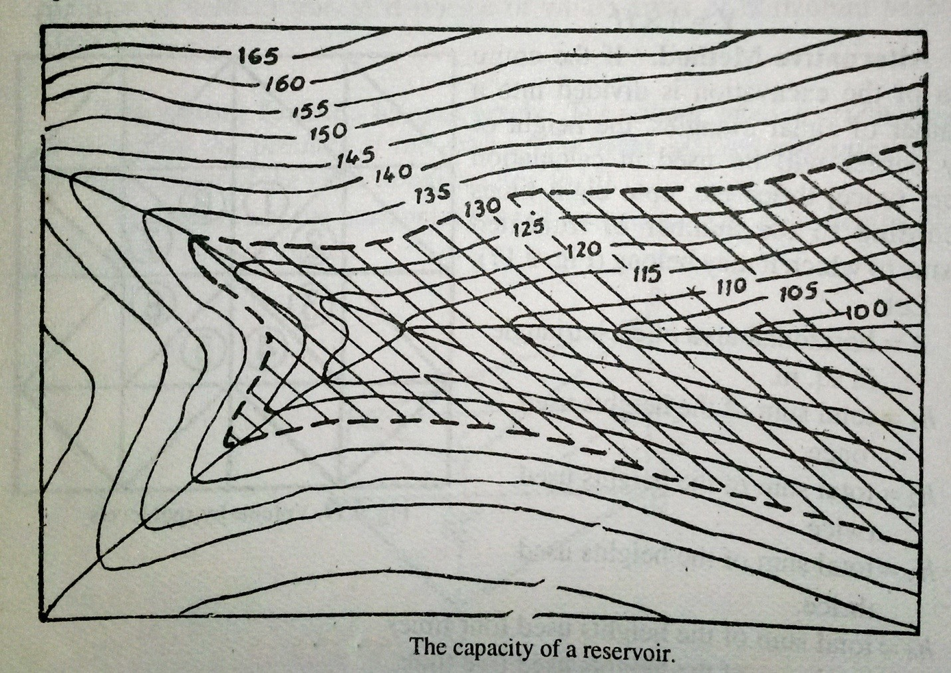

Trapezoidal formula :
Æ1+Æ2

V= L [
2
+ A₂ + A₃ +…..+ A_{n-1} ]

Prismoidal formula :
D
V = [ A₁+ A_{n} + 2∑ odds + 4∑ evens
3

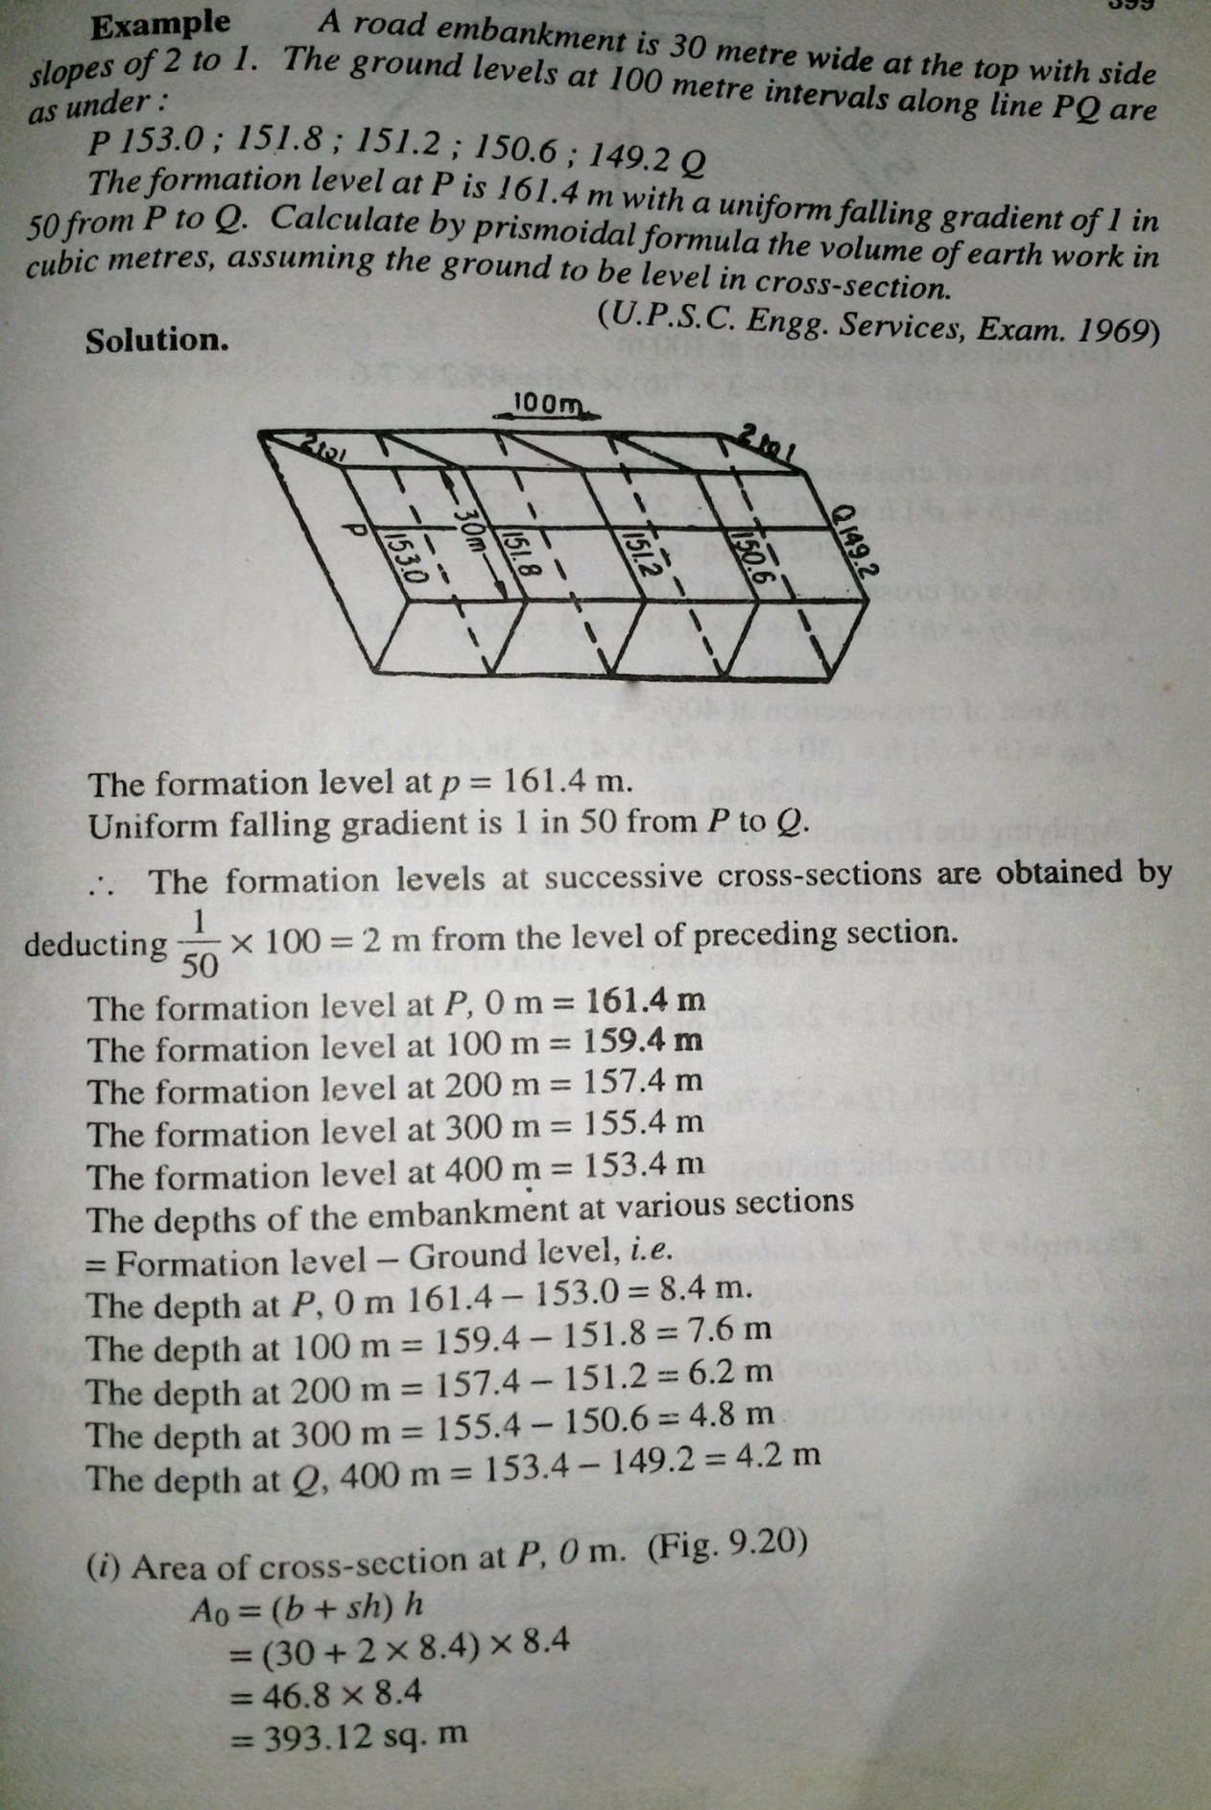

114

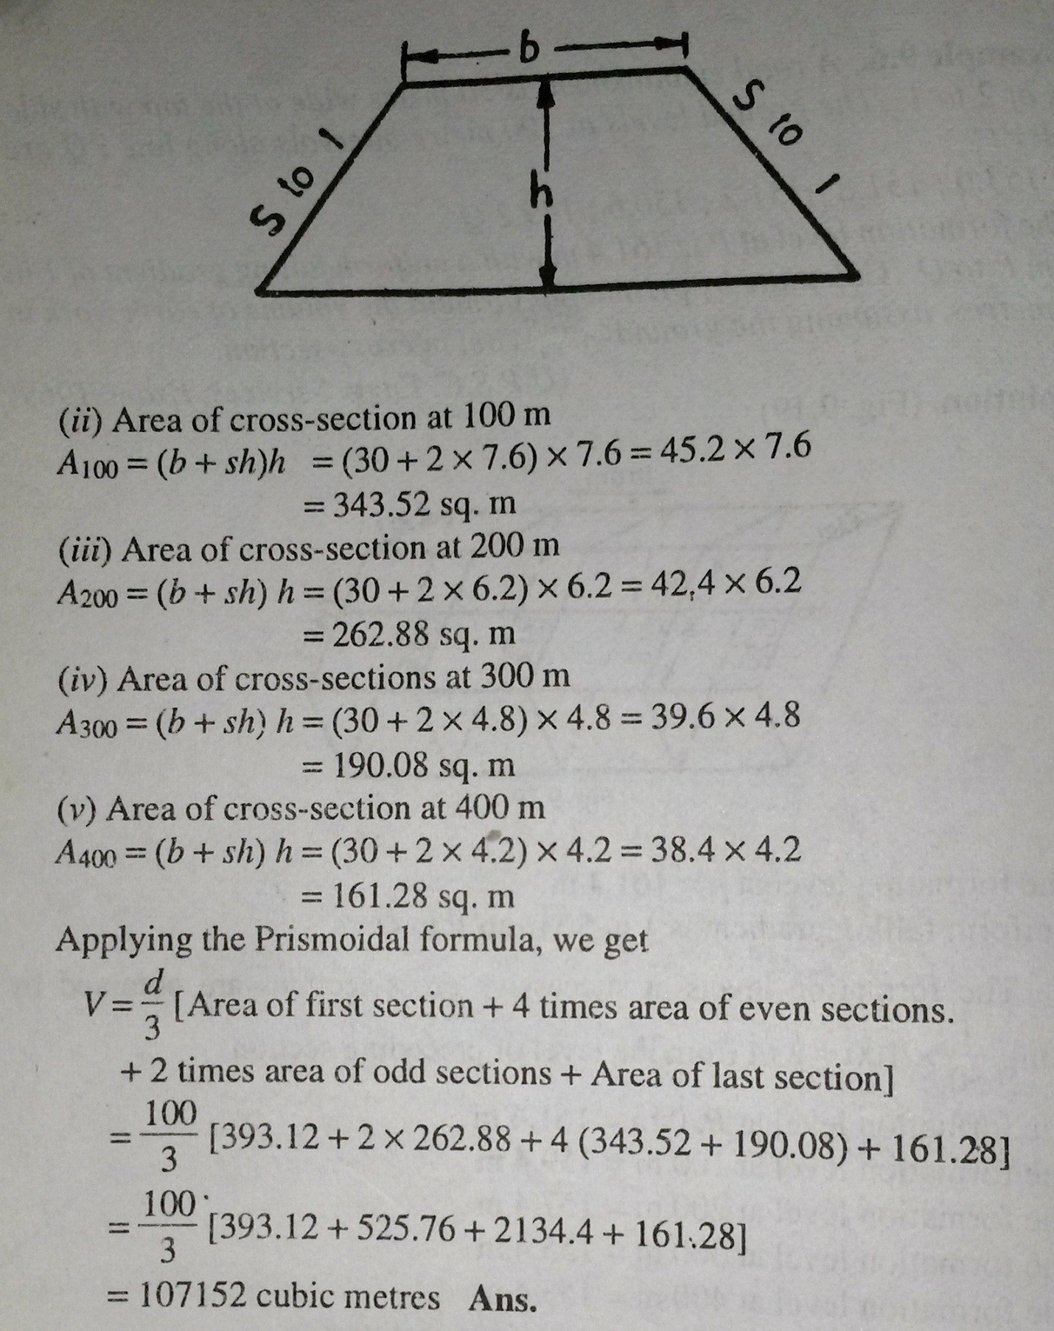

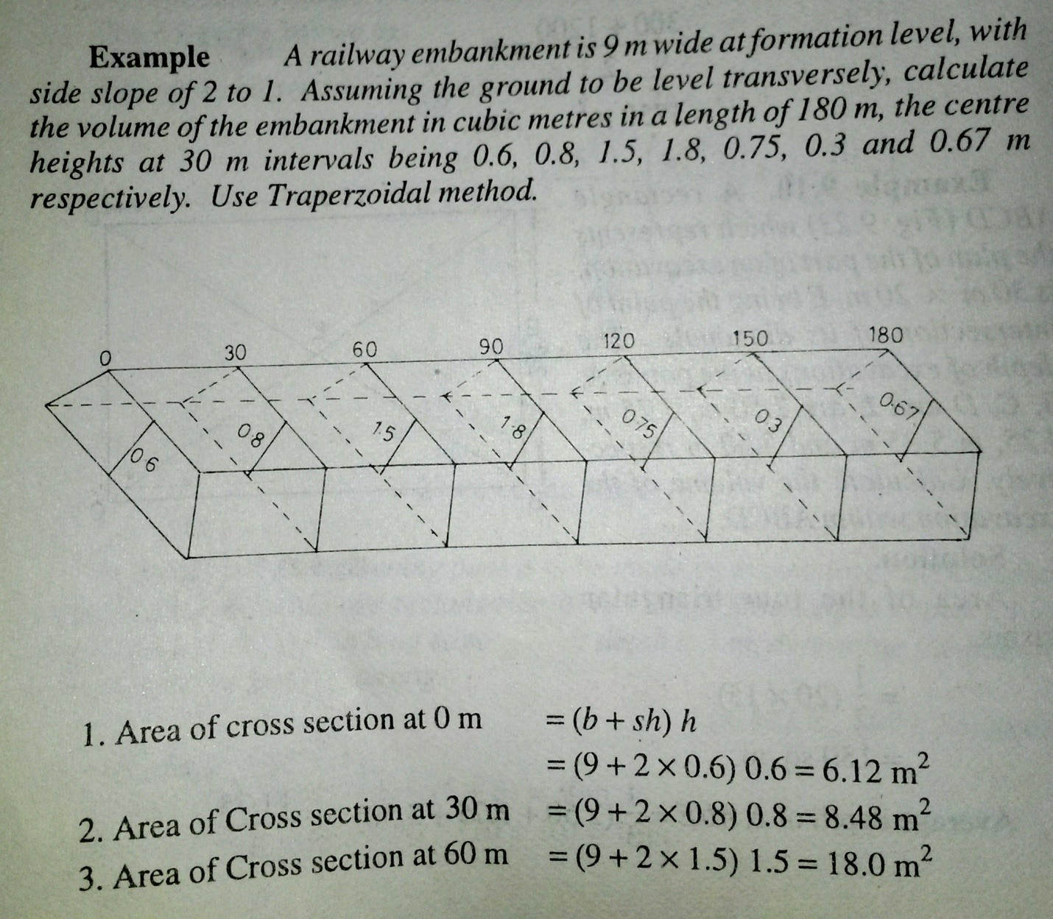

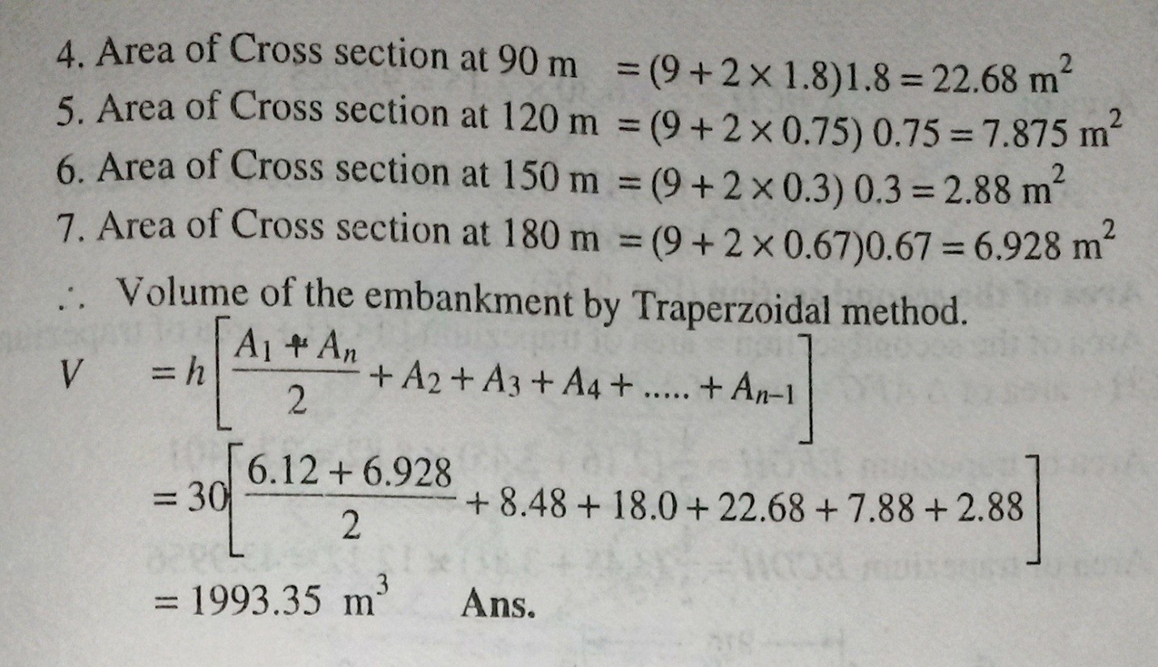

MassDiagram:

    - Mass haul diagram used for ascertaining in advance, proper distribution of excavated material and the amount of waste and borrow required for the estimation ofcost.,
    - It is a curve plotted on a distance base, the ordinate at any point of which represents the algebraic sum of the volumes of cuttings and fillings from the starting point of the earth work to thatpoint.
    - In plotting a mass diagram, cuttings are assumed as positive and the fillings as negative.
    - If cuttings and fillings are on the same length of the longitudinal section, as in hill side road, their difference only is used in the algebraic summations, the sign of the greater volume is accepted in thecomputation.

The definitions of important terms are listed below.

- Haul distance. It is the distance at any time between the working face of an excavation and the tip end of the embankment formed from the hauledmaterial.
- Average haul distance. It is the distance between the centre to gravity of a cutting and center of gravity offilling.

- Haul. . It is the sum of the products of the each volume by its haul distance i.e .Σ v . d = VD, where V is the total volume of an excavation and D is the average hauldistance.
- Free haul distance. It is the specified distance in terms of contracts, up to which the excavated material, is transported regardless to the hauldistance.
- Over haul distance. If the excavated material from a cutting has to be moved to a greater distance than the free haul distance, the extra distance is known as over hauldistance.
- Balancing line. Any horizontal line drawn on the curve balances the volumes of cutting and filling because, there is no difference in aggregate volume between the two points, such a line is known as, a balancing line, i,e MN inFig

Construction of a Mass Diagram
The following steps are followed for the construction of a Mass Dagram:
  - Divide the length of the road or railway in separate sections of convenient distances.
  - Calculate the volumes of the earth work for eachsection.
  - Plot a longitudinal section of each section of the road on a convenientscale.
  - Plot the volumes as ordinates and distances between the sections which are kept same, as the longitudinalsection.
  - Plot the positive volumes above the base line and the negative volumes below the baseline.
  - Join the ends of the adjacent ordinates by a smooth curve to obtain the required massdiagram.

Characteristic of a Mass Diagram

- If the slope of the curve in the direction of the increasing abscissa is upward, it indicates an excavatedsection.
- If the slope of the curve in the direction of the increasing abscissa is downward it indicates anembankment.
- The vertical distance between a maximum ordinate and the next forward minimum ordinate represents the whole volume of afilling.
- The vertical distance between a minimum ordinate and thenext forward maximum ordinate, represents the whole volume of acutting.
- The vertical distance between two points on the curve which has neither a maximum nor a minimum point, represents the volume of earth work between their abscissa i.e. the changes.
- If the mass diagram curve cuts the base line at any two points in succession then, the volume of cutting equals that of filling between these points, since the algebraic sum of the quantity between such points, iszero.
- Any horizontal line MN drawn parallel to the base line and intersecting the curve at two points, indicates a length over which the volumes of cutting and filling will beequalized.

- When the loop of the curve cut off by a balancing line, the direction of haul must be backward.
- The length of a balancing line intercepted by a loop of the curve is equal to the maximum distance involved in disposing off the excavation. In Fig. 9.30, the haul distance for the loop MN ismn, where MN is the balancing line. The haul distance increases from zero at m to a maximum at pointn.
- The area enclosed by a loop of the curve and a balancing line, measures the haul in that direction.
- The haul over any length is a maximum when the balancing line is so situated that the sum of all areas cut off by it, ignoring the sign, is aminimum.

Use of mass diagram:

The mass haul diagram is used for the following purpose

- To find out an economical scheme for distributing the excavated material by comparing a number of balancing lines drawn on thecurve.
- To avoid the wastage of the material at one place and borrowing at anotherplace.
- To overcome the difficulty of estimates of the proposed wastage the designer may advise widening an embankment or a cutting wherenecessary.
- To known the cost of excavation and balancing one cubic metre as compared to balancing to waste one cubic metre plus that of excavating and hauling one cubic metre from the borrowpits.

Example Draw a mass diagram for a road 590 meters in length. The detail of the earth work involved is tabulated here under.

Distance (meters) | Cutting (+) | Filling (-) | Total Volume (cubic meters)
0 |  | 140 | 0
40 | 140 |  | -140
80 | 130 |  | 0.0
120 |  |  | +130
160 |  | 100 | 30
200 |  | 140 | -110
240 | 80 |  | -30
280 | 230 |  | +200
320 | 170 |  | +370
360 | 180 |  | +450
400 |  | 150 | +300
440 |  | 140 | +160
480 | 50 |  | +210
520 | 130 |  | +340

560 210 +550
590 20 +530

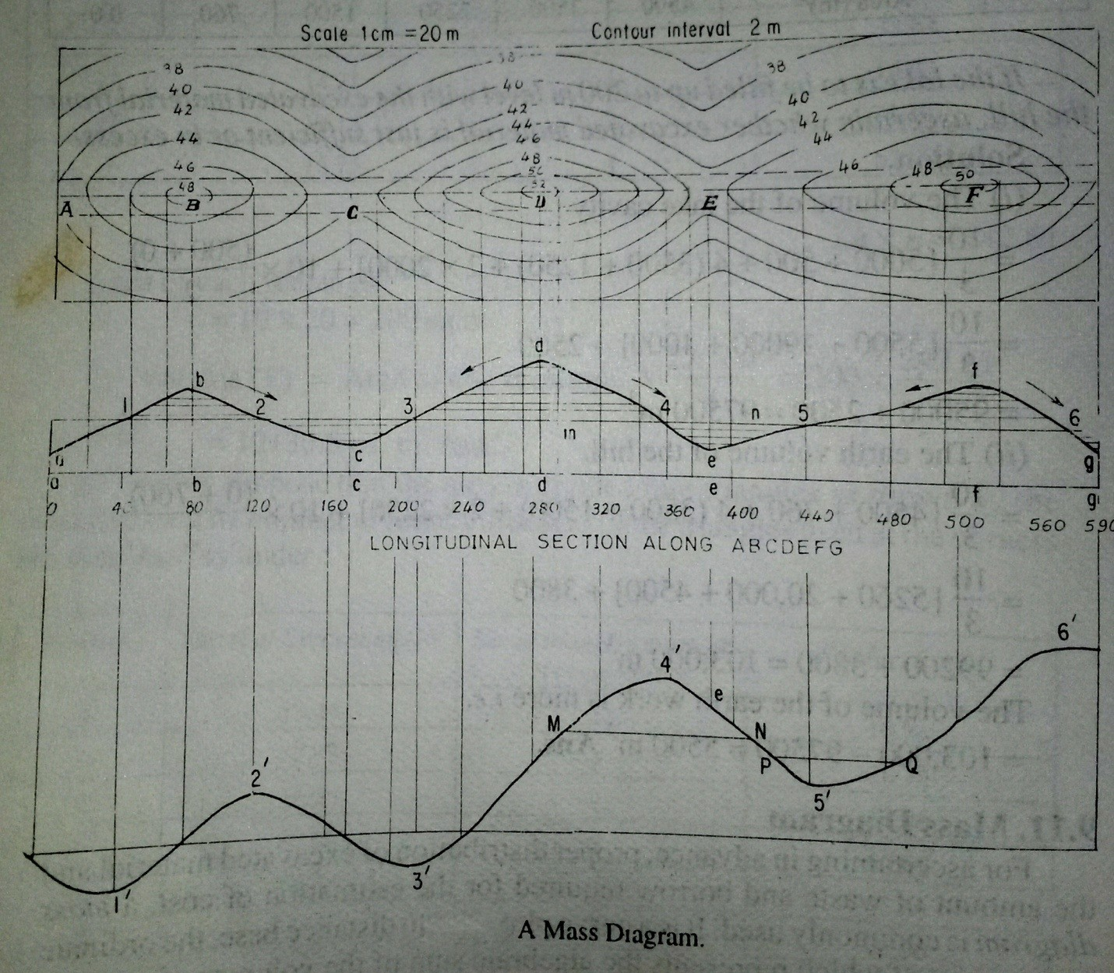
Solution

CHAPTER-9

Micro-optic Theodolites:-

Micro-optic theodolites can read angles to an accurancy of 10” or evenless.The es-sential principle is illustrated in Fig.9.1. The special features of such theodolites are asfollows.
    - Conventional metal circles are replaced by glass circles on which the graduations are etched by photographic methods. The graduations can be made finer and sharper by this technique. Both the horizontal and vertical circles are made of glass and generally graduated to10.
    - Light passing through the circle at the point of the reading is taken through a set of prisms to the field of view of the observer. For passing light through glass circles, sunlight is reflected through a reflecting prism and passed through the circle. In case night operation is required, the battery-operated light provided in the instrument can beused.
    - Both the horizontal and vertical circles are seen at the same in the field of view. This is an advantage, as the readings of both the circles can be taken at the same time. Some manufacturers make a switching arrangement so that the horizontal or vertical circle reading can be seen along with the micrometerreading.
    - The optical micrometer is used to read fractions of the main scale division. Depending upon the reading system, angles can be read up to 10’ orless.
    - The circles are generally graduated to 10’ or 20’ of the arc. The micrometer can be read after coinciding the index with the nearest main scale division. The fractions are then read from the micrometer scale, which is also seen in the field ofview.
    - A small, separate reading telescope is provided besided the main telescope. It eliminates the need to move while bisecting an object and taking thereading.
    - In most instruments, diametrically opposite ends of the circle are brought together in the field ofview.

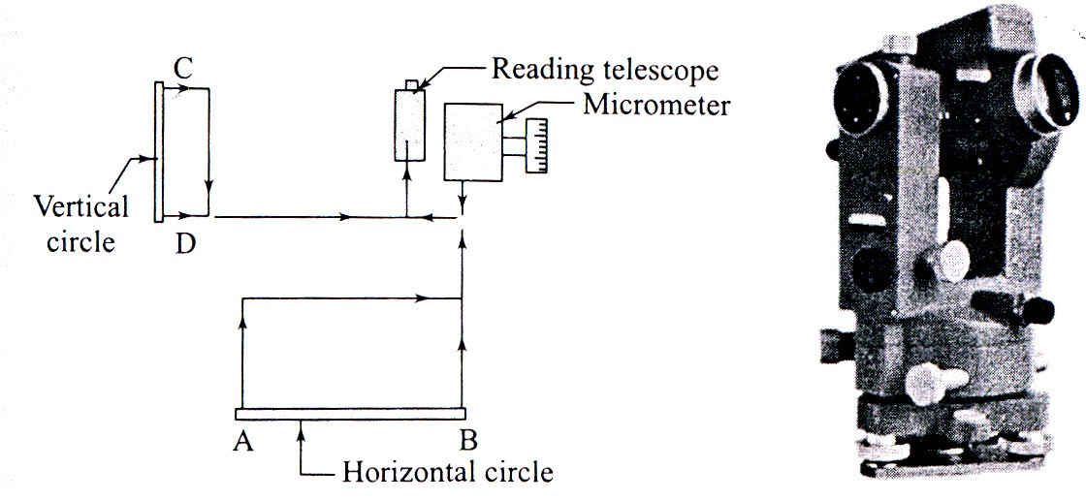

Fig.9.1

Digital theodolites:-

Digital theodolites are very fine instruments for angle and distance measurements. The instruments are light weight and are simplar to electronic theodolites in construction.
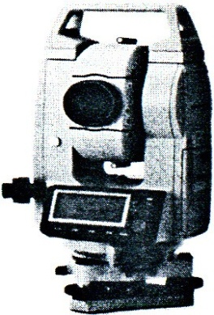
The instrument is set up over a station as in the case of normal theodolites. They will have extendable tripod legs which can be adjusted for comfortable viewing. The centering and leveling operations are done with a circular vial for coarse setting one has to press only a measure button to get the readings of angles and distances. Some models also have a laser pointer for easy alignment in critical cases and for staking out operations. With the arrival of total stations, these theodolites have less demand though they are cheaper compared to a total station.
The following are typical features in a digital theodolite:
- Angle measurement – by absolute encoding glasscircle; Diameter – 71mm
- Horizontal angle- 2 sides; vertical angle – one side; Minimum reading –1”/5”
- Telescope – Magnification – 30x; Length – 152mm;
objective lens –45mm Fig.9.2

- Field of view - 1⁰30’ Minimum focus distance –1m
- Stadia values: Multiplying constant – 100; additiveconstant-0
- Laser pointer – coaxial with telescope; 633 nm class II laser; Method – focusing for alignment and stake outoperations.
- Display on both sides; 7-segment LCDunit
- Display and reticleilluminated
- Compensator- tilt sensor; vertical tilt sensitivity +3’
- Optical plummet – magnification – 3x; field of view - 3⁰; focusing from 0.5 m tiinfinity
- Level sensitivity – Plate vial – 40”/2mm; circular vial –10’/2mm
- Power supply – 4 AA size batteries; Operating times – Theodolite only – 140hours
- Laser only – 80 hours; Theodolite + laser – 45hours
- Weight – 4.2kg.

Electronic Distance Meter(EDM):

EDM equipment can be classified based upon the type of wave used, into M (microwave) DM and EO (electro-optical) DM equipment. The first type uses low-frequency short radio waves while the second type uses high-frequency light waves. They cal also be classified based upon the range asfollows.
  - Short-range equipment such as teleprompters and mekenometers with a range of up to 3 km.
  - Medium-range equipment such as geodimeters with a range of up to 25 km. The range is about 5 km during the day and can go upto 25 km atnight.
  - High – range equipment with a range of up to 150 km. Tellurometers and distomats come under thiscategory.
The accuracy varies with the range. Short-range equipment has an accuracy of ± (0.2 mm) + 1 mm/km. Medium-range equipment has an accuracy of ± (5 mm + 1 mm/km) while high-range equipment ha san accuracy of ± (10 m + 3 mm/km). Distomats have replaced other forms of equipment due to their compact design, ease of operation, and precision.

All types of equipment using electromagnetic waves perform the following functions.

- Generation of two waveforms for carrier and measurementfunctions.
- Modulation and demodulation ofwaves.
- Measurement of phasedifference.
- Computation and display of distance or the results ofmeasurement.

TotalStations

One of the recent developments in surveying equipment is the integration of distance- and angle-measuring components in one piece of equipment. A total station is the integration of an electronic theodolite with the EDM equipment. Many companies market total stations. Though the technology details used by different manufacturers may be different, they all have common features, which will be discussedbelow.
A digital theodolite is combined with one of the many forms of EDM equipment to obtain a very versatile instrument that can perform the required functions veryeasily.

Digital Theodolite:

The electronic or digital theodolite was discussed in Chapter 4. We will just recapitulate some salient points. These instruments have glass circles, which are encoded in the incremental or absolute mode. These are read by an optical scanning system and the reading is converted into angles and displayed or stored by the instrument. All the instruments are provided with anoptical plummet for centering and a compensator system (single-axis or dual-axis) to take care of the tilt of the and the displayed angles and distances are previously corrected for such minor errors. The user can choose the required accuracy of angular measurement. These theodolites are normally operated by a rechargeable battery pack. The charged batteries can work for 40-80 hours. Some instruments need a prisms. Even reflecting tapes are used. A digital theodolite comes with the followingfacilities.
    - Zero-setting
    - Bidirectionalmeasurement
    - Precisionsetting
    - Horizontal and verticalangles
    - Slant distance and horizontaldistance

    - Difference in elevations
    - Entry and display ofdata
    - Display and storage ofresult
    - Data management system and data transferfacility
A total station has all the above facilities and in addition measures horizontal distance using a built-in EDM module. Total stations come with a lot more facilities of data storage and manipulation. The following are the salient features of a total station.
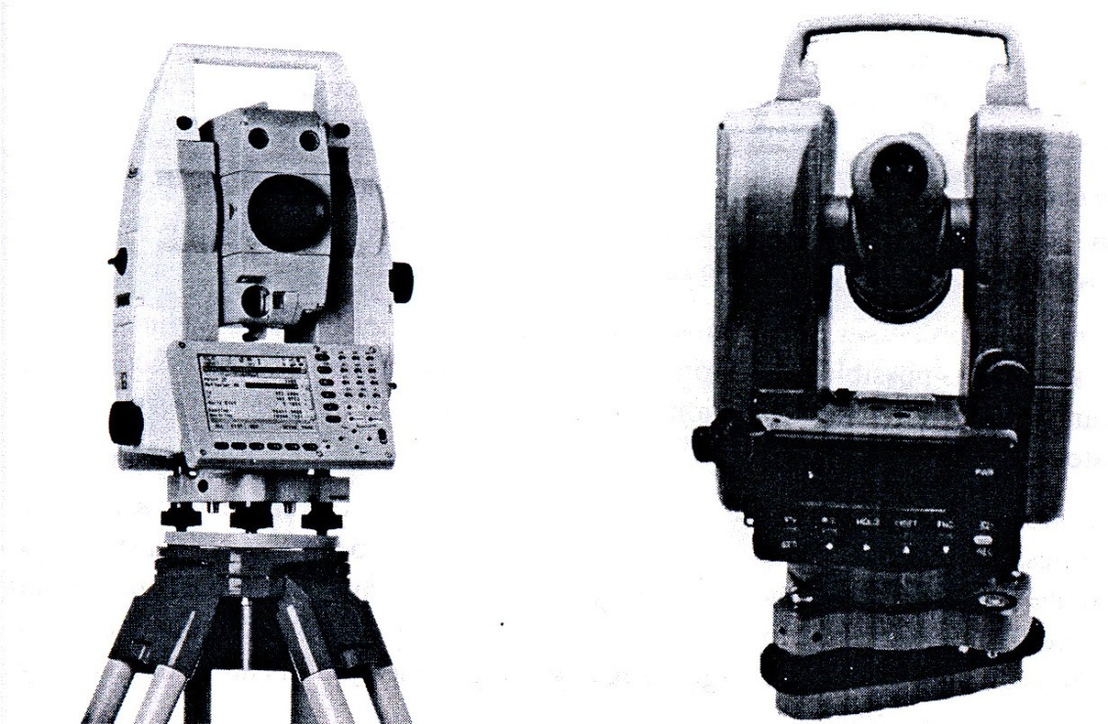
Angle measurement:- Horizontal and vertical angles are measured to an accuracy of 1”-5”. The angles are displayed on the display unit of the console. Many instruments have console units on both sides of theinstrument.

Fig.9.3

Distance measurement:- This is done with an EDM module functioning coaxially with the telescope tube. The distance measured is the slant distance if the stations are at different elevations. Reflecting multiple prisms are commonly used as targets, even though reflectorless distance measurement has also been made possible. The instrument uses the vertical angle measured by the theodolite and calculates the horizontal distance measurement can be done in different modes such as standard or coarse mode, precision mode, and fast mode, and fast mode. The precision and time taken vary depending upon the mode.
Microprocessor and software:- The onboard software in total stations can per form many functions. The processor is per-programmed, and in some cases can be programmed by the user to perform many useful functions with the measured data. The details may very with the manufacturers but some of the common features are as follows.
Automatic target recognition:- Most of the modern total stations have the facility of automatic target recognition (ART). In ATR, the telescope has to be roughly pointed towards the target while the measurement key is pressed. The instrument automatically points to the target before measurement. The instruments have motorized endless drives to facilitateATR.
Reflectorless distance measurement:-Until recently, total stations had to be used with special multiple prisms as targets for EDM. The new versions of total stations can measure distances without a prism target. This means that distances to points where a target cannot be erected can now be measured easily without any extra survey effort. This has been made possible by a red laser, which can direct to a point on any surface.
Computation of reduced levels:- The reduced levels are measured from slope distance and vertical angle. Data input enables the user to input the height of instrument, height of target prism, and the RL of the station occupid. The instrument calculates the RL of the target station and displays the same.
Orientation:- The instrument automatically orients to any direction specified by the user. If the coordinates of two points are input, the horizontal circle will be oriented to measure the bearing of the line automatically.

Automated processes:- Automatic computation of coordinates of points, areas, offsets, etc. is possible with a total station. More and more on-board functions are being incorporated in total stations. Setting out points on the ground using coordinates or directions ispossible.
Wireless keyboard and remote unit:- Many new total stations some with a separate wireless keyboard. The input of data to the station becomes very easy with a handheld keyboard. Another development is the availability of a remote unit so that the person at the prism can operate the total station for almost all the functions. As there is no need to bisect a target or read the angle, the system can be operated by one person positioned near thetarget.
Data management system:- Total stations have a very efficient data management system. Data transfer to data recorders, computers, or flash cards is possible. The in-built memory can store up to 10,000 blocks of data.
Graphic display:- Many new instrument have extremely powerful graphic display programmes. With large display panels, the data can be plotted anddisplayed.

Working with total station:-

Total stations are manufactured by many leading manufacturers of Survey equipment. Leica geosolutions, Topcon, Pentax, Nikon tripod data systems, Stonex are some of the major manufacturers of total stations. While specific details may vary with the manufacturers, some features are common to all of them.
A total station, as mentioned earlier, is a versatile equipment for surveying operations. The equipment details and operations can be understood by referring to the user manual provided with the equipment.

AerialSurveying

The procedure for aerial surveying includes reconnaissance of the area, establishing ground controls, flight planning, photography, and then paperwork including computation and plotting.
Reconnaissance is undertaken to study the important features of the ground for reference purposes. Ground control is required in order to obtain a set of points known position based on

which other points are located and plotted. The number of ground control points depends upon the extent of area covered, scale of the map to be prepared, flight plan, and the process of preparing the maps. A minimum of three control points must appear in each photograph. These points are established by triangulation or precise traversing.
Flight control is achieved by flight planning, which takes into account the extent of the area, type of camera and its focal length, scale of the photographs, altitude speed of aircraft, and the overlaps of the photograph. The area covered by each photograph. Time interval between exposures and the number of photographs quired are decided based upon such flight planning.

Stereoscopes:-

There are many types of stereoscopes- mirror stereoscope, lens stereoscopes, scanning mirror and zoom stereoscopes. Lens and mirror stereoscopes are handy and commonly used.
Mirror stereoscope :-The schematic diagram of the mirror stereoscope is shown in fig.9.4 (a). The mirror stereoscope consists of two viewing eyepieces. A stereoscopic pair of photographs is placed at a distance from the stereoscope. The photographs are adjusted so that one photograph is seen through one eyepiece. The instrument has four mirrors, two mirrors attached to each eyepiece. As the viewer looks through the stereoscope, he/she sees the image of the same object (the overlapping part) on the two photographs and this gives a stereoscopic view by fusion. The terrain is seen in relief due to this.
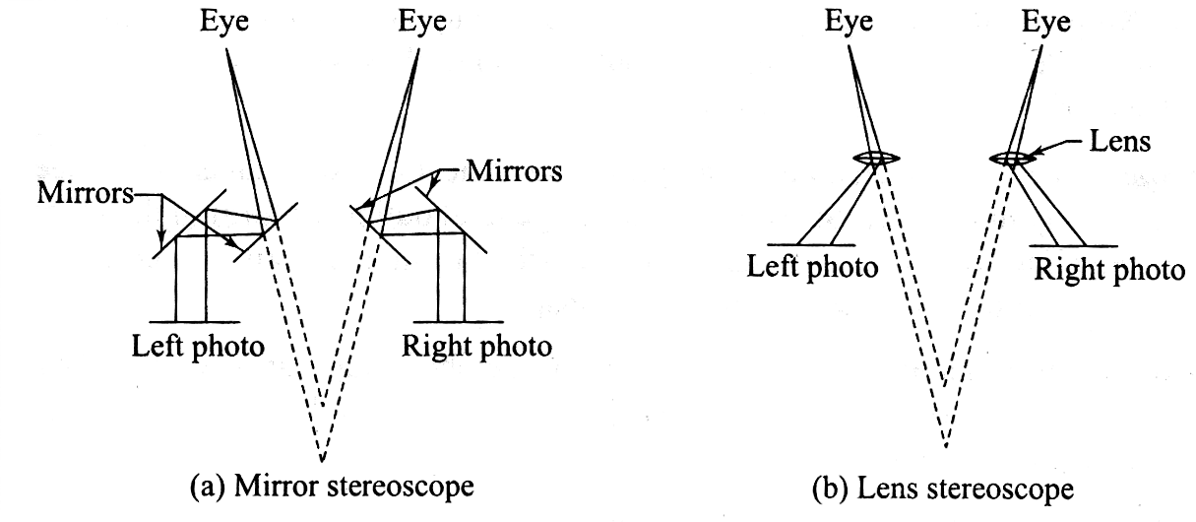

Fig.9.4

Lens stereoscope:- A lens stereoscope has two eyepieces through which the observer sees the photographs, providing the experience of stereoscopic or spatial view. The lenses help to magnify the image as seen by each eye. The distance between the eyepieces is adjustable and can be set by the observer as per requirement. This distance is approximately equal to the distance between human eyes. The lenses tend to magnify the object and its height. Lens stereoscopes are more compact than mirrorstereoscopes.

Photo-interpretation:-

Photo-interpretation is the key to effective use of photographs. It refers to the accurate identification of the features seen in photographs. Objects seen in photographs are often not easy to recognize, and it takes some amount of skill on the part of the interpreter to correctly identify the objects and judge their significance. It is more difficult to identify objects in vertical photographs than in tilted photographs owing to the familiarity of view in oblique photographs. Colour photographs are easier to interpret than black and white photographs due to tonal variations. A stereoscopic pair is easier to interpret due to the depth available in the photographs when seen through a stereoscope. Considerable amount of practice and experience is required to correctly interpret photographs.
Interpretation of aerial photographs is required extensively in developmental project design and execution. It has been successfully applied in a variety of fields. The success of project planning depends on the effective and efficient interpretation of photographs by engineers and others and others. A good deal of patience and ingenuity is required to interpret photographs.

General Features of Photographic Images:-

The knowledge of some of the basic characteristics of the image in aerial photographs helps helps one to interpret these images. Photo-interpretation requires large-scale photographs. The success of the interpretation depends upon the experience of the person in addition to the conditions under which the photographs should be studied in the correct orientation with respect to the light conditions at the time of photography. Some of the basic features of photographs that help in identification are discussed here.

Size:- The size of an object in the photograph is sometimes helpful in interpretation. Knowing the photograph scale, it is possible to have an idea about the size knowing the correct size, one may not confuse among objects having similar shapes such as a river, road, canal, ordrain.
Shape:- The shape of an object is helpful in identification. Regular shaped objects are generally man-made. Shape relates to the general outline or form of the object. A railway line and a roadway can be distinguished from their form. Objects of the same size can be distinguished from theirshape.
Texture:- it is simply the variation in tone of the photograph. It is produced by a combination of factors such as size, shape, tone pattern, and shadow. Vegetation and other ground features can be distinguished by the tonalchanges.
Pattern:- It is the spatial arrangement of objects in a particular set. A habit can be easily distinguished by the arrangement of roads, houses, etc. because of the pattern.
Shadow:- The shadow of an object formed during photograph is sometimes helpful in identification, as it shows the outline of the object.
Tone:- It is produced by the amount of light reflected back by the object to the camera. If the particular tones associated with specific objects are known, it is easy to identify them.
Location:- The location of an object in the photographs helps in identifying the object itself. Knowing the objects or areas surrounding the object, one can identify the main object. Refer Chapter 24 for more on visual image processing.

Applications and Advantages of Aerial Surveying:-

As has been discussed in the preceding sections, aerial surveying finds many applications in map preparation and map revision for large areas. Modern plotting machines and mostly automated operations have simplified the process of preparing maps from aerial photographs. Aerial surveying also finds extensive application in urban planning and development, transportation network design and calculations, disaster management, forestry, mining operations, reservoirs, agriculture,etc.

With advancements in technology, aerial photography has given way to aerial image processing. High-resolution digital image (soft image) can be made and processed using software to prepare excellent maps. All forms of rectification and corrections can be done automatically before converting the data into a map. Digital photogrammetric equipment and software have developed sufficiently to facilitate the preparation of very accurate maps.

Aerial Photogrammetry:-

Terrestrial photogrammetry virtually went out of use with the advent of aerial surveying techniques. Aerial photogrammetry makes use of cameras fitted in an aircraft to photograph an area from an overhead position. The principle of stereoscopic vision is used in studying and interpreting aerial photographs. Therefore overlapping photographs are taken in the direction of flight as well as in the lateral direction as the aircraft flies along a parallel path. It must be understood that while a map is an orthographic projection by projecting points perpendicular to the plane a photograph is a perspective projection, as all the light rays for forming the image pass through a point.

Basic Terminology:-

An aerial photograph is a record of the ground features at a point in time. Aircraft fitted with cameras moves along predetermined paths and takes photographs at planned intervals. The following are the basic terminology used to describe aerial photography.
Altitude: - Height of the aircraft above the ground.

Flying height: - Height of the aircraft above a chosen datum.

Exposure station:- Position of the aircraft at the time of exposure of the film. It is essentially the position of the optical centre of the camera lens when film I exposed.
Air base: - Distance between two consecutive exposure stations.

Tilt and tip: - Tilt is inclination of the optical axis of the camera about the line of flight. In $ is the tilt. Tip is the inclination of the camera axis about line perpendicular to the line of flight.

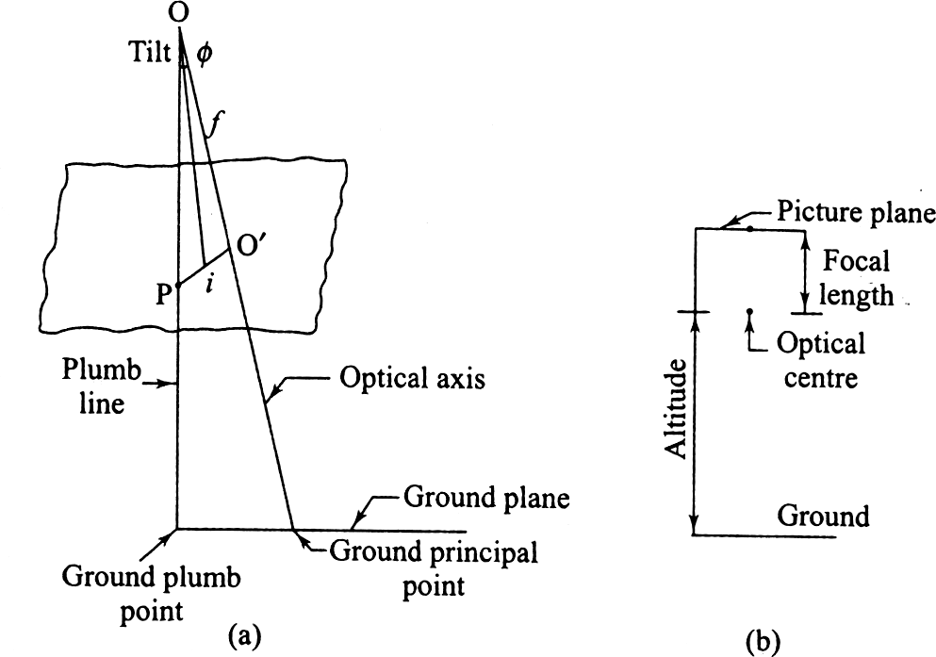

Fig.9.5

Picture plane:- Plane that contains the image at the time of camera exposure.

Ground plane: - Horizontal surface from which heights can be measured and which can be used as a datum surface.
Principal point:- Point of intersection of the optical axis of the camera with the photographic plane. O is the optical centre and O′ is the principal point. When the optical axis is extended downwards, the point of intersection with the surface is known as the principal ground point.
Isocentre: - Point on the photograph at which the bisector of the angle of tilt meets the photographic plane. ‘i’ is the isocentre, at a distance of f cos $ along the principal line, where f is the focal length of the camera.
Plumb points: - The points at which the vertical line through the optical centre meets the photographic plane and the ground surface. The plumb point on the ground surface is also known as ground nadir point. The plumb point on the photograph is known as nadir point.
Homologous points: - Points on the ground and their representations in the photo graph in perspective projection.

9.4 RemoteSensing

Remote sensing, as the name implies refers to collecting data from a remote location without being in physical contact with the object. Remote sensing is not as uncommon as we may think. We have many remote sensing activities in day-to-day life. When we see an object and recognize its colour as red, we are using the concept of remote sensing. Similarly, our sense of smell also helps us to use remote sensing. Some of the common methods of remote sensing are describedbelow.

Active and passive system of remote sensing:

In an active system of remote sensing, the sensing equipment emits radiation, which is reflected back from the object. Radar is a typical example of such a system. Radar equipment transmits radiation and the reflected radiation is analysed to determine the distance and presence of any object in the ranging area.
In a passive system of remote sensing, the instrument does not generate and emit radiation. The radiation reflected from an external source is made available to the object. We use the passive system exhaustively in the form of the sun’s radiation. Taking a photograph using light from the sun is an example. Photographic cameras, still or motion picture, and television cameras use the passive system of remote sensing.

Applications/Uses of Remote Sensing

Remote sensing has applications in a wide spectrum of areas. Remote sensing can be used for taking sound decision for planning many human development activities. It is also possible to take preventive action as in the case of forest fire and natural disasters, Weather forecasting is another important application. Some of the application areas are givenbelow.
Land use and land cover analysis:- Perhaps one of the prime uses of satellite remote sensing is in the study of land use and cover. Land cover through vegetation and specific crop areas can be studied using remote sensing data. Forest cover is an important aspect, which has been studied: the depletion of forest areas has been identified with the help of remote sensing. It is also possible to study crop diseases over largeareas.

Mineral exploration:- It will be possible to use satellite data ana discover the presence of valuable minerals and ores that are vital to economic development. Non-renewable energy resources, such as fossil fuels, can be identified using remote sensing data.
Environmental studies:- Global weather phenomena are a major area for study using remote sensing data. Global warming and ozone layer depletion can be continuously monitored using remote sensing. Similarly, oceanographic studi4es also provide valuable information about the various characteristics of oceans around the world. Assessing water resources, their extent and depletion, snow cover studies, etc have proved to be valuable.
Archaeology:- Archaeological studies can make use of remote sensing data. The underlying old settlements can be recognized from remote sensing data and appropriate action can be taken to excavate and study the various aspects of old civilizations.
Disaster management: - This is another important application area of remote sensing. It has been possible to predict earthquake hazards by detecting unusual movements in the earth’s crust. Floods .landslides, forest fires, etc can be detected on time and appropriate action can be taken for preventive action in disastermanagement.
Geomorphology: - Geological studies can provide valuable data on faults, tectonic movements, rock type identification, etc using remote sensing data.
Topography and cartography: - This is another application related directly to surveying. Remote sensing can be used to accurately locate points with reference to ground surveys are difficult or time consuming. This data can be used to prepare maps or revise existing maps.
Other applications: - Remote sensing data is now being used to study troop movements, etc for defense purposes. Other applications include urban planning studies, traffic studies, and assessment of earth’s resources for various purposes, and so on.

Image Interpretation:-

Image interpretation is the process of extracting useful information from remote sensing data. Both qualitative and quantitative information can be extracted from maps .Earlier, the data was in analog form which is generally interpreted by humans Today, the data is generally is digital formwhichcanbeinterpretedbyhumansofprocessedbycomputers.Thecorrectinterpretation

of remote sensing data is very important if it is to be useful for the various purposes for which it has been obtained.

Visual Image Processing:-

The remote sensing data can come in either of the two forms – raw data or processes after certain corrections. Visual images can be monochromatic or grey scale images or colour composites or colour photographs. The objective of visual interpretation is to obtain qualitative information about objects seen in the image. This includes finding their size, location, and relationship with other objects the way our eye perceives an object is different from the way remote sensing data is obtained. first, the image is taken from an aerial platform- an aircraft or a satellite. The view from above will be quite different from the view seen from the ground. Second, the sensors used for imaging record radiations from many parts of the electromagnetic spectrum including the visible band. This makes the imagery look different from what we see otherwise. Third, resolution obtained and scale of the image may be quite unfamiliar to the eye. Finally, the ground relief feature may not be evident in two-dimensional photograph or image. Stereoscopes are used to view photo pairs having common imagery to get a feeling ofdepth.
The following three processes are involved in image interpretation:

(1) Image reading is the first step in image interpretation and involves identifying objects in the image by their size, shape, pattern, etc.
- Measurement from images is the extraction of information such as length, width, height, and other parameters like density or temperature from data keys asreference.
- image analysis is the understanding of the information extracted and comparing with ground reality or the status of the features as existing at the time ofimaging.
Visual interpretation as it is done using photographs has to be supported by ground investigation for correctness of the interpretation. This becomes very necessary as the image may have many features which are not immediately understandable by the interpreter. Multiple images in multiple scales and multi- spectral images have to be interpreted and verified before reaching anyconclusion.

Elements of visual Interpretation:-

Some key elements that assist the interpreter in studying and extracting information about the objects in the image are the following:
Location: - It refers to the information about the objects in the image in terms of any of the coordinate systems used such as latitude, longitude, and elevation. If some points are available in the image with known coordinates, then the coordinates for other points or objects can be obtained by measuring distances from the known points. Actual ground surveys can also be performed using easier methods that use GPS or by traditional methods of surveying that use total station to get coordinates. Computer processing of the image after rectification can also be employed to get information about coordinates.
Size: - The size of an object seen in an image depends upon the scale of the image. Knowing the scale of the image, the length, width, perimeter or area can be used to extract information about the subject. The absolute size of an object along with its relative size is also important in distinguishing between features having the same shape. The size can help distinguish between objects of the same shape such as a building or a football field.
Shape:- The shape of an object is distinguishable in the image and can help the interpreter to identify the object. Objects of regular shapes such as rectangles square, circle or oval are generally man-made structures. Irregular boundaries of an object generally mean that the object is of natural origin such as forest area or a lake. Since the imaging is done from above, it is necessary to know how an object looks from thetop.
Shadow:- Shadows are generally not desirable in images as they change the nature of the image that would have been seen otherwise. However, shadows help in finding the heights of tall structures like towers and multi-storey buildings. Shadows are created due to low sun angles. In addition to aiding in ascertaining the height of objects, shadows also provide a profile view of objects which is helpful in identification.
Tone: - It is the relative brightness or colour intensity of the image. A black and white photograph is a grey tone image with brightness ranging from black to white. The remote sensing sensor receives and displays a band of the spectrum of electromagnetic radiation and this is displayed as continuous shades of grey which gives different tones in the image. Tones are useful

features of interpretation because different objects give unique tonal qualities due to their reflectance. Tonal differences can occur due to different bands in multi-spectral images. Experience and a clear eye help to distinguish the tonal variation.
Color :- Color images are obtained from colour films. Colour photographs or images hold a lot more information than black and white grey tone images. From the natural colour of the image in the film many features like vegetation can be identified. Colour can change depending upon the type of film and filters used. Colour corrections can be done to images to give true colours of the objects.
Texture:- It can be defined as the characteristic placement and variations in definite patterns for objects in the grey tone image. Textures are classified as smooth or coarse. This is due to the visual impression created by the tonal changes. Coarse textures are due to sudden changes due to abrupt changes in tone in small patches giving a mottled appearance. Smooth texture comes from very little changes in tone. Texture helps to identify objects in an image due to characteristic textures of objectse, especially vegetation and forest trees.
Pattern: - It refers to the randomness or regularity of similar objects in the image. The pattern seen in the image is helpful in identification. Arrangement of trees in a forest is random, while trees in a orchard are placed in an orderly way. Same is true of houses in a neighborhood or buildings in a developed area. Such patterns can be identified and the objects recognized from thepattern.
Elevation: - As mentioned in Chapter 22, stereoscopes are used in association with photo pairs to have a view of the difference in elevation of objects. The overlapping areas of the images in photo pairs are useful in finding the elevations of points and also to have an idea about the relative heights of different objects seen in theimage.
Interpretation keys: - These are used to help in visual interpretation of images. The keys are prepared by experienced interpreters who from past experience and ground verification prepare keys based on major elements of identification. Keys can be prepared for specific uses such as forestry, urban studies, network studies, and so on.

